Lytchett Bay 2015

Shaun Robson

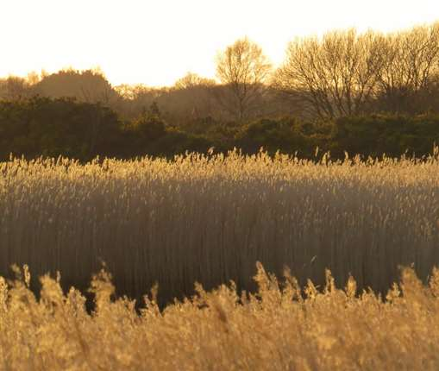

The Bay was visited on all but 6 days (!) as set out below. Records came from an increasing number of birders but Ian Ballam again takes the honors as an almost “ever present”.

JAN | FEB | MAR | APR | MAY | JUN | JUL | AUG | SEP | OCT | NOV | DEC
29 | 26 | 31 | 30 | 31 | 30 | 31 | 31 | 30 | 31 | 30 | 29

2015 proved to be a year of quality and quantity. Lytchett Fields continued to develop as an attractive habitat and there were many excellent birding days in both spring and autumn. Given this change it was perhaps surprising that many of this year’s rarities were found in other parts of the Bay.

Three records are still outstanding with the Dorset Records Panel. They are included here and in this summary marked *. On the assumption that all 3 are accepted then the annual species list reached 160 for the first ever time. Once decisions are forthcoming then updates will be published in future reports.

3 new species were added to the Bay list. Wryneck was long overdue and showed well to those who arrived quickly. A Melodious Warbler* was always a potential addition and a wet, warm August day produced the right fall of warblers. Sanderling, my personal favourite. Completely out of place on the mud at the “back” of Poole Harbour. The Lytchett Bay list is now 222*.

In terms of pure thrill our 2nd Bluethroat probably brought the most joy. Though for the finder, two vis-mig Penduline Tits*, also our 2nd, will never be forgotten. Similar memories will be banked by the finder of another “fly-by”, our 2nd Lapland Bunting which called with jaw dropping clarity overhead.

Other notables included 3rd Great White Egret*, 4th and 5th Egyptian Geese, 5th Little Tern and Black Redstart, 6th Kittiwake.

Redshank bred again and Shelduck bred for the first time in a number of years.

The following species occurred in either greater numbers or greater frequency than ever before. And it was perhaps the spectacle of waders and waterfowl on Lytchett Fields which brought the most pleasure to visiting birders.

Teal, Shoveler, Spoonbill, Marsh Harrier, Ringed Plover, Little Ringed Plover, Grey Plover, Knot, Ruff, Green Sandpiper, Wood Sandpiper, Common Sandpiper, Mediterranean Gull, Wood Pigeon, Kingfisher, Tree Pipit, Grey Wagtail, Whinchat, Grasshopper Warbler, Sedge Warbler, Garden Warbler, Blackcap, Willow Warbler, Chiffchaff and Goldcrest.

I have birded the Bay for 24 years and I think this year was my most enjoyable.

Nick Hull has again produced a fine illustrated report of mammals, amphibians, reptiles and insects. See page 58.

I am also pleased to be able to include our first plant and biophyte surveys thanks to Katie Wilkinson and Jim White of Dorset Wildlife Trust. See page 76.

No of bird species seen annually at Lytchett Bay 1995 - 2015

Lytchett Bay – people and wildlife
2015 built on the progress which began in 2014 (see last year’s report). Two major access improvements were made and these were supported by improved interpretation and an electronic guide to birding the Bay. A number of events were hosted and there is no doubt that more people were able to enjoy Lytchett Bay and its wildlife than ever before.

The primary improvement in terms of access occurred thanks to a partnership between The Birds of Poole Harbour and the RSPB at Lytchett Fields. With development of some high quality and very bird friendly habitat in the preceding couple of years we had a real desire to open up every day access for people to enjoy the birds. This was realised before the spring migration with the creation of the Sherford and French’s viewpoints. A new view was also installed at The Pool. These changes proved hugely popular with visitors. Thanks to the RSPB’s field management the birds loved the habitat and the views were splendid.

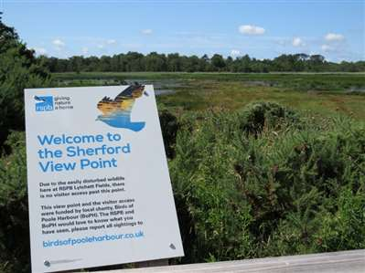
Lytchett Fields were the centre of attraction during early autumn. Numbers and diversity of migrant waders reached a new high. (S.Robson)

At Lytchett Bay View, Lytchett and Upton Town Council’s excellent leadership in developing the site continued. Thanks to a partnership with The Borough of Poole, Birds of Poole Harbour and support from Viridor landfill tax credit schemes and Wessex Water, a new board walk was installed which created a circular walk linking Turlin Moor and Chad’s Copse. Management works on the whole site were carried out to increase diversity and tree structure. As these changes bedded in the feedback and increased use of the site was very positive. New interpretation was installed in partnership with The Great Heath and a bloom of Pyramidal Orchid’s attracted much interest.

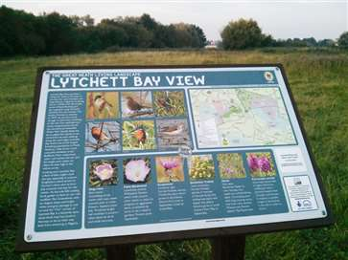
Lytchett Bay View is used by many local people for dog walking and recreation. This board helps draw attention to special nature interest in the site. (S.Robson)
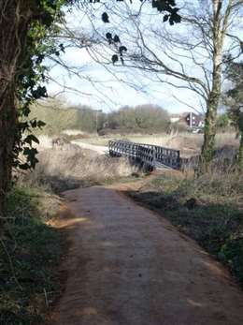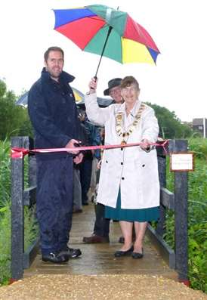
The new boardwalk linking Lytchett Bay View and Turlin Moor open space was one of the successes of the year. Project manager Terry Elborn cuts the ribbon at the official opening in conjunction with LMUTC Mayor, Cllr Mrs June Richards.

The Great Heath sites continued to improve with better signage and further improvements to footpaths. In partnership with Stour Ringing Group, another successful bird ringing demonstration was “sold out” in late August. 2 guided walks were hosted to share the birds of Lytchett Bay and covered Dorset Wildlife Trust’s nature reserve and Lytchett Bay View.

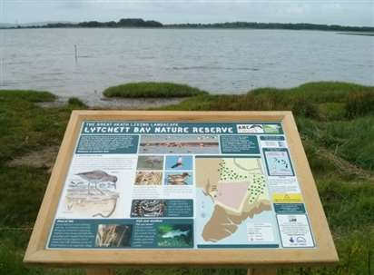
Fine views of Lytchett Bay can be had from the end of the public footpath at Dorset Wildlife Trust’s Lytchett Way site. (S.Robson)

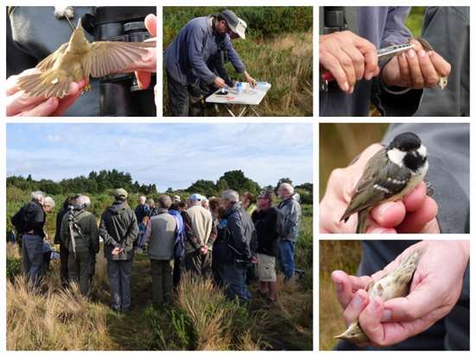 Another successful bird ringing demo with Stour Ringing Group (J.Grierson )

After last year’s improvements to the Turlin Moor bird screen, The Borough of Poole worked with local charity the Richmond Fellowship to repair the screen and give it a face lift.

Before
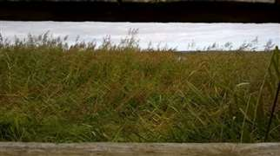
After
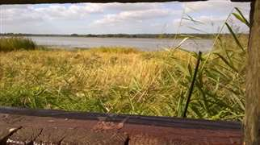
Attention to small details can make a big difference. Reed management ensured that views of the Bay were retained. (Z.McMinn)
With all of these changes going on we took the opportunity to promote the site. A birders guide was created and this hosted by the Birds of Poole Harbour website and is available here.

http://www.birdsofpooleharbour.co.uk/sites/default/files//A%20Guide%20to%20Birding%20Lytchett%20Bay-12.pdf

Thanks to this progress our motivation to do more grows. A future vision for Lytchett Fields is in preparation and engagement has begun. Lytchett and Upton Town Council are preparing a management plan for Lytchett Bay View. Community events connected to the Great Heath project are planned for 2016.

Livability, the occupants at Holton Lee are working in partnership with the RSPB to manage land on the south side of the Sherford and this supports the overall vision of seeing the Bay as a whole ecosystem with the future goal of fitting this within the wider context of Poole Harbour.

Finally, the planning application for house building at Policeman’s Lane was granted. This application contains an exciting opportunity to open up a SANG to the west of Slough Lane. This will not only provide opportunity for dog walking and thereby relieve pressure on more sensitive sites it also has the added benefit of creating addition habitat for nature.

On a personal note I’d like to thank everyone from the organisations mentioned for their passion, commitment and support.

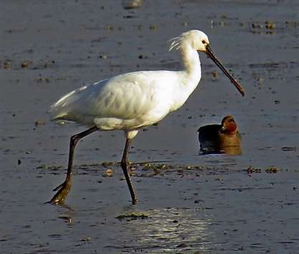
Before 2013 there had only ever been 5 records of Spoonbill. This year the species was recorded on 69 dates! (I.Ballam)

Frequent feedback over the years has been that this report needs a map of the Bay and the recording area. Thanks are again due to Nick Hull who has kindly obliged. Whilst we have named as many sites as we can, please remember that some areas remain private and we would be grateful if visitors stick to the extensive network of public and permissive pathways that are available.

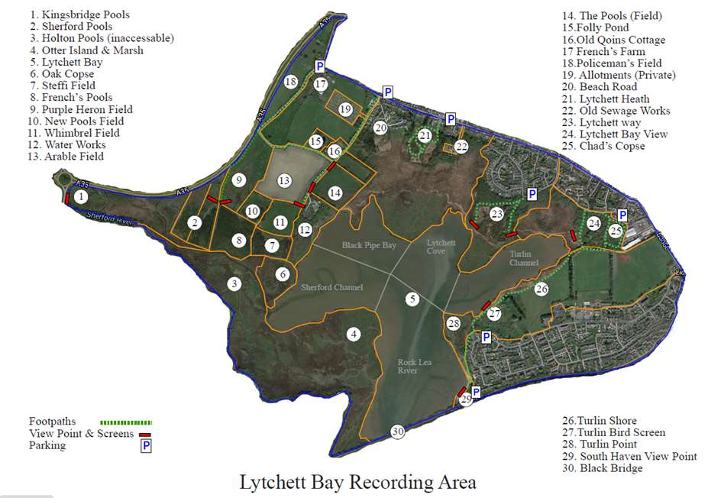

Bird Ringing 2015
1904 birds were ringed at Lytchett Bay. Efforts were spread around 3 ringing sites. The banks of the Sherford at Lytchett Fields (512 birds / 8 dates), Sandy Close Pond (131 birds / 16 dates) and at Lytchett Heath and reed bed (1261 birds / 23 dates).

Early summer was blessed with very good conditions and more than 100 birds were ringed on 5 mornings. This included more than 200 on 3 mornings.

Our main target remained the “red listed” Aquatic Warbler but conditions remained almost entirely unfavourable during August. When winds did move to the south east during September we could not take the opportunity.

This quantity of birds produced an excellent selection of re-traps and controls. These are all detailed in the species accounts in the systematic list. Studying the patterns of passerine migrants makes for interesting reading. Several birds make counterintuitive northerly movements during autumn, birds ringed on the same morning in the same weather conditions then head off in entirely opposite directions despite having apparently similar final wintering destinations. More typically we continue to establish that many of our Sedge Warblers move south in staged flights stopping to refuel on the Atlantic coast of France.

Colour-ring reading produced plenty of highlights and interesting information about our visiting waders. Black-tailed Godwits, Avocet and Spoonbill again starred. We also have information on our first colour-ringed Common Sandpiper and Black-headed Gull.

21,802 birds of 82 species have been ringed since 1983. Bluethroat being added to the list this year.

The full details of controls, recoveries and interesting re-traps are in the systematic list. Appendix 2 details the individual species totals at the end of the systematic list.

Acknowledgements
Stour Ringing Group would like to thank Wessex Water, The RSPB and the landowner, the Lees Estate, for their kind permission to ring at Lytchett Bay.

The Dorset Wildlife Trust and ARC for their permission to ring on land around Lytchett Heath, we are very grateful for this, the site continued to prove its value to migrant and breeding birds.

Thanks are due to the RSPB, DWT, ARC, Lytchett & Upton Town Council, The Birds of Poole Harbour Charity and The Borough of Poole for their support in relation to various matters associated with their site and we look forward to continuing to work with them in 2016.

I’d like to add additional thanks to Ian Ballam and Paul Morton for their enthusiasm for birding at Lytchett. To friends at Stour Ringing Group for companionship and hard work. Nick & Jacqui Hull who put considerable effort in to collating a checklist of other wildlife, carrying out breeding warbler surveys and operating our first “listening station”. To all of the observers who supplied records and comments via Twitter and other information sources. We look forward to seeing you all again this year.

Systematic List 2014
4543 specific records were collated during the year and all of these have been submitted to the BTO’s Birdtrack database. This has enabled some data for regularly occurring species to be presented using graphs. These show the weekly maxima throughout the year. The interpretation of these requires some caution as not all common species are counted every week; this can lead to gaps in the data. Where necessary this is clarified in the text.

Species names are followed by up to 3 numbers. The first is the maximum known count recorded at the Bay. This now includes historical counts by observers going back to 1975. The middle figure (when necessary) is the max count in the period since 1992. The final figure is the number of years in which the species has been recorded since 1992. This is the year in which the current spell of comprehensive coverage began.

The symbol which follows each species name shows the direction of travel of the species status at Lytchett Bay over the last 5 years. I think these are quite intuitive; strongly increasing, increasing, stable, declining and strongly declining. Hopefully this feature will enable others to compare the data from this site with experiences at their own site and engender some debate and understanding.

Mute Swan: (58 – 24)
Uncommon resident. Bred between 2002 and 2007. After a significant increase from 2003 onwards numbers of this species visiting the Bay started to decline in 2012. The amount of macro algal matt has decreased in recent summers. Both Wigeon and Mute Swan numbers peaked when this weed was most abundant.

A pair bred this year for the first time since 2007. Impressively they hatched 7 cygnets and these all survived until at least the end of Aug.

JAN | FEB | MAR | APR | MAY | JUN | JUL | AUG | SEP | OCT | NOV | DEC
2 | 2 | 4 | 2 | 4 | 9 | 9 | 9 | 9 | 11 | 5 | 3

Greylag Goose: (32 – 16)
Scarce feral wanderer. Recorded in every month except Jul and Nov and on 22 dates, similar to 2014. Max 16 on 9th Oct.

Dark-bellied Brent Goose: (88 – 16)
Uncommon winter visitor. Birds were present on and off from 24th Jan until 5th Apr. The first returning birds were on 1st Nov and the species was recorded frequently until the end of the year. Overall numbers were lower than in 2014. Max 16 on 4th Dec.

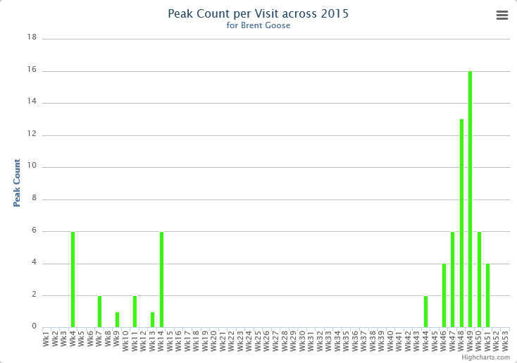

Canada Goose: (209 – 24)
Increasingly frequent visitor. Possibly bred for the first time. A pair with a very young chick was seen between 28th Jun and mid Jul. 200 on 28th Oct was the max count. Regular large flocks roosted in autumn.

JAN | FEB | MAR | APR | MAY | JUN | JUL | AUG | SEP | OCT | NOV | DEC
4 | n.c. | 3 | 5 | 25 | 3 | 55 | 133 | 32 | 200 | n.c. | n.c.

Egyptian Goose:
Fourth and Fifth records. 2 lingered in the Bay for a short while on 4th May (SR) and 2 flew west over Lytchett Bay View on 19th Oct (SR).

Shelduck: (645 – 548 – 24)
Occasional breeder and winter visitor. 3 pairs bred around the area raising 6, 4 and 2 juveniles. This is the first successful breeding since 2010. The largest congregations of the year again involved presumably non-breeding birds at Lytchett Fields in early summer.

Bay monthly max:
JAN | FEB | MAR | APR | MAY | JUN | JUL | AUG | SEP | OCT | NOV | DEC
43 | 32 | 58 | 85 | 166 | 76 | 46 | 9 | 0 | 6 | 50 | 31

Wigeon: (671 – 24)
Common winter visitor. A better year than 2014. Particular increase in the second period. Absent from 29th Mar until 16th Jun.

Bay monthly max:
JAN | FEB | MAR | APR | MAY | JUN | JUL | AUG | SEP | OCT | NOV | DEC
89 | 91 | 46 | 0 | 0 | 1 | 1 | 4 | 79 | 270 | 174 | 209

Gadwall: (73 – 19)
Increasingly frequent visitor. Birds were around Lytchett Fields from Jan to early Aug (as 2014) but there was no proof of breeding. Most birds in spring are presumed to be non-breeding individuals.

JAN | FEB | MAR | APR | MAY | JUN | JUL | AUG | SEP | OCT | NOV | DEC
11 | 4 | 6 | 8 | 17 | 15 | 1 | 3 | 0 | 1 | 10 | 3

Teal: (1094 – 24)
Winter visitor and passage migrant. There was no identifiable period without records this year but breeding was not suspected. For the third year in a row numbers increased, reaching four figures for the first time. 1094 were counted on Lytchett Fields on 31st Oct. Despite much scrutiny no American cousins were found. In fact for much of the year wildfowl variety on the fields was limited to 3 species. Teal, Shelduck and Gadwall. Quite why these three species find the fields so attractive whilst other dabblers don’t is a mystery.

JAN | FEB | MAR | APR | MAY | JUN | JUL | AUG | SEP | OCT | NOV | DEC
332 | 250 | 186 | 196 | 3 | 12 | 11 | 200 | 853 | 1094 | 399 | 642

Garganey: (3 - 5)
Rare visitor. Records for the second year in a row.

Single males were seen in the Bay. 1 on 25th Mar (IB), the earliest record at the Bay, and 1 on 11th Jul (IB). Neither lingered for very long.

Mallard: (106 – 24)
Breeds at several sites around the recording area. Very regular on Sandy Close Pond.

Bay monthly max:
JAN | FEB | MAR | APR | MAY | JUN | JUL | AUG | SEP | OCT | NOV | DEC
n.c. | 16 | Br | Br | Br | 44 | n.c | 37 | 14 | 22 | 6 | n.c.

Northern Pintail: (21 - 16)
Scare visitor. Seen on 7 dates (same as 2014). 2 on 3rd Apr was the only record in the first 8 months. After 4 on 27th Sep there was 1 on 8th Nov, 5 on 22nd Nov, 2 on 23rd and the last single on 27th Dec. All birds were in the Bay except for the flock of 5 over Lytchett Bay View.

Shoveler: (28 – 23)
Scarce visitor, which can occur at any time. Much less frequent this year but an exceptional and record influx of 28 on 22nd Nov. These birds were mixed between the Bay and migrants overhead. The previous best was a mere 7 on 10th Dec 2005. In addition 14 bird days on 9 dates was far more typical.

Tufted Duck: (20 – 12)
Scarce visitor. An eclipse drake on 19th Aug was the only record of the year (IB).

Goldeneye: (12 – 23)
Declining winter visitor. Another poor year. 4 records up to 15th Feb. Max 2 on 29th Jan. In the second period just one. A male on 31st Dec.

Red-breasted Merganser: (73 – 24)
Winter visitor. Recorded on at least 29 dates. Present until 3rd Apr and from 22nd Nov. Max 18 on 20th Jan.

Bay monthly max:
JAN | FEB | MAR | APR | MAY | JUN | JUL | AUG | SEP | OCT | NOV | DEC
18 | 9 | 14 | 1 | 0 | 0 | 0 | 0 | 0 | 0 | 7 | 5

Red-legged Partridge: (4 – 4)
Very scarce visitor, no doubt emanating from recent releases for shooting. One on 6th and 7th Apr in the Arable Field was the first since 2008.

Pheasant:
Common resident. Established in all parts of the recording area. Recent increases have not been sustained and records this year have been far fewer than the last few years.

Little Grebe: (12 - 24)
Winter visitor. This species was present for a longer period than usual but numbers were very low. Recorded until 25th Mar and from 17th Jun (earliest return date). Max 3 on several dates.

Great Crested Grebe; (4 - 21)
Increasingly frequent visitor. Recorded on 38 dates between 13th May and the year end. Max 3 on 21st Nov.

Cormorant: (203 – 24)
Regular visitor. Max 130 on 27th Oct.

Little Egret: (32 – 23) Common visitor. Maximum monthly counts across the year showed remarkably little variation. A small evening roost was identified on the boundary of the recording area for the first time. It was hard to observe but at least 8 birds were using it during Dec.

Bay monthly max:
JAN | FEB | MAR | APR | MAY | JUN | JUL | AUG | SEP | OCT | NOV | DEC
15 | 15 | 15 | 14 | 11 | 15 | 22 | 13 | 22 | 18 | 19 | 10

Great White Egret: (1 – 3)*
3rd Record. 1 was watched for 10 minutes at Lytchett Fields on 18th Mar (subject to acceptance by DRP). The much anticipated increase in records and occurrence of this species is still not happening. All three records have involved very brief visits. Is the habitat at the Bay simply not to this species liking?

Grey Heron: (10 – 24)
Recorded frequently throughout the year. Max 4 on several dates.

Spoonbill: (15 – 6)
Increasing winter visitor. Before 2013 there had only ever been 5 records of this species. This year the species was recorded on 69 dates! Sightings spread evenly between the Lytchett Fields and Bay. Max 12 on 30th Nov.

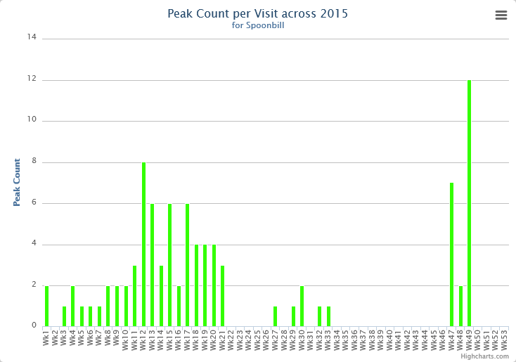
B(AE) + W(AE) – was present on 13th Mar 2015. It had been ringed as a pullus at Schiermonnikoog, Netherlands on 19th Jul 2006. It had previously visited the Bay on 23rd Mar 2013. Over the years it has commuted back and forth between Holland and Poole Harbour with occasional visits to the Somme, France.

YfG(m)/GYL – was present on 17th-18th May 2015 and again on 19th Nov 2015.
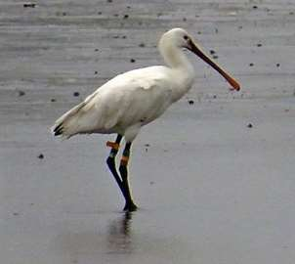
I.Ballam

It had been ringed as a pullus at Schiermonnikoog, Netherlands on 1st Jul 2014. It seems to have spent the summer around Poole Harbour as it was on Brownsea in Aug. This is not unusual for 1st yr birds.

Thanks to Petra de Goeij and Carl Zuhorn for this information

Red Kite: (2 – 10)
Scarce migrant. 1 over Lytchett Way on 21st Mar (LW). 1 over Bay on 10th Oct (LW, IB et al)

Marsh Harrier: (6 – 23)
Increasingly regular visitor. Noted on 103 dates, a 30% increase on last year’s record. Seen in every month of the year. No evidence of a winter roost forming. Max day count was 4 on 16th Nov.

Hen Harrier: (2 – 23)
Irregular Visitor. Birds were recorded on a very respectable 13 dates.

At least 2 individuals made up sightings on 8 dates between the beginning of the year and 22nd Mar. 1 “grey male” and 1 “ringtail”.

At least 2 individuals a “grey male” and a “ringtail” were seen on 5 dates from 9th Oct (earliest return date).

Sparrowhawk: (3 – 24)
Uncommon visitor. Recorded on 97 dates and in every month except Feb. This is a 70% increase on last year. However this may well be a direct result on the increased observer coverage of the site this year. 3 on 22nd Nov was the biggest single day count.

Common Buzzard: (15 – 24)
The commonest raptor of the area. Breeds widely in the vicinity.

Osprey: (4 – 23)
Annual passage migrant. 2 spring records. Birds passing north on 7th and 20th Apr. In autumn again rather scarce. After 2 on 20th Aug, singles were seen on 7 further dates until 25th Sep.

Kestrel: (3 – 24)
Declining resident. Logged on 10 dates until 6th Jun. There were then 3 records to the 18th Oct. After this a bird took up residence around Lytchett Fields and was seen daily till the year end.

Merlin: (2 – 20)
Scarce winter visitor. A good year with singles on 6 dates. 2nd Jan, 2nd Feb, 1st Nov, 13th Nov, 3rd Dec and 11th Dec.

Hobby; (3 – 22)
Irregular summer visitor. 11 singles on 11 dates between 4th Jun and 31st Aug. Recorded across the whole site. A good year but well short of the records set in 2013.

Peregrine: (3 – 23)
Uncommon visitor, rare in early summer. Recorded on record 46 dates (previous record 39 dates). This increase may be due to increased coverage of the site rather than an increase in occurrence? Recorded in every month except May.

Water Rail: (67 pairs – 24)
Common resident and winter visitor. No change in status after 2013’s complete breeding survey. 1 ringed.

Moorhen: (15 – 24)
An uncommon resident. Scattered sightings from across the recording area, including pairs at Folly Pond, Lytchett Fields and Turlin Stream. Successfully bred at each of these sites. 15 together at Lytchett Fields on 17th Jan was record count at a single site.

Coot: (62 – 13)
Very scarce visitor. Last year I commented that “This species has one of the oddest histories at the Bay”. This year did nothing to alter that. The species was not seen this year. However it was sound recorded flying over on 4 nights.

NH’s “listening station” near Lytchett Way picked up nocturnal migrants as they called whilst passing over head.

1 on 9th May at 23:00
1 on 9th Oct at 00:41 A recording of this bird is available on Soundcloud via the following link:

https://soundcloud.com/two-owls/coot-flight-call?utm_source=soundcloud&utm_campaign=share&utm_medium=email

1 on 11th Oct at 04:05
1 on 12th Oct at 01:20

Oystercatcher: (400 – 24)
A common winter visitor and passage migrant. Turlin Fields and Turlin Shore at high tide remain the favored locations, though more birds now remain in the bay to feed at low tide than in previous years. There were occasional records of small numbers using Lytchett Fields in spring and summer. The maximum count was on 31st Dec.

Bay monthly max:
JAN | FEB | MAR | APR | MAY | JUN | JUL | AUG | SEP | OCT | NOV | DEC
75 | 57 | 26 | n.c. | 4 | 4 | 42 | 100 | 86 | n.c. | 74 | 205

Pied Avocet: (327 – 23)
Increasingly regular winter visitor and passage migrant. Occurrence closely related with cold weather. There were no records between 20th Feb and 29th Oct. The max count of 145 was on 11th Dec.

Bay monthly max:
JAN | FEB | MAR | APR | MAY | JUN | JUL | AUG | SEP | OCT | NOV | DEC
173 | 305 | 0 | 0 | 0 | 0 | 0 | 0 | 0 | 14 | 105 | 86

RB+LL – was present on 8th Feb 2015.

It had been ringed as a pullus at Nosterfield NR, North Yorkshire on 17th Jul 2011. It has returned to breed at Richmond, North Yorkshire since it was ringed. This bird had previously visited us on 25th Jan and 16th Feb 2014.

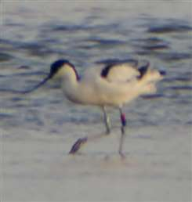
S.Robson

RB+GY – was present on 23rd Nov 2014.
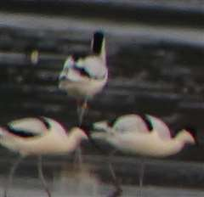
S.Robson

It had been ringed as a pullus at Seal Sands, Teesside, Cleveland on 12th Jun 2012. A movement of 438km over 894 days. It has also been seen in Essex during 2013.

GB+BY – was present on 8th Feb 2015.

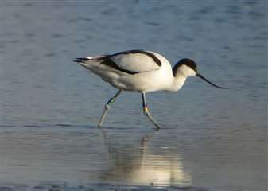
S.Robson

It had been ringed as a pullus at Beaulieu River, Hampshire on 25th Jun 2014. A movement of 44km over 228 days.

RB+RL – was present on 8th Feb 2015.

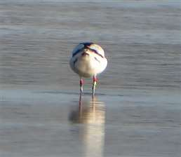
S.Robson

It had been ringed as a pullus at Seal Sands, Teesside, Cleveland on 13th Jun 2011. A movement of 438km over 1336 days. It had been seen in Holes Bay in Feb 2012 and Lincolnshire in Aug 2013.

Many thanks to Chris Brown and the BTO for this information.

Ringed Plover; (23 – 20)
Passage migrant, previously scarce. For the 3rd year in a row numbers increased dramatically. There were 292 bird days on 60 dates (101 on 29 in 2014). As can be seen from the graph below, the species only visits the Bay on migration. First spring record was on 26th Apr and the last on 10th Jun. Autumn migration commenced on 2nd Aug and continued until 3rd Oct. Why birds never visit in winter remains a mystery. The huge majority of records came from Lytchett Fields. 23 on 23rd Aug was a record count for the site breaking the 30 year old record of 17 on 1st Jan 1985.

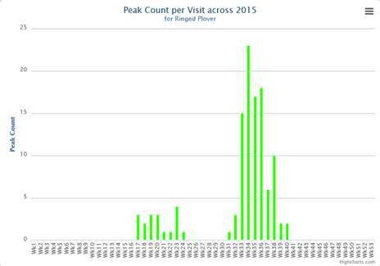

Little Ringed Plover: (5 – 13)
Increasingly frequent summer visitor. 2015 produced yet another record year. Birds were recorded on 67 dates (40 in 2014) with a bird day total of 140 bird days (78 in 2014). Almost every record came from Lytchett Fields.

The first record was on 20th Mar. The earliest ever, (previously 21st March 1995).

Birds were present very regularly from early Apr until the 23rd Aug. The largest gaps being 30th Apr – 7th May, 18th – 24th May, 1st – 8th Jun and 15th – 27th Jun.

Territorial behavior and song flight was noted but no birds gave any indication of incubating eggs.

The first juv of the year arrived on 30th Jun but there was no indication that it had hatched anywhere nearby.

As can be seen in the following graph 5 birds were noted on several dates

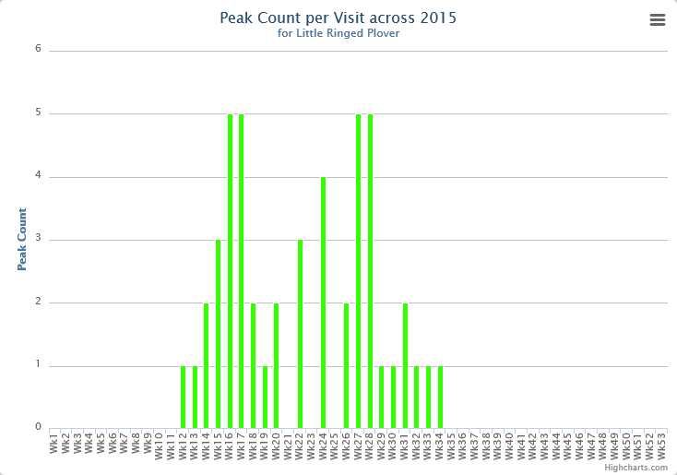
Golden Plover: (160 – 13)
Scarce visitor. 2 records of singles. On 22nd Jan and 15th Feb. Both at Lytchett Fields.

Grey Plover: (18 – 18)
Scarce visitor. Only seen on 4 dates but a record count on an unexpected date. 18 flew over the Bay on 1st Jan (NHu,JH). This was a new record passing the previous best of 14 on 9th Apr 1995. After this there was a smart sum plum bird in the Bay on 8th – 9th May and one at Lytchett Fields on 14th Oct.

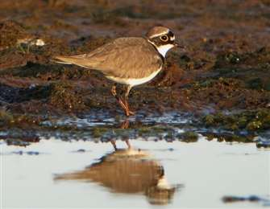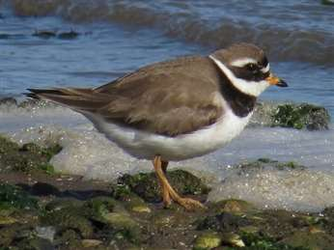
Both Little Ringed and Ringed Plovers both enjoyed record years thanks to attractive habitat at Lytchett Fields. This Ringed Plover was a June passage bird on the Turlin Shore. (S.Robson)

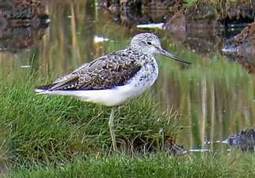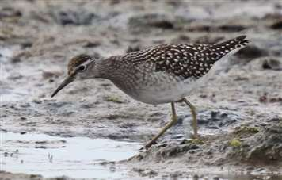
Greenshank have not responded to the changes unlike Wood Sandpipers which had their best year in Dorset for 33 years (I.Ballam, S.Carey)

Lapwing: (3000 – 24)
Formerly bred, now a non-breeding visitor in smaller numbers. Bred regularly during early 1990’s. Last confirmed breeding 1999. Display was noted in May but there was no evidence of a breeding attempt. Birds were recorded in every month of the year and on the huge majority of visits. The max count of 666 was on 6th Jan.

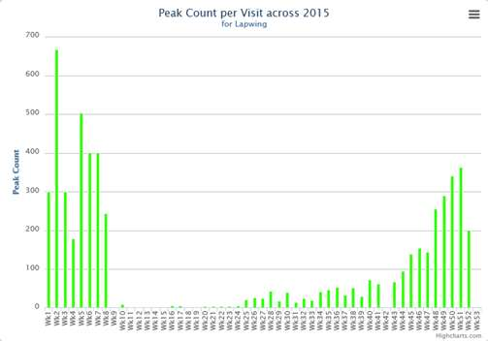

Red Knot: (34 – 15)
Scarce visitor. An excellent year with records on 29 dates. In terms of bird days this was a record by a big margin. The max was 22 on 16th Sep. Still well short of the record 34 on 17th Sep 1995.

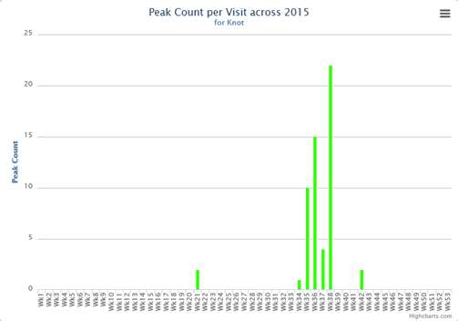

Sanderling:
First and second records. 7 were seen on the rising tide on morning of the 12th May (IB,SR). Another was seen in similar circumstances on the evening of 18th May (SR). For me, the species of the year! See finders account in Appendix 1.

Little Stint: (7 – 9)
Rare visitor. Another good year with 20 bird days. 2 on 23rd Aug were the first of the autumn. 2 birds were seen each day until 28th but these were not the same individuals. 2 juvs became an adult and a juv before returning to 2 juvs! Only 1 was present on 29th but we were back to 2 on 30th - 31st. The last bird of the year was present from 24th – 26th Sep. All were seen on Lytchett Fields.

Curlew Sandpiper: (4 – 9)
Rare visitor. Another good year. 2 moulting Ads on Lytchett Fields on 31st Aug. This was followed by a juv from 16th – 22nd Sep at the same location.

Dunlin: (1800 – 1200 – 24)
Regular winter visitor and passage migrant. Numbers wintering in Poole Harbour, and Britain as a whole, have been declining since the mid 90’s. In this context the numbers using the Bay, in particular Lytchett Fields (majority of records) is encouraging. Spring passage was protracted but numbers were poor. There were no records between 14th Jun and 19th Jul (earliest departure and arrival dates). Max 460 on Lytchett Fields on 15th Dec.
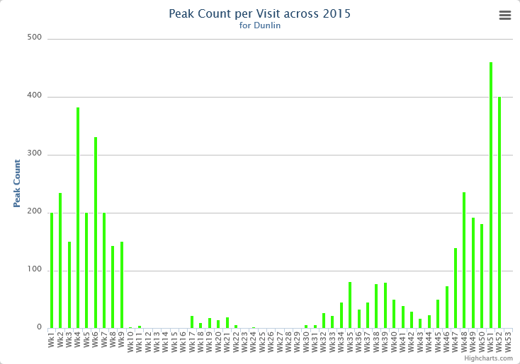

Ruff: (9 – 20)
Scarce visitor. Another excellent year, recorded on 58 dates, producing 143 bird days. Spring was simply wonderful after 1 from 7th – 10th Apr we were treated to the arrival of 5 breeding plumaged males on 12th May. They were still present the next day then the number decreased until the last 2 departed on the 29th. The first returning birds were 3 on 5th Aug. There were then daily sightings until 18th Sep. Max 5 on 26th. The final sighting of the year was one on 23rd-24th Oct. All records from Lytchett Fields.
Jack Snipe: (5 - 16)
Scarce but under recorded winter visitor. A poor year. This might be partially due to changes in habitat and/or less walking across wet fields. 3 were found in a night survey on 20th Jan. Other than this just 4 singles on 19th Jan, 23rd Feb, 7th Dec and 21st Dec.

Snipe: (160 – 132 – 24)
Winter visitor and passage migrant. Recorded until 26th Apr, returning on the 18th Jul.

Numbers of birds present are likely to be significantly under recorded due to the inaccessibility of the site. The birds recorded in the graph are those seen following scans with a telescope. Many more are likely to have remained hidden. Blank weeks within the period of occurrence are an indication that counts were not made, not that birds were not present. A big influx in late autumn produced a minimum of 130 on 2nd Nov.
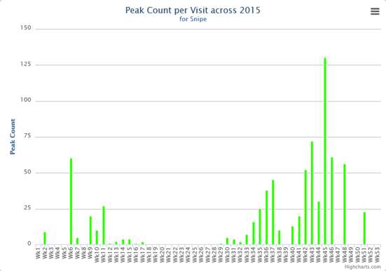
Woodcock: (5 – 14)
Scarce but under recorded winter visitor. The number of records of this species is largely a reflection of the effort made to see them. Nick Hopper studied Woodcock during early 2014 on behalf of The Birds of Poole Harbour. Following transects at Lytchett Bay the estimated winter population was predicted to be 8 birds (No more than 5 have ever been seen on one visit).

Present until at least the 8th Mar and from 11th Oct. Recorded on only 5 dates. 1 sitting in the middle of Lytchett Fields in broad daylight on 11th Oct was unusual.

Black-tailed Godwit: (1240 – 24)
Common passage migrant and winter visitor. The species was present throughout the year often in reasonable numbers.

In contrast to the previous two winters large numbers were present in Jan. Peaking at 840 on 12th.

Birds began to gather and feed at high tide on Lytchett Fields from Apr onwards, peaking at 270 on 18th May. This habitat was used well into the autumn.
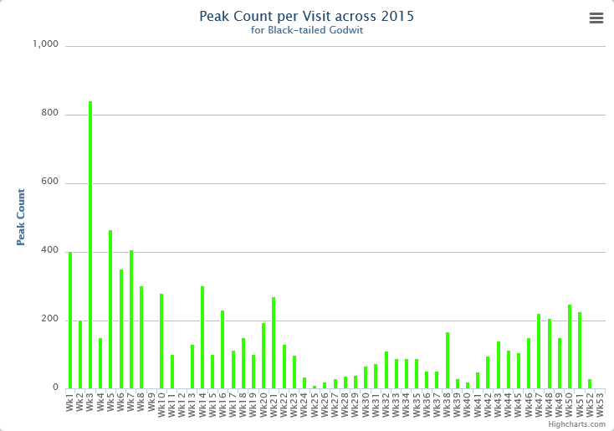

Over the last 20 years colour ringed birds have proved that birds visiting Lytchett Bay breed in Iceland (L.l.islandica). Birds seen at Lytchett Bay also visit western France, Portugal, Ireland, Holland, Belgium, E England as well as many locations along the south coast.

Colour ringed birds were recorded as follows.

LG+ RO was present on 8th Feb 2015

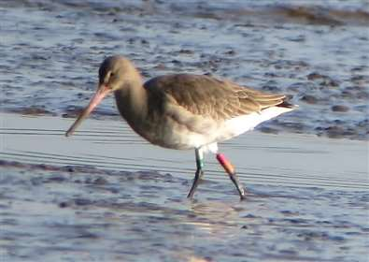
S.Robson

It was great to welcome back this “old friend”. It has previously visited the Bay in 2006, 2007, 2008, 2012 and 2013. It was ringed on 27th Jun 2002 at Langhús, Fljót, N Iceland as an Ad female. This makes the bird at least 14 years old and it becomes the oldest that we have recorded at the Bay. The oldest bird in the Operation Godwit scheme is 22-23yrs old. A nominate Limosa bird was found to be 32 yrs old after metal ringing (P.Potts pers comm).

During its life this bird has also been seen in Portugal, western France, Humberside and Hampshire.

GNR +YRY was present on 6th May 2015.
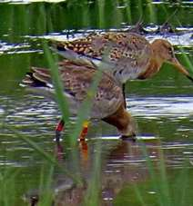
I.Ballam

It had been ringed on 10th Nov 2013 at Axe Estuary, Seaton, Devon. It had previously visited the Bay on 25th Apr and 28th Jun 2014. It has not been seen outside of Dorset and Devon.

B//R+RN was present on 28th Apr 2015.
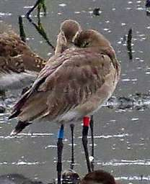
I.Ballam

It had been ringed on 15th Oct 2013 as 1stW at Farlington Marshes, Hampshire and had spent its 1st winter in West Sussex. It had previously been seen at The Bay on at least 6 dates between 19th May and 1st Aug 2014.

LNL+YRY was present on 3rd Mar 2015.
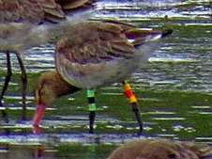
I.Ballam

It had been ringed on 10th Nov 2013 at Axe Estuary, Seaton, Devon. It had previously been seen at the Bay on 28th May, 9th Jun and 22nd Jun 2014. It has also been seen at Arne NR.

GO+RO(Z) was present at the end of 2014 and remained at the Bay early in the year being seen on 2nd and 18th Jan and 3rd Mar.
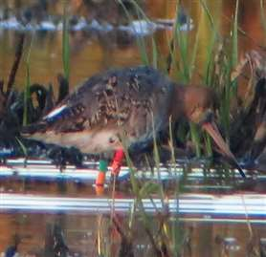
S.Robson

It had been ringed as an Ad F on 20th Jun 2013 at Flói, Árnessýsla, S Iceland. It had previously been seen at the Bay on 30th Jul 2014 and again between 22nd Dec 2014 and the end of year. It seems to be spending this winter in the Avon Valley on the Hants/Dorset border.

GRY+RNR was present on 18th Jan and 20th Feb 2015.
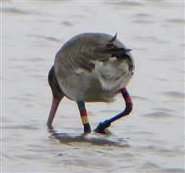S.Robson
It had been ringed at Harty, Swale Estuary, Kent on 13th Jul 2013. It had previously been seen at the Bay from 15th Dec 2014 until the year end.

RW(8)+ YW was present on 2nd Jan 2015.
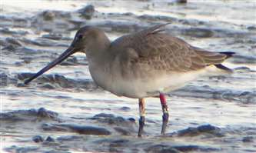
S.Robson

It had been ringed on 14th Jul 2010 at Siglufjordur, Iceland. It has subsequently been seen back in Iceland in the summers of 2011 and 2014, in Kent in late summer of 2011, 2012, 2013 and 2014, Devon in winter 2012. It had previously visited the Bay on 20th – 30th Dec 2014.

GR+RO(Z) was present on 2nd Jan, 20th Feb, 3rd Mar and 6th Jul 2015.
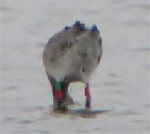
S.Robson

It had been ringed on 9th Jul 2012 at Friðland, Árnessýsla, S Iceland. It was seen in Iceland in summer 2013 and at Swineham in 2012. It had previously been seen at the Bay on 21st Dec 2014.

LN+OW(X) was present on 17th, 21st and 28th Apr 2015.

It had been ringed on 10th Jul 2008 at Hrisholl, Berufjordur, Reykholar, NW Iceland. It had previously been seen at the Bay on 25th Apr 2013. It has also been seen in Devon and back in Iceland in summer 2013.

L//R+LY was present on 3rd Mar 2015.

It had been ringed on 10th Sep 2008 at Farlington Marshes LNR, Langston Hbr, Hampshire. It has been seen at Austurey, Árnessýsla, S Iceland summer 2012 and 2013, which is presumably its breeding site. It has also been seen in Norfolk in 2010 and Suffolk in Aug 2014.

NW+OfL was present on 8th Feb, 14th Mar, 21st Aug and 20th Dec 2015.

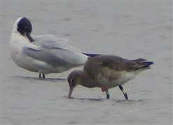
S.Robson

It had been ringed on 29th Jul 2014 at Moeze, Charente Maritime, France as an Ad male. It has not been seen at any other locations.

GYG+BYG was present on 17th Apr 2015.
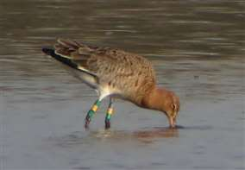
S.Robson

It had been ringed on 4th Oct 2013 as an Ad female at Iken, River Alde, Suffolk. It was seen at Akureryri causeway, N Iceland on 29th Apr 2014. It has also been seen in Somerset and Devon.

WNY+YRY was present on 5 dates between 14th May and 29th Aug and presumably spent the summer here.
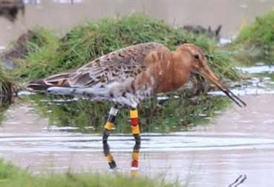

It had been ringed as an Ad male on 18th Jan 2015 at Axe Estuary, Devon. It has also been at Titchfield Haven, Hants.
LNY+YRY was present on 17th Jul and 8th Aug 2015.

It had been ringed on 10th Nov 2013 as an Ad at Axe Estuary, Devon. So far these are the only sightings outside Devon.

GOG+YNY was present on 25th Oct 2015.
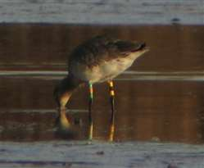
S.Robson

It had been ringed on 20th Sep 2014 at Brownsea Island, Dorset by Stour Ringing Group. This is the first sighting since ringing.

YOfl+RY was present on 3rd and 8th Aug 2015.
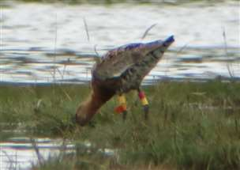
S.Robson

It had been ringed on 2nd Sep 2009 as an Ad at Yves, Charente Maritime, France. It was seen in Iceland in 2011 at Hafnir, Sandvik. It has returned to winter in France and has been seen there each winter including 2015.

RNW+YRY was present on 2nd Nov, 2nd and 18th Dec 2015.
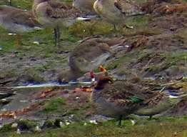I.Ballam
It had been ringed on 18th Jan 2015 as a 1stW female at Axe Estuary, Devon. It was also seen at La Manche, Normandy, France on 29th Apr 2015.

Left leg always given first, all rings above the tibia (unless preceded by the mark //). Recently some birds have been marked with leg flags rather than rings. Colours are:

O = Orange | L = Lime (this can look very washed out in the field, approaching white)
R = Red | G = Green
W = White | B = Blue
Y = Yellow | N = Niger

Many thanks to Pete Potts and the Farlington Ringing Group, Böðvar and the Iceland Wader Group, Andy Welch and Vincent Lelong for supplying this information.

Bar-tailed Godwit: (110 – 20)
Scare visitor. 1 on 7th - 8th May was the only record.

Whimbrel: (157 – 24)
Passage migrant, most numerous in Spring. A very poor year with only 70 bird days in spring between 17th Apr and 31st May. Max 8 on first date.

Autumn passage involved 29 bird days between 5th Jul and 21st Aug. Max 3 on 1st.

The records came from most parts of the recording area. Traditionally most records come from the Bay at low tide. A contribution to the poor showing is likely to be that Lytchett Fields are drawing the focus and time of birders away from the Bay. Compared to recent years observer hours here were certainly reduced.

Curlew: (116 – 24)
Common winter visitor and passage migrant. Present throughout the year. Regularly seen on the Pool and Lytchett Fields in winter. 74 on 20th Dec was the biggest count of the year. The high variance shown in the graph is product of recording rather than actual occurrence.

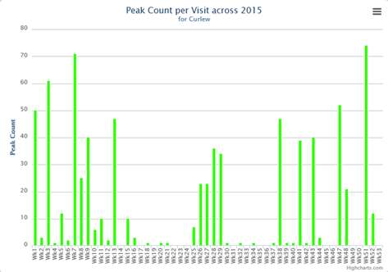
Common Sandpiper: (14 – 24)
Uncommon passage migrant. A poor spring was followed by another record autumn.
Only 2 records in spring. 1 on 13th Apr and 2 on 15th May. Return passage began on 2nd Jul but was slow during that month. However things really took off in mid Aug when numbers using Lytchett Fields increased dramatically. The age old day record count going back to 10 on 10th Jul 1994 was finally broken with a conservative 14 present on 27th Aug. The graph shows how migration was strongly concentrated in to a 3 week period.
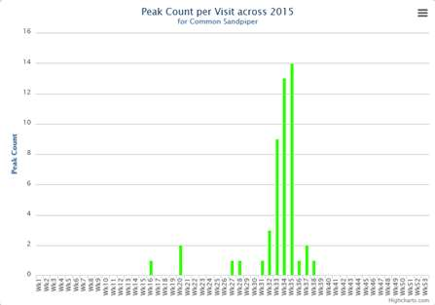
In total there were 148 bird days in autumn to the 17th Sep. The previous best being 92 in 2014 and before that 45 in 1997 and 1998. A good demonstration of the value of the new habitat at Lytchett Fields in supporting migrant birds. 1 ringed.

P/metal+/BY – was present on 22nd Jun 2014.

It had been ringed at Grainfoot, Ladybower north, Derbyshire on 27th Jun 2011 as a fledged juvenile. A movement of 296km over 1091 days.

Green Sandpiper: (18 – 24)

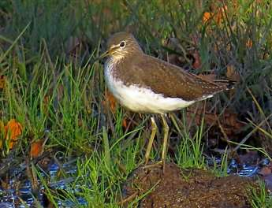  Heard as often as seen, this bird posed nicely on The Pool (I.Ballam) | Common non-breeding visitor. Lytchett Fields and western most part of the Bay are the favoured sites. Present until 15th Apr and from 15th Jun. After which birds were seen on most visits until the year end. Getting an accurate count of the number of birds present was very difficult due to their reclusive nature and the large area visited for feeding. At least 18 were present on 11th Aug, this is a record for the site.

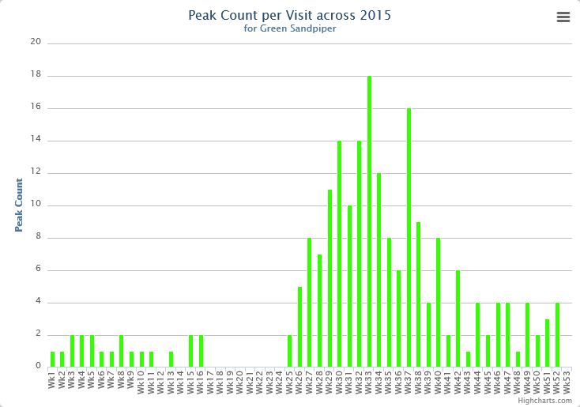

Wood Sandpiper: (5 – 12)
Scarce migrant.

Who would ever have thought that we would need a graph for Wood Sandpiper…..
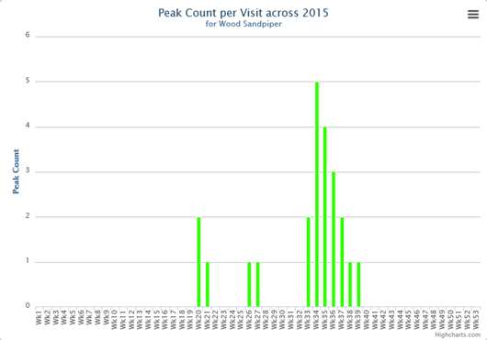
An incredible year with records on 49 dates (21 in 2014) and 94 bird days (26 in 2014).

One on 11th May was followed by 2 the following day. There were then daily records of up to 2 until the 19th.

Return passage started early with 1 on 28th – 30th Jun. The main movement commenced on 11th Aug and by the 19th we had a Poole Harbour record of 5 together. There were still 4 on 28th after which numbers started to reduce. A single bird remained and was seen daily from 14th – 22nd Sep (latest ever record).

It is impossible to ascertain how many individuals were involved in these autumn records. 2015 was an exceptional year in a British context as shown by the following Birdtrack graphic.

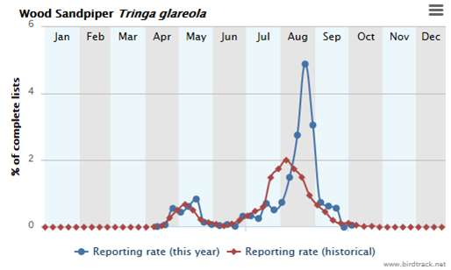
Spotted Redshank: (68 – 42 – 24)
Declining passage migrant and scarce winter visitor. Recorded on 68 dates (85 in 2014, 44 in 2013, 15 in 2012, 18 in 2011). However many of these were in the first winter period through to early Apr after which the species became scarce. No records between 5th May and 7th Jul. Max 5 on 3rd Feb. It seems that this species has largely abandoned the Bay in favour of Brownsea Lagoon where numbers remained buoyant (Max 19 in Sep)

Bay monthly max
JAN | FEB | MAR | APR | MAY | JUN | JUL | AUG | SEP | OCT | NOV | DEC
2 | 5 | 2 | 2 | 2 | 0 | 2 | 1 | 1 | 4 | 2 | 1

Greenshank: (49 – 27 – 24)
Common passage migrant and winter visitor. This species is almost a daily ever present. The last bird of spring was on 3rd Jun and the first of autumn was 6th Jul. A spring max of 9 on 2nd May was very good but autumn numbers were poor, only just reaching double figures on 15th Sep.

Lytchett Fields was far and away the most used habitat.

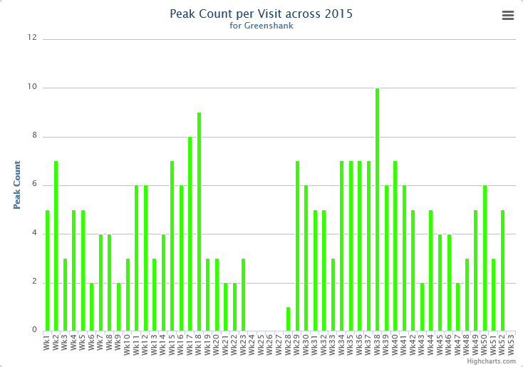

Redshank: (608 – 436 – 24)
Common winter visitor with small breeding population on salt marsh. After last year’s breeding success it is a pleasure to report that this year there were 2 territories on Lytchett Fields. One of these pairs fledged 2 young in Jun.

What happened after this was quite remarkable. For the first time large numbers started to use Lytchett Fields at high tide. By the end of Jun more than 30 could regularly be found. The number continued to grow and it eventually peaked at 217 on 30th Sep. Use continued in Nov (max 132 on 13th) before declining.

The Pool was used frequently as a high tide roost, with a max of 159 in Oct.

Monthly max (all sites):
JAN | FEB | MAR | APR | MAY | JUN | JUL | AUG | SEP | OCT | NOV | DEC
80 | 117 | 26 | 30 | Br | 34 | 78 | 151 | 287 | 270 | 150 | 133

Black-headed Gull: (12000 – 7000 – 24)
A very common visitor. Though the large numbers that stop in the Bay en-route to their roost in the Wareham Channel seem to be reducing. The Max count was 4000 in mid-March. The first juveniles were noted on the rather late date of 2nd Jul. 1 ringed.

2FFN (black figures on a yellow ring) was present on 11th May 2015.

It had been ringed 156 days earlier as an Ad on 6th Dec 2014 at Pitsea Landfill, Essex. Thanks to North Thames Gull Group for these details.

Mediterranean Gull: (139 – 23)
Spring and early summer visitor, occasional at other times. The explosion in this species population in Britain continues.

The peak occurrence at the Bay is during the period when pairs are establishing territories at the breeding islands in the Wareham Channel. This is quite different to other parts of Poole Harbour where maxima occur after the breeding season.

Assessing bird days between Mar and Jun was again impossible due to abundance of bird movements. The peak count made was 139 through the Bay between 16:30 and 17:30 on 27th Mar. A new record for the Bay but still less than the actual number present that day! Juveniles were recorded on 7 dates.

Monthly max:
JAN | FEB | MAR | APR | MAY | JUN | JUL | AUG | SEP | OCT | NOV | DEC
1 | 38 | 139 | n.c. | n.c. | 42 | 71 | 1 | 0 | 0 | 1 | 1

Common Gull: (3000 – 24)
A common winter visitor and passage migrant, especially in spring, where max of 400 on 15th Mar. The first returning bird was on 10th Jul which was rather late. 405 on 5th Dec was a good late year count.

Lesser Black backed Gull: (2128 – 24)
Abundant autumn and common spring passage migrant and uncommon winter visitor. Rarely counted.

Herring Gull: (2500 – 24)
Common winter visitor and passage migrant. No counts made this year.

Yellow legged Gull: (65 – 23)
Frequent visitor, peaking in summer. Another really poor year. The max count of 6 was on 20th Aug. A juv was seen on 15th Aug.

Bay monthly max:
JAN | FEB | MAR | APR | MAY | JUN | JUL | AUG | SEP | OCT | NOV | DEC
0 | 0 | 0 | 0 | 0 | 1 | 1 | 6 | 1 | 1 | 1 | 0

Great Black backed Gull: (151 – 24)
Daily visitor throughout the year in small numbers.

Little Gull: (2 – 14)
Scarce visitor. It seems that winter is almost as likely to produce one these dainty gulls as spring. A 1st W flew through the Bay in stormy weather on Jan 1st. The only other record was a 1st S at Lytchett Fields on 26th – 27th May.

Kittiwake:
6th record since 1992. An Ad was in the Bay on 17th Nov (IB). The only reward arising from 9 weeks of persistent westerly wind and rain at the year end.

Sandwich Tern: (6 – 24)
Uncommon summer visitor. Recorded on 18 dates between 2nd Apr and 6th Oct. Max 4 on 19th Sep.

Common Tern: (25 – 24)
Uncommon summer visitor. Another reduction compared to an already poor 2014. Recorded on only 7 dates. Another example of observer concentration switching to Lytchett Fields from the Bay?

There were 11 bird days between 27th Apr and 22nd Sep. Max 4 on 28th Jun.

Little Tern: (10 – 7 - 4)

5th record since 1992.  One was in the Bay on the latest date of 22nd Sep (IB). This is the first record since 2008 when there were 2 on 15th May and 3 on 25th Jul. Also recorded on 13th Jun 2002 (1) and 11th Jul 1997 (7). The record count of 10 was on 18th Sep 1983. | 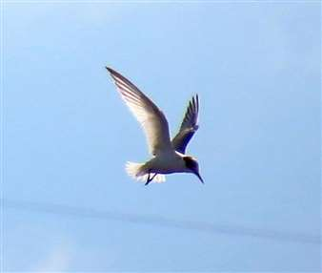  I.Ballam

Stock Dove: (72 – 24)
Uncommon Resident. Frequently seen and widely scattered records particularly in the first 6 months. One visited Sandy Close Pond feeders on a number of occasions. Very few noted with Woodpigeons on migration.

Woodpigeon: (17,785 – 24)
Common resident and autumn migrant. Passage is usually concentrated into a few days in the first 10 days of Nov. This year the weather for the first 21 days was wholly unsuitable with strong westerly winds. By the 16th coastal sites were seeing signs of birds moving in very inclement weather. The first signs at Lytchett were on the 21st when 5,025 passed west in a NW gale. Seemingly good conditions on 22nd produced a great movement across the central part of Poole Harbour (c140K!!) but only 2,825 at Lytchett. By the 23rd we thought we’d missed our chance but were delighted to have a site record of 17,785 fly NW in little more than 40 minutes till 08:30 when the movement abruptly ceased (SR, NHu, JH). Surprisingly there was further signs of movement when 900 flew W in two flocks on the 4th Dec. 1 ringed.

Collared Dove: (14 – 24)
Uncommon resident. No specific records of note but no change in status.

Cuckoo: (2 – 23)
Scarce visitor in spring. 6 records from 15th Apr to 17th May, mainly from the west of the recording area. Another rare autumn record involved a juv at Lytchett Fields on 29th Aug.

Short-eared Owl: (1 – 5)
Very scarce migrant in autumn or spring. The autumn of 2015 produced an exceptional influx of Shorties in to Britain from the continent. Lytchett enjoyed a small slice of this.

1 was seen over Lytchett Way on 22nd Oct and that evening it or another was at Lytchett Heath. The latter sat on the pole holding up mist nets in our futile attempt to catch Pied Wagtails!

Early on the morning of the 26th one flew high north over the bay harassed by corvids.

Finally, and most sadly, a 1stW M was found freshly dead at Lytchett Fields on 1st Dec. This bird was emaciated and presumably struggled to feed in the unrelenting SW gales and rain which started at the beginning of Nov.

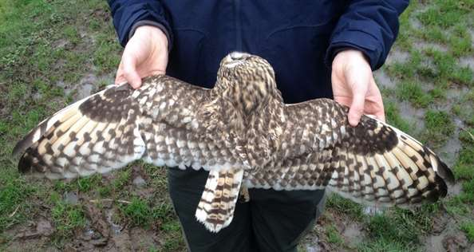
P.Morton

Tawny Owl: (2 – 24)
Uncommon resident. Bred successfully. Dispersing birds heard at Sandy Close Pond in late summer. First record from Turlin Moor – 2 birds in Feb.

Barn Owl: (2 – 15)
Bred at French’s Farm till 2009. Shortly after this the nest box was removed. Since then the species has been very scarce. 3 records this year. Singles on 8th Mar, 26th Apr and 19th Nov. All in vicinity of Lytchett Fields.

Nightjar: (3 – 15)
Irregular breeder. Present at Lytchett Heath during the breeding season from at least 10th Jun to 15th Aug. 1 juvenile ringed.

Swift: (113 – 24)
Passage migrant and occasional local breeder. First seen on 4th May. Spring passage peaked in the 2nd week of Jun. 75 on 9th and 91 on 10th. Rarely seen in summer. Last record was 8 on 7th Aug.

Kingfisher: (4 – 24)

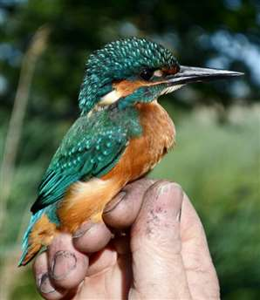  Always a pleasure (D.Jones) | Passage migrant and uncommon winter visitor. Bred in 2000.  Sightings in May suggested that breeding took place not far up the Sherford, if not within the recording area. 9 ringed, including 4 on 22nd Aug, a new record day count for the Bay.

Green Woodpecker:
Breeding resident. Bred successfully and recorded in all parts of the Bay. No change in status.

Great Spotted Woodpecker:
Breeding Resident. Seen regularly in most parts of the Bay. Drumming heard in most areas during spring. 7 ringed.

Lesser Spotted Woodpecker: (1 - 9)

Very scarce visitor. The first records for more than 11 years. The last being at Lytchett Bay View on 25th Jan 2004.  Amazingly 3 records this year for this red listed species which has declined by 81% in Britain over the last 25 years.  A female in oaks at Lytchett Fields on 18th Sep (IB). One flew N at Lytchett Bay View during a particularly special vis-mig watch on 22nd Nov (SR). A male showed well at Lytchett Bay View on 12th Dec (SR et al). | 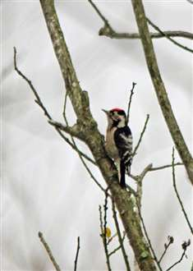  The first photo of this species at the Bay.(N.Hull)
Wryneck:
First record. This species was long awaited but I doubt anyone predicted the first to occur would be in mid-April. 1 on 16th Apr at Lytchett Heath (DJ et al). Thanks to modern communication the bird was widely twitched during its very short stay. It showed well feeding along the edge of a ditch. See Dave’s account in appendix 1

The 16th Apr is becoming a special date in the Lytchett calendar, a Hoopoe was discovered on the same date in 2003.

Woodlark: (15 – 14)
Irregular visitor. This species is always scarce when we do not have very cold weather. This year we had 2 autumn records involving migrants. 2 over Lytchett Heath on 3rd Oct and 2 over Lytchett Way on 20th Oct.

Skylark: (781 - 24)
Scarce breeder and passage migrant. 2 territories established and held throughout the spring. 6 on spring passage, 22nd Mar, were unusual. Autumn passage involved only 61 bird days between 9th Oct and 28th Nov. Max of 24 on 19th Oct.

Sand Martin: (5000 – 24)
Common passage migrant. A typical year. First record was of 2 on 4th Apr. Generally scarce. Max of 70 on 27th Aug. The last record of the year was on 29th Sep. 4 ringed.

Swallow: (1000 – 800 – 24)
Common passage migrant, breeds at French’s Farm. Recorded from 27th Mar until 26th Oct. Max count was a very poor 150 on 20th Apr. The latest bird ever to be seen at the Bay occurred at dusk on 22nd Nov, surpassing previous latest of 18th Nov 1982. 51 ringed.

House Martin: (1800 – 24)
Common passage migrant, breeding colonies on edge of recording area at Watery Lane. First noted on 4th Apr (our earliest return date). Previously 9th Apr 1994. The last bird being seen on 15th Oct.

No of House Martin nests at the Watery Lane colony 2003 – 2015. No of nest collapsed or destroyed in brackets.

2003 | 2004 | 2005 | 2006 | 2007 | 2008 | 2009 | 2010 | 2011 | 2012 | 2013 | 2014 | 2015
13 (9) | 15 (4) | 15 (5) | 16 (6) | 14 (5) | 13  (8) | 15  (5) | 8  (7) | 13  (4) | 2  (0) | 4  (1) | ? | 7  (3)

Tree Pipit: (17 – 20)
Scarce passage migrant. All records were restricted to Aug. 25 bird days between 15th and 29th. These were largely inflated by a record count of 17 over Lytchett Heath on the morning of 28th. This was a record count. Previous best was 10 on 17th Sep 2012. 1 ringed.

Meadow Pipit: (300 - 167 – 24)
Breeding resident and common passage migrant. No evidence of breeding this year. Between 30-50 were on site during Jan. Autumn passage was late recorded from 29th Sep. Max 80 on 2nd Oct.

Rock Pipit: (50 – 24)
Common winter visitor. Recorded until 9th Mar and from 19th Oct. Common on saltings throughout the winter. No specific counts submitted but common on the saltings between these dates.

BLB .13678780 – A 1stW bird ringed at Nieuwpoort, West-Vlaanderen, Belgium on 11th Oct 2014 was controlled 21 days later on 1st Nov 2014 at Lytchett Bay. A movement of 338km.

Interestingly the Belgian ringers described this bird as being Scandinavian Rock Pipit A.p.littoralis. This would make sense given that the nominate race is not known to breed in Belgium and that the continental race winters there and occurs as migrant. This would also fit with our belief that all of the birds occurring at Lytchett Bay are of this race. However (and perhaps not unexpectedly given the age of the bird and the date of the photograph) there is nothing in the birds appearance to suggest any differences with A.p. petrosus

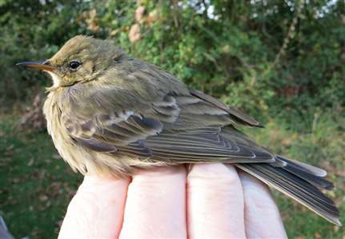
Presumed 1stW Scandinavian Rock Pipit, 1st Nov 2014 (S.Robson)

Water Pipit: (20 – 18)
Scarce winter visitor. An exceptional year, the best since 1997. 1 or 2 were present continually in the first winter period until 7th Mar. Returned on 30th Oct after which birds were seen almost daily until the end of the year. Max 13 on 27th Nov. Lytchett Fields and The Pool were the preferred locations.

Yellow Wagtail: (150 – 24)
Uncommon passage migrant. 6 bird days between 8th Apr and 3rd May constituted a pretty good spring. Max 2 on 2 dates. Autumn migration started on 2nd Aug but was relatively poor and an 80% reduction on the record breaking numbers seen in 2014. There were only 116 bird days to 13th Oct (latest departure date). Max 20 on 6th Sep. 1 ringed.

Grey Wagtail: (15 – 24)
Winter visitor, passage migrant and occasional breeder. Recorded frequently throughout the autumn when passage peaks in Sep. 15 over Lytchett Fields on 16th Sep was a record day count for the Bay surpassing 12 on 23rd Sep 1996.

Pied Wagtail: (500 – 24)
Recorded throughout the year, common in autumn. Bred successfully. Birds roost at various points around the Bay during peak migration in October. Max was a rather poor 100 on 12th Oct. 42 ringed.

White Wagtail:
Scarce migrant. Only 1 this year, on Lytchett Fields on 13th Mar.

Wren:
Common resident. 28 ringed.

Dunnock:
Common resident. 9 ringed.

Robin:
Common resident.35 ringed.

Bluethroat:
2nd record. On the 29th Aug the ringing group was operating at two locations. At Lytchett Heath for a pre-arranged ringing demonstration and at Lytchett Fields. Shortly after 06:30 I received a text containing only five letters “BLUTH”. The BTO code for this gorgeous chat. Thankfully with 45 minutes to spare before the start of the demo and a large and experienced ringing team on site, a small band of “Lytchett listers” were able to dash to the second site for a look at this stunning 1stW male prior to release. (RG et al).

This is the 2nd record for the site. The first was on 26th – 29th Sep 1971.

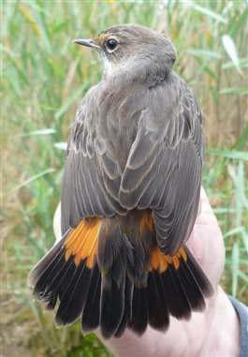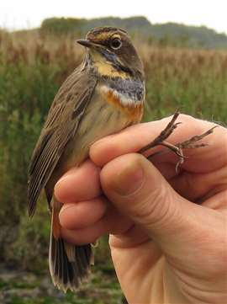
“Bluethroat Bob” strikes again. 23 years after he caught the last Poole Harbour bird at Keysworth, he went and did it again. (T.Elborn (L), S.W.Smith (R))

Common Redstart: (2 – 17)
Scarce autumn migrant. Another good year with 11 bird days on 9 dates.

A female at Lytchett Fields on 8th Apr was the only record in spring.

The autumn started very early with a bird in juv plumage trapped at Lytchett Heath on 31st Jul. It was still present on 2nd Aug. Another juv was ringed there on 7th Aug. Despite this there is no suggestion that this species bred at the Bay.

These were followed by 5 records spread between Lytchett Fields and Turlin Moor between 31st Aug and 17th Sep. Max 2 on 2 dates. 2 ringed.

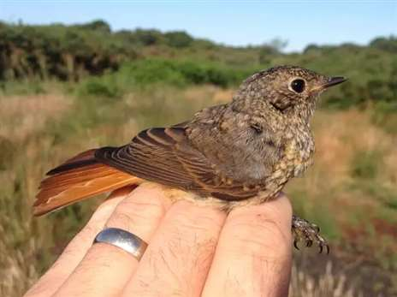
This Redstart in almost complete juvenile plumage was the source of some head scratching. How far had it travelled from the nest? (I.M.Lewis)

Black Redstart: (1 – 5)
5th record since 1992. One was at French’s Farm on 28th Oct (IB). Presumably the same bird was in the nearby allotments on 1st Nov (SI-H). One day we will have a lingering winter visitor!

Whinchat: (11 – 22)
Scarce passage migrant. A record year by some distance. The previous best was 52 bird days in 2002. Albeit the record day count of 11 on 12th Sep 2002 remains in-tact.

3 spring records were exceptional. 20th & 29th Apr and the 4th May. All at Lytchett Fields.

Autumn produced an astonishing 83 bird days between 15th Aug and 2nd Oct. Max 5 on 16th and 18th Sep. Lytchett Fields was again the favored site but records also came from Lytchett Heath.

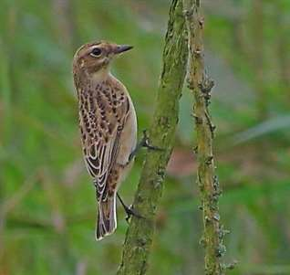  I.Ballam | The increase in records was not thought to be due to increased observer coverage as this is an “easy to see” species and is rarely missed if present, even on the briefest visit. Instead the likely explanation was the eastern origin of the weather throughout Sep and/or a good breeding season in UK?  One intriguing aspect is how many different individuals were involved? Might the large number of bird days be an outcome of the same individuals stopping over for an extended period? The only indication that we have on this is that the two birds ringed did not linger and were not seen again after ringing.
Stonechat: (23 – 24)
Past common breeding resident (7 pairs in 2002), last bred in 2005. Changed status to winter visitor and passage migrant. The best year since the species ceased breeding at the site.

Present from start of the year until 20th Mar and from 2nd Aug. Max 12 on 12th Oct spread between Lytchett Fields and Lytchett Heath. 2 ringed.

Northern Wheatear: (39 – 24)
Uncommon passage migrant. Almost every record of this species occurs in the north west of the recording area. This year there was very little suitable habitat to attract migrants. Grass lengths in all areas being too long for this ground feeding species.

A poor spring with only 15 bird days between 9th Apr and 10th May. Max 2 on 2 dates.

Autumn produced birds on only 6 dates between 20th Aug and 10th Oct. Not more than 2 on any one date.

Blackbird: (45 – 24)
Common Resident. 71 ringed, mainly at a post breeding roost.

Fieldfare: (559 – 23)
Uncommon winter visitor. Very scarce in the first winter period. First returning birds were seen on 12th Oct when 4 flew north at Lytchett Bay View. This is the earliest return date. There were no major flights. Max 50 on 8th Nov. Very scarce again at the year end.

Song Thrush: (1256 – 24)
Breeding resident. Minimum of 8 territories identified. Flights on autumn migration were very weak with no more than 21 identified on 12th Oct. 14 ringed.

Redwing: (1000 – 514 – 24)
Winter visitor and passage migrant. Recorded until 3rd Apr. Max 50 on 7th Feb. First of the autumn was on 3rd Oct. 288 was a good flight over Lytchett Heath / Lytchett Bay View on 14th Oct. Small flocks seen at various sites until the year end. 27 ringed.

Thrush Sp:
The identification of small silent thrushes on active migration continues to puzzle us. This year flights were limited but 157n on 12th Oct and 152n on 13th Oct were notable. A recording session at NH’s “Listening Station” produced 36 Song Thrush contacts and 42 Redwing contacts on the night of 11th/12th Oct. Assumptions as to which species is involved when migrating birds are silent should be made with care!

Mistle Thrush: (60 - 20 – 24)
Uncommon resident. Recorded frequently during the first 7 months suggesting that a pair bred somewhere not too far away. Autumn passage was exceptional by recent standards. There were at least 81 bird days between 3rd Oct and 27th Nov. 20 around the arable field on 16th Nov was the best count at the Bay in the last 24 years.

Cetti's Warbler: (11 males – 23)
Breeding resident. At least 11 territories, a return to the peak of 2007. It is possible that there were one or two more as the upper parts of the Sherford were not surveyed. Present at Sandy Close Pond occasionally in autumn. 6 ringed.

The first documented record for the Bay is in 1982, 10 years after the first Dorset record. The species probably bred in the mid 80’s but remained scarce until the early 90’s.

Grasshopper Warbler: (8 – 17)
Passage migrant, predominantly in autumn. Under recorded.

In spring one was reeling at the Water Works on 19th Apr (earliest date, previously 22nd Apr 2004).
A record autumn with 45 bird days between 31st Jul and 5th Sep. These included 40 trapped and ringed. Unusually 3 birds were re-trapped on days subsequent to their ringing. One stayed in the area for 6 days. To put this into context, we have now ringed 201 Grasshopper Warblers since 2004 and only 5 have been re-trapped at the site subsequent to ringing.

We also had a record day count with 8 on both 23rd and 29th Aug.

Y717162 – An Ad bird ringed at Titchfield Haven, Hampshire on 24th Sep 2013 was controlled 337 days later on 28th Aug 2014 at Lytchett Bay. A movement of 57km.

Z408417 – A 1stW bird ringed at Lytchett Bay on 29th Aug 2015 was re-trapped 13 days later on 11th Sep 2015 at Icklesham, East Sussex. A movement of 192km.

Sedge Warbler: (219 – 24)
Passage migrant. Spring passage was typically poor with 7 birds between 26th Apr and 11th May, max 4 on 8th May. Autumn passage was very strong for the second autumn in a row with 936 bird days. Max 219 (139 trapped and 80 others seen) on 15th Aug. This was another record day count at the Bay (previous 200 (trapped) on 8th Aug 2014). The last record was on 3rd Oct. 767 ringed.

Daily max and bird days are given in the following table.
JAN | FEB | MAR | APR | MAY | JUN | JUL | AUG | SEP | OCT | NOV | DEC
 |  |  | 1 | 4 |  | 80 | 219 | 34 | 4
 |  |  | 1 | 6 |  | 103 | 733 | 106 | 4

D461948 – A 1stW bird ringed at Lytchett Bay on 8th Aug 2014 was re-trapped 8 days later on 16th Aug 2014 at Woumen, West-Vlaanderen, Belgium. A SE movement of 374km.

FRP 7034764 – An Ad female bird ringed at the wonderfully named Terres d'Oiseaux, Braud-et-Saint-Louis, Gironde, France was controlled 730 days later on 7th Aug 2015 at Lytchett Bay. A N movement of 614km.

D461579 – A 1stW bird ringed at Lytchett bay on 1st Aug 2014 was re-trapped 17 days later on 18th Aug 2014 at Reserve Naturelle de l'etang des Landes, Creuse, France. A S movement of 600km.

D461215 – A 1stW bird ringed at Lytchett Bay on 27th Jul 2014 was re-trapped 5 days later on 1st Aug 2014 at Sandouville, Seine-Maritime, France. A S movement of 218km.

D461827 – A 1stW bird ringed at Lytchett Bay on 5th Aug 2014 was re-trapped 9 days later on 14th Aug 2014 at Tour aux Moutons, Donges, Loire Atlantique, France. A S movement of 378km.

Y820948 – A 1stW bird ringed at Lytchett Bay on 17th Aug 2013 was re-trapped 364 days later on 16th Aug 2014 at Tour aux Moutons, Donges, Loire Atlantique, France. A S movement of 378km.

D461976 – A 1stW bird ringed at Lytchett Bay on 8th Aug 2014 was re-trapped 9 days later on 17th Aug 2014 at Tour aux Moutons, Donges, Loire Atlantique, France. A S movement of 378km.
D461892 – A 1stW bird ringed at Lytchett Bay on 8th Aug 2014 was re-trapped 10 days later on 8th Aug 2014 at Tour aux Moutons, Donges, Loire Atlantique, France. A S movement of 378km.

D461628 – A 1stW bird ringed at Lytchett Bay on 1st Aug 2014 was re-trapped 6 days later on 7th Aug 2014 at Etang des Mattes, Saint Gervais, France. A S movement of 419km.

D213527 – A 1stW bird ringed at Titchfield Haven, Hampshire on 3rd Aug 2014 was controlled the following day, 4th Aug 2014 at Lytchett Bay. A W movement of 57km.

Z187543 – A1stW bird ringed at Lytchett Bay on 5th Sep 2014 was re-trapped 324 days later on 26th Jul 2015 at Kirkton of Logie Buchan, Aberdeenshire, Grampian, Scotland. A N movement of 736km.

Z541216 - A 1stW bird ringed at Rye Meads, Hertfordshire on 2nd Aug 2015 was controlled 21 days later on 23rd Aug 2015 at Lytchett Bay. A SW movement of 184km.

D690983 – A 1stW bird ringed at Uskmouth, Newport, Wales on 22nd Aug 2014 was controlled 12 days later on 3rd Sep 2014 at Lytchett Bay. A SE movement of 110km.

Z408389 – A 1stW bird ringed at Lytchett bay on 23rd Aug 2015 was re-trapped 6 days later on 29th Aug 2015 at Uskmouth, Newport, Wales. A NW movement of 110km.

Z408148 – A 1stW bird ringed at Lytchett Bay on 15th Aug 2015 was re-trapped the following day on 16th Aug 2015 at Hengistbury Head, Dorset. A E movement of 21km.

Z408151 – A 1stW bird ringed at Lytchett Bay on 15th Aug 2015 was re-trapped 14 days later on 29th Aug 2015 at Icklesham, East Sussex. A E movement of 192km.

D316453 – A 1stW bird ringed at Hengistbury Head, Dorset on 16th Aug 2015 was controlled 7 days later on 23rd Aug 2015 at Lytchett Bay. A W movement of 21km.

Z408494 – A 1stW bird ringed at Lytchett bay on 4th Sep 2015 was re-trapped 3 days later on 7th Sep 2015 at Squires Down, Dorset. A NW movement of 35km.

Reed Warbler: (84 males – 24)
Common summer visitor. Present between 14th Apr and 17th Oct. No survey undertaken but status unchanged. 210 ringed.

Y820999 – A 1stW bird was ringed at Lytchett Bay on 23rd Aug 2013. It was re-trapped 8 day later on 31st Aug 2013 at Squires Down, Dorset. A NW movement of 35km.

Z507519 – An Ad male was ringed at Wicken, Cambridgeshire on 26th Jul 2015 was controlled 5 days later on 31st Jul 2015 at Lytchett Bay. A SW movement of 238km.

Z408527 – A 1stW bird was ringed at Lytchett Bay on 23rd Aug 2015. It was re-trapped 6 days later on 29th Aug 2015 at Romsey, Hampshire. A NE movement of 48km.

Melodious Warbler:*
First record. 1 was found at Lytchett Fields during heavy showers on 14th Aug (IB, IML). It was skulking in a large hedge and occurred with a good early fall of other warblers. (Subject to acceptance by DRP)

Dartford Warbler: (2 pairs – 22)
Breeding resident. Resident at Lytchett Heath throughout the year where at least 2 pairs were present. At least 1 brood raised. There were also records at the Water Works on 16th May and at Lytchett Fields on 11th Aug. 3 ringed.

Lesser Whitethroat: (3 – 19)
Scarce passage migrant. Has bred or attempted to breed twice. After one on 23rd Apr at Lytchett Fields, a male held territory at Turlin Moor from 7th May until 17th Jun but breeding was not confirmed. Another was singing at Lytchett Fields 16th – 22nd May. In autumn there were 4 bird days between 7th Aug – 2nd Sep. Max 2 on 1st Sep. 1 ringed.

Whitethroat: (18 – 22)
Uncommon passage migrant. Bred in 2013. Only recorded on 3 dates in spring between 20th Apr and 3rd May. However one of these, the 23rd produced a record count of 18 at Lytchett Fields (previous best 10 on 24th Aug 2014). 48 bird days in autumn between 23rd Jul – 22nd Sep. Max 6 on 2nd Sep. This was the second best autumn on record. 2002 with 58 bird days remains the best. 7 ringed.

Garden Warbler: (5 – 22)
Scarce passage migrant. There was only one in spring, at Lytchett Fields on 23rd Apr. Widely recorded in a record breaking autumn with 21 bird days between 31st Jul and 9th Sep. A record equaling max of 5 at Lytchett Heath on 7th Aug. 9 ringed.

Z604061 – A 1stW bird was ringed at Stortons GP, Northampton on 30th Jun 2015. It was controlled 38 days later on 7th Aug 2015 at Lytchett Bay. A SW movement of 184km.

Blackcap: (20 – 24)
Passage migrant, summer visitor and scarce winter visitor. This species seems to be increasing its breeding presence year on year. 14 territories were located. 15 years ago the species was described as an “occasional breeder”. By 2005 there up to 8 territories, which had increased to 10 by 2012.

Regularly seen during the first winter period at Sandy Close Pond with a max of 4 on 25th Feb. Also at Lytchett Way on 1st Feb.

Identifying the first summer arriving migrant is made more difficult due to the risk of counting south-east bound continental winterers as north bound summer migrants! By the 15th Apr spring migration was no doubt well underway and the spring’s max day count of 17 occurred the following day. Autumn migration was steady but 20 at Lytchett Fields on 8th Sep was a record day count for the Bay. 36 ringed.

A male was at Sandy Close Pond from 12th Dec.

Daily max and bird days are given in the following table.
JAN | FEB | MAR | APR | MAY | JUN | JUL | AUG | SEP | OCT | NOV | DEC
2 | 4 | 3 | 17 | b | b | b | 6 | 20 | 8 | 1 | 1
w | w | w | 53 | b | b | b | 11 | 61 | 27 | 1 | w

D155881 – A juv was ringed at Longham Lakes, Dorset on 29th Jun 2014. It was controlled 404 days later on 7th Aug 2015 at Lytchett Bay. A SW movement of 11km.

Willow Warbler: (60 – 24)
Breeding summer visitor and passage migrant. This species has been lost as a local breeder. However for the first time since 2009 there were 2 territories. Lytchett Heath 22nd Apr – 8th Jun and at Lytchett Way, throughout May (not included in table below).

The first record was on 7th Apr at the Water Works. Autumn migration started on 31st Jul and lasted until 18th Sep. Passage was exceptional and very late. At least 60 on 15th Aug. 18th Sep produced a large fall of phyloscopus warblers at Lytchett Fields and incredibly 60 of these were Willows. Our previous record of 25 on 7th Sep 2014 was broken 5 times in the autumn season. The best year at the Bay by a huge margin. The previous best autumn’s being 123 bird days in 2014 and 105 in 2010. 78 ringed.

Daily max and bird days are given in the following table.
JAN | FEB | MAR | APR | MAY | JUN | JUL | AUG | SEP | OCT | NOV | DEC
 |  |  | 6 | 1 |  | 15 | 60 | 60
 |  |  | 25 | 1 |  | 15 | 208 | 216

Chiffchaff: (90 – 24)
Breeding summer visitor and passage migrant. Another species which is doing well at The Bay. Limited breeding surveys found 5 territories at Lytchett Way and 3 at Lytchett Bay View. There were 11 territories across the whole site in 2012.

Singles recorded at 3 sites in Jan. The first record of spring was on 8th Mar. Spring max 14 on 15th Mar. Autumn migration was record breaking both in terms of bird days and max day count. 90 were estimated to be present on 18th Sep in the “phylosc fall”. 94 ringed.

Daily max and bird days are given in the following table.
JAN | FEB | MAR | APR | MAY | JUN | JUL | AUG | SEP | OCT | NOV | DEC
1 | 1 | 14 | b | b | b | b | 3 | 90 | 27 | 4 | 2
6 | 1 | 59 | b | b | b | b | 6 | 262 | 200 | 28 | 3

BCT883 – A 1stW bird ringed at Lytchett Bay on 22nd Sep 2010 was re-trapped on 21st Mar 2011 at Arjuzanx, Landes, France. A S movement of 754km.

EBA873 – A 1stW bird ringed at Lytchett Bay on 9th Oct 2015 was re-trapped the following day on 10th Oct 2015 at Squires Down, Dorset. A NW movement of 35km.
Another example of a seemingly odd vector of migration, a south bound bird moving NW in autumn.

Goldcrest: (27 – 24)
Passage migrant, which occasionally breeds. It feels that this species is making a comeback. The autumn saw a massive influx of birds into Dorset.

Singing males were singing at 4 locations in Apr-Jun. A juv was seen at one of these sites on the 27th Jun.

Whilst the Bay did not enjoy the same numbers as coastal sites it was still record year, birds could be found across the site during Oct and Nov. 27 on 7th Oct is a record day count. 4 better than last year’s 23 on 30th Oct. 23 ringed.
Daily max and bird days are given in the following table.
JAN | FEB | MAR | APR | MAY | JUN | JUL | AUG | SEP | OCT | NOV | DEC
1 | 1 | 3 | b | b | b |  |  | 8 | 27 | 12 | 9
3 | 2 | 14 | b | b | b |  |  | 16 | 139 | 90 | 42

Firecrest: (3 – 12)
Scarce visitor. A reasonable year even if not quite as good as 2014.

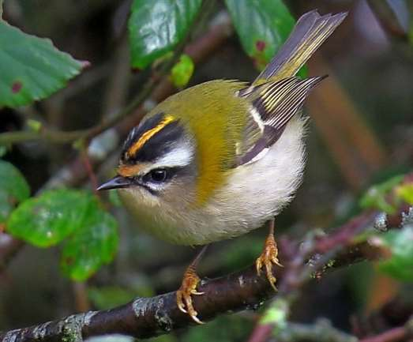
This photo of a confiding Firecrest at Lytchett Fields is one of the best I have seen (I.Ballam)

In the first half of the year 1 was at Old Quoins on 17th Jan and may be the same bird at the Water Works on 31st. 1 was at Lytchett Fields on 13th Mar.

There was a single summer record at Lytchett Fields on 15th Aug.

The next was at the same site on 3rd Oct. This was followed by 1 at Turlin Moor on 2nd Nov, 3 at Lytchett Bay View on 3rd, 1 in the arable field on 4th, 1 at Lytchett Bay View on 4th Dec and finally 1 at Sandy Close Pond on 13th Dec. 1 ringed.

Spotted Flycatcher: (8 – 6 – 24)
Passage migrant, previously bred. In terms of bird-days this was a record year just surpassing 40 B.D in 2002. 1 in spring on Lytchett Fields on 8th May. 41 bird days between 12th Aug and 28th Sep seen at several sites. Max 6 on 18th Sep. No doubt helped by great weather in Sep and increased observer coverage.

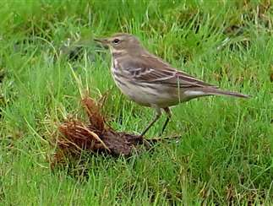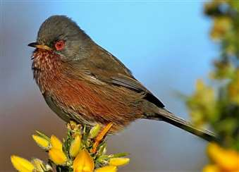

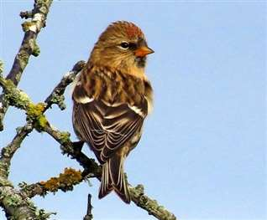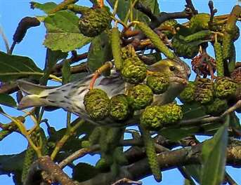
Water Pipit, Dartford Warbler, Lesser Redpoll and Siskin. Fine examples of Ian Ballam’s’ patient and skilled work with the Canon SX50.
Pied Flycatcher: (1 – 10)
Rare visitor. 1 on a wet morning at Sandy Close Pond, 23rd Aug (SR). This was for the first record for this site.

Bearded Tit: (33 – 24)
Scarce breeder and scarce passage migrant. At least 1 pair bred with recently fledged juveniles ringed in Aug. Seen at Lytchett Heath and around the Sherford in the breeding season.

No large congregations in autumn. Max 6 on 23rd Oct. 15 ringed.

X108204 – A male was ringed at Abbotsbury, Dorset on 13th Nov 2013. It was controlled 632 days later on 7th Aug 2015 at Lytchett Bay. A E movement of 40km.

Long tailed Tit:
Common resident. Regularly recorded from most sites at the Bay. 28 ringed.

Coal Tit:
Uncommon resident, increasing. Recorded from most sites across the calendar. 6 ringed.

Blue Tit:
Common resident. 98 ringed.

Great Tit:
Common resident. 35 ringed.

Nuthatch:
Uncommon. Seen occasionally throughout the year. 1 was around Lytchett Bay View and Sandy Close Pond throughout the last 3 months of the year.

Treecreeper:
Uncommon. Not recorded until 21st Jul after which records submitted on only 6 dates. Records from Sandy Close Pond (3), Lytchett Fields (3) and Lytchett Way (1). 1 ringed.

Penduline Tit:*
2nd record and 11th Dorset record. The 22nd Nov had produced an excellent early vis-mig watch by local standards. It became unforgettable when 2 of these masked beauties flew NE calling over the Lytchett Bay View watch point (SR). Despite extensive searching they could not be located around the Turlin Stream. 4 Hours later they were discovered 8miles NE at Longham Lakes! (subject to acceptance by DRP)

The first record was the long staying bird in Jan 1998 at Turlin Shore.

Jay: (12 – 24)
Resident. Regularly seen throughout the year but most often in autumn.

Magpie:
Common Resident.

Jackdaw: (346 – 24)
Resident. Recorded throughout the year. This species has always overflown the site at dusk on its way to roost at Upton Heath. These flights are usually numbered in 10’s. However in the second winter period the flights were very pronounced and an impressive 346 were seen on 13th Dec. A record for the Bay passing 205 on 10th Nov 2007.

Rook: (185 – 24)
Breeds on edge of recording area. 23 nests at the Watery Lane colony. The same as 2014. (25 in 2013, 22 in 2012, 20 in 2011, 16 in 2010).

Carrion Crow: (100 – 24)
Common Resident. Breeds widely across the area. The absence of stubble, and in particular maize, meant that there were no large or lingering flocks this year.

Raven: (7 – 21)
Increasingly regular visitor. Now recorded on almost a daily basis.

Starling: (35000 – 5600 – 24)
Common resident. No significant roosts or flights noted this year. 12 ringed.

House Sparrow: (100 – 24)
Resident. Usually recorded around the urban fringe. Bred at Turlin Moor, Border Road and French’s Farm. Biggest single flock was 30 at Turlin Moor in Dec. 3 ringed.

Chaffinch: (450 – 24)
Breeding resident and winter visitor. No arable crops this year, consequently there was nothing to attract a winter flock. Max of the year was only 20. These were migrating over Lytchett Heath on 19th Oct. Up to 12 were regularly attracted to feeders at Sandy Close Pond. 5 ringed.

Brambling: (10 - 20)
Scarce winter visitor. After none in 2014 it was good to record the species this year. However there was only one (!) which paused its migration briefly at Lytchett Bay View on 4th Nov.

Greenfinch: (60 – 24)
Common breeding resident, which has declined due to on-going Trichomonosis disease in the population. This arrived in late summer 2006 and has had a severe impact on English Greenfinch populations. No noticeable change this year. Still widespread across the area. Biggest flock was 25 at Turlin Moor on 2nd Sep. 17 ringed.

Goldfinch: (120 – 24)
Common breeding resident and passage migrant. At least 120 were present in the Turlin Moor / Lytchett Bay View area on 2nd Nov. 35 at the Water Works on 18th Nov. 17 ringed.

Siskin: (280 – 21)
Passage migrant and occasional winter visitor. Very scarce early in the year. 2 singles at Sandy Close Pond in March. A pair bred locally and visited Sandy Close Pond regularly during May and Jun. A decent autumn with regular records. Max 19 at Lytchett Fields on 9th Sep, 36 at Lytchett Bay View on 13th – 14th Oct. Small numbers around the Water Works at the year end. 1 ringed.

Linnet: (250 – 24)
Uncommon breeding resident. Confirmed breeding with recently fledged young ringed. The roost at Lytchett Way was used early in the year. Max 113 on 15th Feb. Light vis-mig noted in autumn. Max single site counts of 38 on 13th Oct and 35 on 26th Oct. Both at Lytchett Bay View. 4 ringed.

Lesser Redpoll: (40 – 20)
Scarce passage migrant. 24 bird days on 13 dates from 3rd Oct to 4th Dec. Max 7 at Lytchett Heath on first date. 1 ringed.

Bullfinch: (11 – 24)
Uncommon but increasing. In keeping with recent years, widely recorded across the area throughout the year. No more than 5 at any one site. 6 ringed.

Red Crossbill: (21 – 9)
Scarce passage migrant. 4 records this year, all overhead migrants. 2 Lytchett Way on 25th Aug, 6 Lytchett Bay View on 30th Sep, 6 Lytchett Heath on 3rd Oct and 2 Lytchett Heath on 19th Oct.

Lapland Bunting:
2nd record. One flew NW over Lytchett Heath on 19th Oct calling beautifully at a height of 12m (PM). One the more gripping records this year (Eds).

The first was on 14th Oct 2006. Also a fly over.

Yellowhammer: (13 - 14)
Extinct breeding species. Very scarce passage migrant. Only 2nd year in the last 10 that this species has been recorded. 1 in the arable field on 18th Oct (SR).

Reed Bunting: (110 – 24)

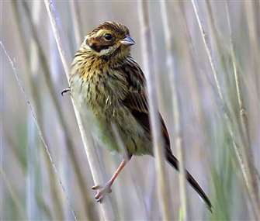  Juv Reed Bunting (I.Ballam) | Breeding resident. No breeding survey but no reason to suspect any change from 2011 when 23 singing males were present. There was also no census of the roosts monitored in 2012. 3 visited feeders at Sandy Close Pond in Jan.  Max flock sizes at any one site; 30 in arable field on 21st Feb and 60 at the same site on 9th Oct. 68 ringed.

Records received from: I.H.Alexander, I.Ballam (IB), D.Bandfield, M.Constantine, Mo Constantine, T.Elborn, R.Farrington, O.Frampton, R.Gifford (RG), P.Harvey, N.Hopper, J.Hull (JH), N.Hull (NHu), S. Isherwood-Harris (SI-H), D.Jones (DJ), K.E.Lane, I.M.Lewis, Z.McMinn, P Morton (PM), G.Owen, A.Robjohns, B.J. Robson, S.Robson (SR), M.Smith, A.Taylor, S.Walls, R.Webb, M.Wood, L.Woodford (LW), C.Young. With additional information from Bird Track, Holton Lee log, Rare Bird Alert and the Dorset Bird Club. Apologies for any omissions.

Appendix 1 – Finders accounts

Wryneck - 16th April 2015, Dave Jones
Having just moved to Dorset, I decided to start exploring my new local patch by wandering around the DWT/ARC Great Heath reserve at Lytchett Heath, so I grabbed my bins and my camera and I set out for a good old poke around to see what was about.
I entered the reserve at around 17:00 and walked along the footpath until the first fork, where, instead of turning left down onto the main reserve path, I carried on down the smaller track that runs parallel with the rear gardens of Sandy Lane. Suddenly, a small, grey blur flew up from the sandy path and perched in a small willow tree. Initially, my first thoughts were Mistle Thrush, but swiftly dismissed it on account of its small size. I peered through my bins to get a better view, but the leaves obscured the bird. I softly crept around the tree, expecting to see a Blackcap, but on my second look through my bins, I saw it.
Silver-grey with mottled black on the mantle and wings, an uplifted and stubby bill, a dark brown eye stripe and sandy breast with delicate grey barring. Being a relatively novice birder, I couldn’t believe what I was seeing, so I took out my phone and checked the RSPB bird guide app. It confirmed what I was looking at, I had just seen my first Wryneck!
I managed to quickly get off a couple of photos – both with completely incorrect settings – but they had just enough detail that the species could be made out. Then the bird flew into the dense undergrowth and I was unable to relocate it.
After I announced the bird on social media, Shaun Robson managed to relocate it in the southeast corner of the reserve and he was soon joined by most of the Lytchett birding fraternity and their telescopes, offering superb views of a fantastic bird. It showed well until dusk but sadly but not surprisingly it was gone the next morning.
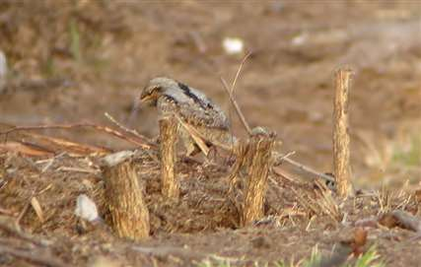
Never quite close enough to get a good picture. A digi-scoped record shot was as good we could manage (S.Robson)
Sanderling – 12th May 2015, Shaun Robson
Sanderling might not be near the top of everyone’s target list but it was mine, though I never imagined it would actually happen. There is too much suitable habitat, in too close proximity. Why would any birds passing Studland, Shore Road or Brownsea choose the mud of Lytchett Bay instead? 23 years of watching the site and Sanderling was no longer on the “possibles” list.

Nonetheless when Ian Ballam called to say that he had 7 distant waders in the heat haze that had white bellies and that some had dark chests it was too much to dwell on. I was there in minutes. Thankfully the trusty Swaro scope cut through the haze and confirmed 4 breeding plum, 2 partial plum and 1 winter plum Sanderling. On the mud! At Lytchett Bay! 1st site record. They did not stay long. 20 mins and they were off to the harbour. High fives all round.

Typically having waited 23 years for the first we did not have to wait long for another. A single on 18th May, again on the rising tide.

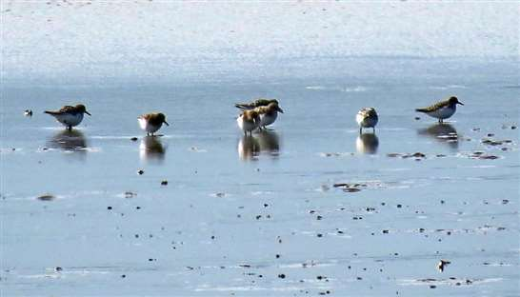
Bird of the year for me. Thanks to Ian for not giving up on the distorted images in his scope. C Ian Ballam

Appendix 2 – Bird ringing at Lytchett Bay 2014
Full grown Pulli Recoveries Total
Water Rail 1 0 0 1
Common Sandpiper 1 0 0 1
Black-headed Gull 1 0 0 1
Woodpigeon 2 0 0 2
Nightjar 1 0 0 1
Kingfisher 9 0 5 14
Great Spotted Woodpecker 7 0 1 8
Sand Martin 4 0 0 4
Swallow 51 0 0 51
Tree Pipit 1 0 0 1
Yellow Wagtail 1 0 0 1
Pied/White Wagtail 42 0 0 42
Wren 28 0 13 41
Dunnock 9 0 4 13
Robin 35 0 9 44
Bluethroat 1 0 0 1
Redstart 2 0 0 2
Whinchat 2 0 0 2
Stonechat 2 0 0 2
Blackbird 71 0 24 95
Song Thrush 14 0 1 15
Redwing 27 0 0 27
Cetti's Warbler 6 0 4 10
Grasshopper Warbler 40 0 4 44
Sedge Warbler 767 0 7 774
Reed Warbler 210 0 19 229
Dartford Warbler 3 0 0 3
Lesser Whitethroat 1 0 0 1
Whitethroat 7 0 1 8
Garden Warbler 9 0 1 10
Blackcap 36 0 2 38
Chiffchaff 94 0 2 96
Willow Warbler 78 0 0 78
Goldcrest 23 0 3 26
Firecrest 1 0 0 1
Bearded Tit 13 2 6 21
Long-tailed Tit 28 0 7 35
Coal Tit 6 0 0 6
Blue Tit 98 0 39 137
Great Tit 35 0 15 50
Treecreeper 1 0 0 1
Starling 12 0 0 12
House Sparrow 3 0 0 3
Chaffinch 5 0 1 6
Greenfinch 17 0 1 18

Retraps/
Full grown Pulli Recoveries Total
Goldfinch 17 0 1 18
Siskin 1 0 0 1
Linnet 3 1 0 4
Redpoll (Common/Lesser) 1 0 0 1
Bullfinch 6 0 3 9
Reed Bunting 68 0 10 78
Total for: Lytchett Bay 1901 3 183 2087

  - Lytchett Bay Annual Report

Non-Avian Wildlife
Nick Hull

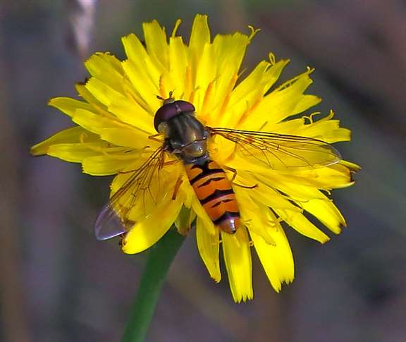
Marmalade Hover Fly - Ian Ballam

2015

Introduction
In 2014 we started to record all non-avian wildlife that could be found on the Lytchett Bay patch. Though our knowledge of some of the species non-avian was limited, it was a start and we have continued on during 2015 to increase our knowledge of the species using the area. With growing knowledge and use of various websites and knowledgeable contacts we have collectively managed to identify and increase the variety of species recorded in the area. In 2015, a total of three hundred and eleven species were identified. Ten species recorded in 2014 haven’t been in 2015 and fifty-three species were recorded for the first time.

A Request to anyone visiting the area who has knowledge of any wildlife groups from butterflies and dragonflies to beetle and bugs, or if you spot something unusual and managed to take a photograph of something you can’t identify send it in to me at nickh4142@gmail.com and I’ll try and identify it and add it to the ever growing data of biodiversity for the area.

I would also like to thank the following patch watchers for there contributions to this list: Shaun Robson, Ian Ballam, Jackie Hull, Liz Woodford, Richard Webb, Kevin Lane. I would also like to thank Tony Allen for his help with identifying a number of the Beetles that I’ve needed help with, and to Paul Harris for his help with identification of various moths that gave me problems identifying.

The List
Mammals
Evidence of two species not recorded before both were reported by Richard Webb who found evidence of Badger using the area in May along Watery lane, he also found a Common Shrew on the 17th April then recorded three plus on 15th May, both species of which are possibly under recorded. There haven’t been any visual reports of Otter this year but evidence is often being found in the form of spraint near to the Sherford River.

Common Names | Scienticfic Name | First date recorded
Sika Deer | Cervus nippon | Common
Roe Deer | Capreolus capreolus | Common
Fox | Vulpes vulpes | Common
Badger | Meles meles | May
Otter | Lutra lutra | April
Weasel | Mustela nivalis | 22nd March
Hedgehog | Erinaceus europaeus | Recorded 3+
Water Vole | Arvicola amphibius (=terrestris) | 9th April
Brown Rat | Rattus norvegicus | Recorded throughout year
Wood Mouse | Apodemus sylvaticus | 27th July
Common Shrew | Sorex araneus | 17th Apr & 3 15th May
Grey Squirrel | Sciurus carolinensis | Common
Common Pipistrelle | Pipistrellus pipistrellus | 9th April
Mole | Talpa europaea | 27th March

Reptiles & Amphibians
There doesn’t seem to be any change in this group over 2015 other than no Sand Lizards and no Slow Worms were recorded this year. Going by the number of frog and newts in my garden pond this year both species have had a good season. A species which seems noticeable because of its absence is the Toad but perhaps this is because the ponds just aren’t suitable.

Common Names | Scienticfic Name | First date recorded
Common Frog | Rana temporaria | Recorded
Common Lizard | Lacerta vivipara | 23rd June
Sand Lizard | Lacerta agilis | No records
Slow Worm | Anguis fragilis | No records
Palmate Newt | Lissotriton helveticus | Recorded
Smooth Newt | Lissotriton vulgaris | Recorded
Grass Snake | Natrix natrix | Recorded
Adder | Vipera berus | 26th June

Odonata
Three species recorded in 2014 were not in 2015 Hairy Dragonfly, Common Hawker and Black Darter. It will remain to be seen if these species are recorded again in the future. Amphibian and Reptile Conservation (ARC) who manage part of the Lytchett Way site of the bay area, have carried out conservation work clearing the pond and scrub on the small patch of heathland during the early part of 2015, so hopefully this will produce more odonata in 2016.

There were two new species added, Brown Hawker was seen by Ian Ballam crossing the fields on the 16th September, this species is well known to travel from its ideal habitat and can turn up almost anywhere. The second was a Scarce Chaser seen on 26th June, this is a species that is being found more often in recent years in Dorset and hopefully will increase over the forthcoming years. The third Four Spotted Chaser has probably been overlooked in the past as it is a relatively common species.

Common Names | Scienticfic Name | First date recorded
Large Red Damselfly | Pyrrhosoma nymphula | 23rd April
Azure Damselfly | Coenagrion puella | 24th June
Common Blue Damselfly | Enallagma cyathigerum | Recorded
Blue-tailed Damselfly | Ischnura elegans | 26th May
Hairy Dragonfly | Brachytron pratense | No records
Common Hawker | Aeshna juncea | No records
Migrant Hawker | Aeshna mixta | Recorded
Southern Hawker | Aeshna cyanea | Recorded
Golden-ringed Dragonfly | Cordulegaster boltonii | 25th June
Common Darter | Sympetrum striolatum | 25th June
Common Names | Scienticfic Name | First date recorded
Black Darter | Sympetrum danae | No records
Ruddy Darter | Sympetrum sanguineum | 2nd Aug
Brown Hawker | Aeshna grandis | 16th Sept
Broad-bodied Chaser | Libellula depressa | Recorded
Four-spotted Chaser | Libellula quadrimaculats | 10th July
Scarce Chaser | Libellula fulva | 26th June
Keeled Skimmer | Orthetrum coerulescens | 27th June
Emperor Dragonfly | Anax imperator | 30th June

Lepidoptera
Twenty five species of butterfly were recorded in the area in 2015 and six species stand out this year.

The first confirmed record of Ringlet, which seems to have colonised an area of bramble in the woodland at Lytchett Way.

The second new record was also unexpected visitor on 31st July, during the week of the garden butterfly survey when I found a Grayling sat on our Buddleia. Though there is some remnant heathland close by it doesn’t seem to support any Grayling so this individual must have travelled from either Arne or Upton Heath.

The third was found by Jackie (Hull) who saw what she thought was a Large White pass her by in the garden and it flew straight into the web of a garden spider. It was then Jackie saw that it was creamy yellow with black tipped wings and quickly tried to rescue it, but unfortunately was beaten by the hungry spider. So a quick photo and checking the identification proved it to be the second record of a Clouded Yellow of the form C. f. helice. This form helice apparently occurs in the female, where the individual is a creamy yellow white, rather than rich yellow colour of Clouded Yellow.

Marbled White was also recorded for the first time in a few years. Good numbers were seen in the arable field and at Lytchett Way.

Jackie and I recorded a single Essex Skipper near to the Black Pipe in 2012 but there hasn’t been a record since. Shaun recorded one in the arable field on 10th July, a day or two later Ian Ballam managed to take a photograph and have the identification confirmed by Kevin Lane, I later recorded another a couple days after in the Purple Heron field along with several Small Skippers. It appears that we have possibly overlooked a small population that has been mixed in with the many Small Skippers.

Another species that was last recorded in 2012 was Purple Hairstreak which I saw in the Oaks at Lytchett Way. This year Ian managed to find the species on the hedge between the arable field and the Purple Heron field and a day later I picked one up sat on our garden path making this the third and fourth records of the species for the area.

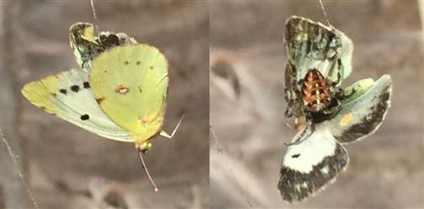
Clouded Yellow form ssp. Helice

Common Names | Scienticfic Name | First date recorded
Essex Skipper | Thymelicus lineola | 10th July
Small Skipper | Thymelicus sylvestris | 27th June
Large Skipper | Ochlodes venata | 25th June
Clouded Yellow | Colias croceus | Recorded
Clouded Yellow ssp. helice | Colias croceus helice | 15th Sept
Brimstone | Gonepteryx rhamni | 5th April
Large White | Pieris brassicae | 10th July
Small White | Pieris rapae | 22nd April
Green-veined White | Pieris napi | 23rd April
Grayling | Hipparchia semele | 31st July
Marbled White | Melanargia galathea | 25th June
Orange Tip | Anthocharis cardamines | 28th April
Purple Hairstreak | Quercusia quercus | 30th July
Small Copper | Lycaena phlaeas | 17th July
Common Blue | Polyommatus icarus | 24th May
Holly Blue | Celastrina argiolus | 28th April
Red Admiral | Vanessa atalanta | 7th May
Painted Lady | Cynthia cardui | 5th June
Small Tortoiseshell | Aglais urticae | 13th March
Peacock | Inachis io | 13th March
Comma | Polygonia c-album | 9th July
Speckled Wood | Pararge aegeria | 7th April
Gatekeeper | Pyronia tithonus | 7th July
Meadow Brown | Maniola jurtina | 25th June
Ringlet | Aphantopus hyperantus | 25th June
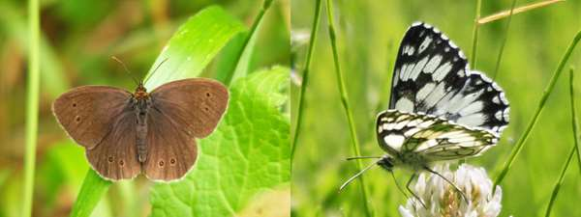
Ringlet Aphantopus hyperantus & Marbled White Melanargia galathea

Moths
Of the day flying moths recorded in 2015 produced only two reports of Hummingbird Hawk-moth the first by Liz Woodford on 18th June then the next by Jackie on 29th September. The first Cinnabar was found on the 21st June followed by Silver Y on 25th June then Six-spot and Five-Spot Burnet on 31st July.

I set the moth trap on twenty-seven occasions between 11th March and the 27th December 2015 compared with twenty-six times between 9th March and 29th September in 2014. Only one hundred and eighty species were recorded this year compared to two hundred and twenty-seven species in 2014. Twenty-six species were recorded for the first time (these are highlighted in red in the list below). This brings the total recorded for the Lytchett Bay recording area to 361 species of macro and micro moth.

A number of species in the list have ‘agg’ written next to the name, this means for a definitive identification the species requires to be genetically dissected to determine the species. As I disagree with killing a species just to identify it I list these species ‘agg’ putting the most likely species name first.

It is always nice to trap a rare or scarce moth and a number of moths were particularly nice to have trapped this year the first was a micro Syncopacma polychromella - listed as a very rare migrant, Small Marbled is a again a very scarce migrant, and occasional breeder in good years. A Balsam Carpet is awaiting acceptance is also a very rare wanderer from Hampshire colonies or possible could be a very rare resident? Ni Moth is a rare, mainly coastal migrant and Angled-barred Pug is probable a migrant/wanderer, and rare resident.
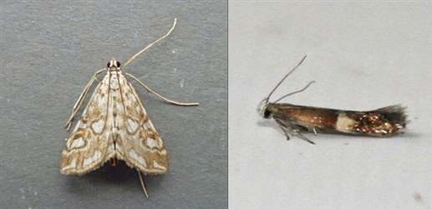
Brown China-mark and Syncopacma polychromella

Code | Common Name | Scientific Name | Adult
169 | Six-spot Burnet | Zygaena filipendulae | 2
170 | Five-spot Burnet | Zygaena trifolii | 1
173 | Festoon | Apoda limacodes | 1
424 | Bird-cherry Ermine | Yponomeuta evonymella | 1
464 | Diamond-back Moth | Plutella xylostella | 2
473 | Leek Moth | Acrolepiopsis assectella | 1
642 |  | Batia unitella | 1
647 | Brown House-moth | Hofmannophila pseudospretella | 2
656 |  | Tachystola acroxantha | 6
850 |  | Syncopacma polychromella | 1
862 | Juniper Webber | Dichomeris marginella | 1
969 | Chequered Fruit-tree Tortrix | Pandemis corylana | 2
Code | Common Name | Scientific Name | Adult
970 | Barred Fruit-tree Tortrix | Pandemis cerasana | 4
972 | Dark Fruit-tree Tortrix | Pandemis heparana | 47
1002 |  | Lozotaenia forsterana | 1
1039 | Strawberry Tortrix agg. | Acleris comariana / laterana | 1
1048 | Garden Rose Tortrix | Acleris variegana | 1
1053 | Tortix agg. | Acleris hastiana / challeriana | 1
1063 |  | Celypha striana | 2
1133 |  | Epinotia bilunana | 1
1175 | Bramble Shoot Moth | Epiblema uddmanniana | 4
1288 | Twenty-plume Moth, Many-plumed Moth | Alucita hexadactyla | 2
1292 |  | Calamotropha paludella | 1
1293 |  | Chrysoteuchia culmella | 3
1305 |  | Agriphila tristella | 1
1307 |  | Agriphila latistria | 1
1309 |  | Agriphila geniculea | 4
1313 |  | Catoptria pinella | 1
1341 |  | Eudonia lineola | 2
1342 |  | Eudonia angustea | 1
1345 | Brown China-mark | Elophila nymphaeata | 1
1350 | Beautiful China-mark | Nymphula stagnata | 1
1354 | Small China-mark | Cataclysta lemnata | 6
1356 | Garden Pebble | Evergestis forficalis | 3
1376 | Small Magpie | Eurrhypara hortulata | 3
1378 |  | Phlyctaenia coronata | 1
1395 | Rusty-dot Pearl | Udea ferrugalis | 5
1398 | Rush Veneer | Nomophila noctuella | 3
1405 | Mother of Pearl | Pleuroptya ruralis | 5
1414 |  | Synaphe punctalis | 8
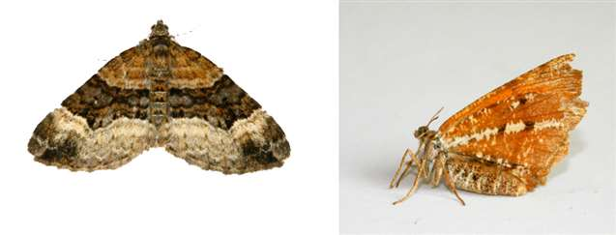
Balsam Carpet Xanthorhoe biriviata and Bordered White Bupalus piniaria

Code | Common Name | Scientific Name | Adult
1470 |  | Euzophera pinguis | 1
1481 |  | Homoeosoma sinuella | 1
1654 | Figure of Eighty | Tethea ocularis | 1
1659 | Yellow Horned | Achlya flavicornis | 1
1680 | Maiden's Blush | Cyclophora punctaria | 6
1690 | Small Blood-vein | Scopula imitaria | 2
1707 | Small Dusty Wave | Idaea seriata | 2
1708 | Single-dotted Wave | Idaea dimidiata | 3
1711 | Treble Brown Spot | Idaea trigeminata | 3
1712 | Small Scallop | Idaea emarginata | 1
1713 | Riband Wave | Idaea aversata | 13
1716 | Vestal | Rhodometra sacraria | 1
1721 | Balsam Carpet | Xanthorhoe biriviata | 1
1722 | Flame Carpet | Xanthorhoe designata | 1
1728 | Garden Carpet | Xanthorhoe fluctuata | 3
1738 | Common Carpet | Epirrhoe alternata | 2
1760 | Red-green Carpet | Chloroclysta siterata | 2
1768 | Grey Pine Carpet | Thera obeliscata | 1
1771a | Cypress Carpet | Thera cupressata | 1
1776 | Green Carpet | Colostygia pectinataria | 1
1825 | Lime-speck Pug | Eupithecia centaureata | 1
1827 | Freyer’s Pug | Eupithecia intricata | 4
1834 | Common Pug | Eupithecia vulgata | 1
1848 | Angle-barred Pug | Eupithecia innotata | 1
1852 | Brindled Pug | Eupithecia abbreviata | 1
1853 | Oak-tree Pug | Eupithecia dodoneata | 1
1855 | Cypress Pug | Eupithecia phoeniceata | 1
1862 | Double-striped Pug | Gymnoscelis rufifasciata | 18

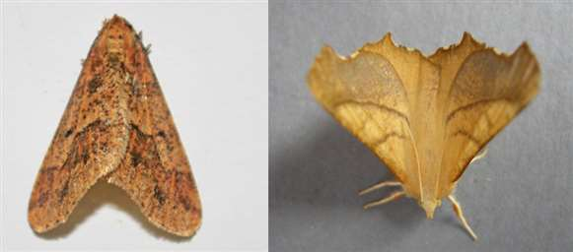
Mottled Umber Erannis defoliaria and Dusky Thorn Ennomos fuscantaria
Code | Common Name | Scientific Name | Adult
1881 | Early Tooth-striped | Trichopteryx carpinata | 7
1882 | Small Seraphim | Pterapherapteryx sexalata | 8
1887 | Clouded Border | Lomaspilis marginata | 25
1890 | Sharp-angled Peacock | Macaria alternata | 3
1902 | Brown Silver-line | Petrophora chlorosata | 4
1904 | Scorched Wing | Plagodis dolabraria | 3
1906 | Brimstone Moth | Opisthograptis luteolata | 11
1907 | Bordered Beauty | Epione repandaria | 2
1913 | Canary-shouldered Thorn | Ennomos alniaria | 12
1914 | Dusky Thorn | Ennomos fuscantaria | 1
1919 | Purple Thorn | Selenia tetralunaria | 1
1931 | Peppered Moth | Biston betularia | 8
1934 | Dotted Border | Agriopis marginaria | 1
1935 | Mottled Umber | Erannis defoliaria | 1
1937 | Willow Beauty | Peribatodes rhomboidaria | 18
1945 | Brussels Lace | Cleorodes lichenaria | 2
1947x | Engrailed/Small Engrailed | Ectropis bistortata/crepuscularia | 1
1954 | Bordered White | Bupalus piniaria | 1
1961 | Light Emerald | Campaea margaritata | 4
1979 | Lime Hawk-moth | Mimas tiliae | 3
1980 | Eyed Hawk-moth | Smerinthus ocellata | 2
1981 | Poplar Hawk-moth | Laothoe populi | 3
1984 | Hummingbird Hawk-moth | Macroglossum stellatarum | 2
1991 | Elephant Hawk-moth | Deilephila elpenor | 7
1994 | Buff-tip | Phalera bucephala | 10
1995 | Puss Moth | Cerura vinula | 1
1997 | Sallow Kitten | Furcula furcula | 1

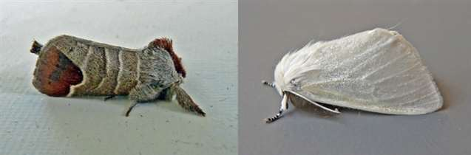
Chocolate-tip Clostera curtera and White Satin Moth Leucoma salicis

Code | Common Name | Scientific Name | Adult
1999 | Lobster Moth | Stauropus fagi | 1
2000 | Iron Prominent | Notodonta dromedarius | 2
2003 | Pebble Prominent | Notodonta ziczac | 1
2005 | Great Prominent | Peridea anceps | 1
2006 | Lesser Swallow Prominent | Pheosia gnoma | 1
2011 | Pale Prominent | Pterostoma palpina | 1
2015 | Lunar Marbled Brown | Drymonia ruficornis | 3
2019 | Chocolate-tip | Clostera curtula | 1
2028 | Pale Tussock | Calliteara pudibunda | 4
2031 | White Satin Moth | Leucoma salicis | 1
2033 | Black Arches | Lymantria monacha | 10
2037 | Rosy Footman | Miltochrista miniata | 3
2043 | Orange Footman | Eilema sororcula | 1
2044 | Dingy Footman | Eilema griseola | 1
2047 | Scarce Footman | Eilema complana | 2
2049 | Buff Footman | Eilema depressa | 1
2050 | Common Footman | Eilema lurideola | 2
2051 | Four-spotted Footman | Lithosia quadra | 3
2060 | White Ermine | Spilosoma lubricipeda | 1
2061 | Buff Ermine | Spilosoma luteum | 6
2063 | Muslin Moth | Diaphora mendica | 1
2064 | Ruby Tiger | Phragmatobia fuliginosa | 2
2069 | Cinnabar | Tyria jacobaeae | 2
2087 | Turnip Moth | Agrotis segetum | 4
2088 | Heart & Club | Agrotis clavis | 2
2089 | Heart & Dart | Agrotis exclamationis | 47
2091 | Dark Sword-grass | Agrotis ipsilon | 4
2092 | Shuttle-shaped Dart | Agrotis puta | 14
2098 | Flame | Axylia putris | 1
2102 | Flame Shoulder | Ochropleura plecta | 12
2107 | Large Yellow Underwing | Noctua pronuba | 150
2109 | Lesser Yellow Underwing | Noctua comes | 14
2110 | Broad-bordered Yellow Underwing | Noctua fimbriata | 5
2111 | Lesser Broad-bordered Yellow Underwing | Noctua janthe | 7
2119 | Pearly Underwing | Peridroma saucia | 1
2120 | Ingrailed Clay | Diarsia mendica | 1
2123 | Small Square-spot | Diarsia rubi | 7
2126 | Setaceous Hebrew Character | Xestia c-nigrum | 9
2134 | Square-spot Rustic | Xestia xanthographa | 28

2154 | Cabbage Moth | Mamestra brassicae | 2
2159 | Dog’s Tooth | Lacanobia suasa | 1
2160 | Bright-Line Brown-Eye | Lacanobia oleracea | 5
2173 | Lychnis | Hadena bicruris | 2
2182 | Small Quaker | Orthosia cruda | 21
2187 | Common Quaker | Orthosia cerasi | 31
2188 | Clouded Drab | Orthosia incerta | 14
2189 | Twin-spotted Quaker | Orthosia munda | 4
2190 | Hebrew Character | Orthosia gothica | 14
2194 | White-point | Mythimna albipuncta | 1
2197 | Southern Wainscot | Mythimna straminea | 1
2198 | Smoky Wainscot | Mythimna impura | 5
2199 | Common Wainscot | Mythimna pallens | 4
2202 | L-album Wainscot | Mythimna l-album | 1
2204 | Obscure Wainscot | Mythimna obsoleta | 3
2243 | Early Grey | Xylocampa areola | 1
2270 | Lunar Underwing | Omphaloscelis lunosa | 12
2273 | Pink-barred Sallow | Xanthia togata | 1
2274 | Sallow | Xanthia icteritia | 2
2280 | Miller | Acronicta leporina | 4
2284x | Grey Dagger / Dark Dagger | Acronicta psi / tridens | 1
2301 | Bird’s Wing | Dypterygia scabriuscula | 1
2305 | Small Angle Shades | Euplexia lucipara | 1
2306 | Angle Shades | Phlogophora meticulosa | 8
2318 | Dun-bar | Cosmia trapezina | 1
2321 | Dark Arches | Apamea monoglypha | 6
2337x | Marbled Minor agg. | Oligia strigilis agg. | 4
2380 | Treble Lines | Charanyca trigrammica | 6
2381x | Uncertain/Rustic agg. | Hoplodrina alsines/blanda | 17
2384 | Vine's Rustic | Hoplodrina ambigua | 19

2385 | Small Mottled Willow | Spodoptera exigua | 2
2387 | Mottled Rustic | Caradrina morpheus | 4
2389 | Pale Mottled Willow | Paradrina clavipalpis | 3
2391 | Silky Wainscot | Chilodes maritimus | 1
2403 | Bordered Straw | Heliothis peltigera | 2
2408 | Small Marbled | Eublemma parva | 1
2418 | Cream-bordered Green Pea | Earias clorana | 7
2425 | Nut-tree Tussock | Colocasia coryli | 6
2432 | Ni Moth | Trichoplusia ni | 1
2441 | Silver Y | Autographa gamma | 5
2343x | Common Rustic agg. | Mesapamea secalis agg. | 14
2450 | Spectacle | Abrostola tripartita | 3
2452 | Red Underwing | Catocala nupta | 1
2473 | Beautiful Hook-tip | Laspeyria flexula | 1
2474 | Straw Dot | Rivula sericealis | 6
2477 | Snout | Hypena proboscidalis | 1
2484 | Pinion-streaked Snout | Schrankia costaestrigalis | 1

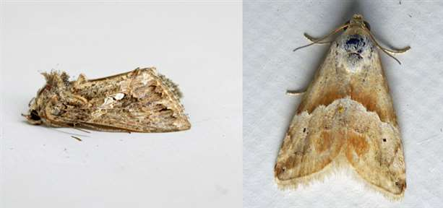
The Ni Moth Trichoplusia ni and Small Marbled Eublemma parva

Other Insect Species Recorded

Due to my health problems at the beginning on 2015 I was restricted to my home garden for three months so to keep myself occupied I started photographing anything that moved in the garden and as I wasn’t allowed to do any strenuous work we allowed our garden to go wild and it certainly made a difference to the insect life that was using it. For instance, allowing the grass to grow provided good habitat for crickets and grasshoppers where before there were none. The few wild flowers and the other high nectar plants that were in the garden seemed to attract even more insects of various species and the bug hotels were being used within two days of being put up. Due to this success in 2015 we are putting in plans for this year to increase the wild flowers in the lawn and hopefully this will attract even more species giving us a better knowledge of which species that are occurring locally in the Lytchett Bay recording area.

The following categories are those that have been the most difficult for us to identify because they are new subjects of learning but for me has been very enjoyable. We have added a total of twenty-five species that haven’t been recorded before, all undoubtedly common species all of which are highlighted in red in the lists below.

Hymenoptera - Aculeates
Bees, Wasps & Ants

Aculeates are part of the vast order Hymenoptera, The defining feature of all aculeates is that the egg-laying ovipositor is modified to form a sting. The majority of species hide their larva and their food provisions in safe retreats.

In Britain there are around 590 species of aculeates, these include ants, bees and wasps. Aculeates life histories are many and varied.

On a few days during November and December due to the mild warm weather on days where the sun popped out, though only briefly I recorded Buff-tailed Bumble Bees in the garden and doing a little research found that winter activity is a recent phenomenon. It is believed that some of the queens from the summer generation start producing workers in early to mid-November. Pollen foraging workers may then be active on warm days throughout the winter and a new generation of queens and males emerges in February. Apparently Mahonia, varieties of winter flowering heather, honeysuckle and Rhododendron seems to be the main winter attracting plants.

Common Name | Scientific Name | Dates first recorded
Honey Bee | Apis mellifera | Recorded
Bumble Bee | Bombus lucorum | Recorded
Bumble Bee | Bombus pratorum | Recorded
Buff-tailed Bumble Bee | Bombus terrestris | 5th April
Carder Bee | Bombus pascuorum | Recorded
Common Wool Carder Bee | Anthidium manicatum | 23rd June
Mason Bee | Osmis rufa | Recorded

There seemed to be fewer Hornets seen in 2015 and two species of Vespa wasp that were common in 2014 weren’t recorded, these were Red and Norwegian Wasp. But German and Common Wasp were very much in abundance particularly around our old plum tree. Three new species of wasp relatives were identified the first I saw was in our garden but I failed to get a photograph, but thought it to be a Bee-wolf, a few days later whilst visiting Lytchett Heath I again saw what I thought was this species but after photographing it, found it to be a relative species Cerceris arenaria which instead of preying on honey bee preys on weevils. It turns out that there is a small population at Lytchett Heath of this intriguing species. The second is another species that parasitises on Lepidoptera larva Ancistrocerus parietinus this species may be one that is inhabiting our bug hotel as it is a tube dweller. The last of these is Astata boops a smaller species that preys on Shield Bug nymphs. One species that was recorded in 2014 but recently identified was Ichneumon stramentarius which has been added to the list.

Common Name | Scientific Name | Dates first recorded
Hornet | Vespa crabro | Recorded
Common Wasp | Vespula vulgaris | 12th July
Red Wasp | Vespula rufa | Not Recorded
German Wasp | Vespula germanica | 1st August
Norwegian Wasp | Dolichovespula norwegica | Not Recorded
Digger Wasp sp. | Cerceris arenaria | 1st August
Digger Wasp sp. | Astata boops | 10th July
Wasp (small wasp sp.) | Ancistrocerus parietinus | 28th April
Black Ant | Lasius nigra | Recorded
Red Ant | Myrmica rubra | Recorded
Ichneumon | Amblyteles armatorius | Recorded
Ichneumon | Ophion luteus | Recorded
Ichneumon | Ichneumon stramentarius | Recently id’ed from 2014
Ichneumon | Netelia testaceus | Recorded
Ichneumon | Alomya semiflava | 10th July

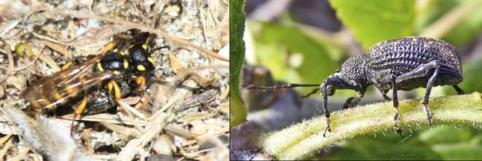
Sand / Digger Wasp - c Cerceris arenaria & Weevil (prey) Otiorhynchus clavipes

Orthoptera
Grasshopper & Crickets

As mentioned above, allowing the lawn grass to grow provided habitat for a number of grasshopper and cricket species. Thanks to Ian managing to take a number of photographs three new species were identified with help from Kevin Lane, Roesel’s Bush Cricket also Long and Short-winged Cone-head. All seven species seem to be fairly common in the patch area.

Common Name | Scientific Name | Dates first recorded
Dark Bush Cricket | Pholidoptera griseoaptera | Recorded
Roesel’s Bush Cricket | Metrioptera roeselii | 1st Record
Long-winged Cone-head | Conocephalus discolor | 1st Record
Short-winged Cone-head | Conocephalus dorsalis | 1st Record
Speckled Bush Cricket | Leptophyes punctatissima | Recorded
Mottled Grasshopper | Myrmeleotettix maculatus | Recorded
Field Grasshopper | Gryllus pennsylvanicus | Recorded

Arachnids
Spiders, Ticks & Scorpions
Spiders are a group often ignored but it’s a group that I’m sure we are under recording and as we continue with the recording this list will grow as will many of the others. Labyrinth Spider in very common throughout the Purple Heron Field and other locations in the recording area though it seems it was overlooked in past years. After finding Wasp Spider in the garden last year Ian managed to find four others in the fields this year so hopefully their colonisation will continue.

Common Name | Scientific Name | Dates first recorded
Crab Spider | Misumena vatia | 3rd May
Zebra Spider | Salticus scenicus | Recorded April
House Spider | Achaearanea tepidariorum | Recorded
Garden Spider | Araneus diadematus | Recorded
Nursery Web Spider | Pisaura mirabilis | 28th July
Labyrinth Spider | Agelena labyrinthica | Recorded
Wasp Spider | Argiope bruennichi | 28th July
Daddy Longlegs | Pholcus phalangioides | Recorded
Money Spider | Lepthyphantes tenuis | Recorded

Diptera
Flies & Relatives
Flies are not always the group that are well loved even less so than the previous group I would imagine, but I’ve been able to add fifteen species to the list in 2015. Most of the new species identified have been hoverflies, all of them found in my garden, though some have been seen in other locations on the patch also.

The crane fly Tipula Maxima though a widespread and common species was nice to find sat on the wall when I went to check the moth trap one morning. As they measure around 100mm across it was something you couldn’t have missed if you tried. Hoverflies are an interesting group and I managed to add seven species to the list.

Common Name | Scientific Name | Dates first recorded
House Fly | Musca domesticus | Recorded
Large Marsh Horsefly | Tabanus autumnalis | 2nd Aug
Flesh Fly sp. | Sarcophaga-sp. | 1st August
Blue Bottle | Calliphora vomitoria | 1st August
Green Bottle | Lucillia sericata | Recorded
Mosquitoe | Culex pipiens | Recorded
Common Crane Fly | Tipula oleracea | Recorded
Crane Fly | Tipula Maxima | 28th Aug
Tiger Crane Fly | Nephrotoma flavescens | Recorded 3+
Bee-fly | Bombylius major | 6th April
Marsh Snipe Fly | Rhagio scolopaceus | 30th June
Drone Fly (Hover Fly) | Eristalis tenax | Recorded April
Large Hover-fly | Volucella zonaria | 21st Aug 15
Hover-fly sp. | Volucella bombylans | 7th June
Hover Fly (Sun-fly) | Helophilus pendulus | 30th June
Marmalade Hover Fly | Episyrphus balteatus | 19th July
Pied Hover Fly | Scaeva-pyra | 31st July
Hover Fly sp. | Eupeodes-bucculatu | 31st July
Hover Fly sp. | Chrysotoxum bicinctum | 4th August
Scorpian Fly | Panorpa communis | 27th July
Sawfly sp. | Tenthredo acrobat | 7th July
Large Rose Sawfly | Arge pagana | 1st August
Soldier Fly sp. | Oxycera pulchella | 12th July
Large Rose Sawfly | Arge pagana | 1st August

Beetles & Bugs
We have managed to record twenty nine species of beetle and bug since we have started recording three of which were not recorded this year. All are species that are easily found and mainly common and many of the ones noted below turned up in my moth trap. Though one species photographed by Ian Ballam on the fields Zabrus tenebriodes isn’t a common species which can be a pest in corn (the larvae eating young shoots).

Two new species one a Mirid bug Stenotus binotatus was found by Ian Ballam and the Weevil Otiorhynchus clavipes was one of the species found in the moth trap.

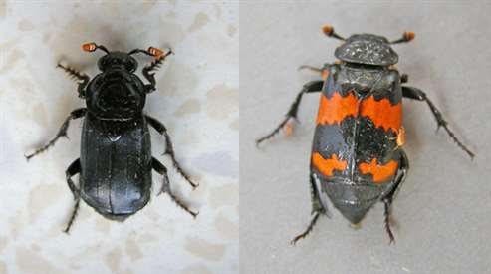
Two species Sexton Beetle – Nicrophorus humator & Nicrophorus investigator

Common Name | Scientific Name | Dates first recorded
Great Diving Beetle | Dytiscus marginalis | Not recorded
Wirlygig Beetle | Gyrinus natator | 1st August
Black-clouded Longhorn Beetle | Leiopus nebulosus | Not Recorded
Longhorn Beetle | Strangalia maculata | 27th June
Soldier Beetle | Rhagonycha fulva | 25th June
Bloody-nosed Beetle | Timarcha tenebricosa | Recorded
Cardinal Beetle | Pyrochroa coccinea | Recorded
Beetle | Zabrus tenebriodes | 28th Aug
Thick-thighed Flower Beetle | Oedemera nobilis | 27th June
Sexton Beetle | Nicrophorus investigator | 3 Records
Black Sexton Beetle | Nicrophorus humator | 1st Record
Common Cockchafer | Melolontha melolontha | 7th May
Mint Leaf Beetle | Chrysolina herbacea | Recorded
Rose Chafer | Cetonia aurata | 27th June
Denticulate-leatherbug | Coriomeris denticulatus | Not recorded
Shield Bug | Nezara viridula | 27th June
Hawthorn Shield Bug | Acanthosoma haemorrrhoidale | Recorded
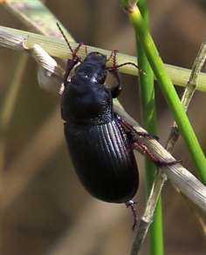
Beetle sp. Zabrus tenebriodes

Forest Shield Bug | Pentatoma rufipes | Recorded
Shield Bug | Coreus marginatus | Recorded
Mirid Bug | Grypocoris stysi | 2nd Recorded
Mirid Bug | Stenotus binotatus | 27th June
Pond Skater | Gerris lacustris | Recorded
Water Boatman | Corixa punctata | Recorded April
2-spot Ladybird | Adalia bipu | 2nd Aug
7-Spot Ladybird | Coccinella 7-punctata | Recorded
22-spot Ladybird | Psyllobora 22-punctata | Recorded
Harlequin Ladybird | Harmonia axyridis | Recorded
Nut Weevil | Curculio nucum | Recorded
Weevil sp. | Otiorhynchus clavipes | 28th Aug
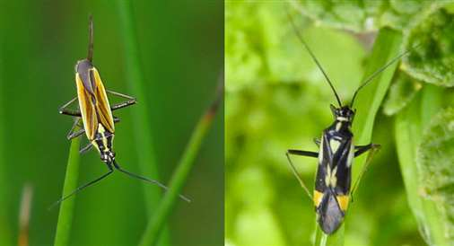
Mirid Bugs - Stenotus binotatus & Grypocoris stysi

Lytchett Bay Plant Summary for 2015 by Katie Wilkinson

Lytchett Bay has been surveyed in 2015 for bryophytes and vascular plants by survey volunteers and expert naturalists including volunteers from Dorset Flora Group and Dorset Wildlife Trust.
Since January 2015 there have been 433 records of vascular plants comprising of 165 species and 133 records of Bryophytes comprising of 59 species recorded for Lytchett Bay. In addition there have been 2 records of fungi comprising of 2 species and 4 records of lichens comprising of 4 species.
Attached are the species summary lists of species found on site courtesy of Dorset Wildlife Trust and Amphibian and Reptile Conservation.
Through surveying the site we have updated records held by Dorset Environmental Centre. This resulted in a number of old records being updated for 2015 and included a record of yellow loosestrife which hadn’t been officially recorded since 1944! Below is a summary of these significant updated records:
Year last seen | Species
1991 | black bog rush, blunt flowered rush, bog asphodel, bog myrtle, deergrass, marsh pennywort, parsley water-dropwort, star sedge, western gorse, white beak sedge
1991-1984 | bristle bent, marsh pennywort, sea arrowgrass, tormentil.
1943/1944 | Skullcap, yellow loosestrife

Lytchett Bay Bryophytes summary by Jim White

In the first season on this reserve for DWT and the Great Heath Project it was relatively easy to assemble a list of plant records as very little systematic recording had taken place before. The habitats include wet and dry acid woodland, wet and dry heathland, reedbed and saltmarsh.

A couple of visits were made in early spring to record bryophytes (mosses and liverworts) and this was accomplished in at least parts of five of the reserve’s compartments. In all some 58 species were noted. The most species were found in the cpt that includes wet and dry heathland with wooded edges, so including some epiphytes as well as a good range of typical heathland spp, with at least eight Bog-mosses Sphagnum spp. Perhaps the most interesting habitats for bryophytes though are the very wet swamp woods that grade out into boggy heath or reedswamp, and the flowering plants here include some interesting spp too. The Sphagnum carpets in these wet woods include much Spiky Bog-moss S squarrosum and there is also an impressive amount of Dotted Thyme-moss Rhizomnium punctatum. These swamps are obviously less acidic and nutrient-poor than the usual Dorset heath mires as another moss found very locally, this time in the fringes of the reeds, was Shining Hookeria Hookeria lucens. The more base-rich character of this habitat is reflected too in the flowering plant flora.

There is much still to explore and the terrain is often difficult but the new reserve almost certainly has much yet to reveal. It is very encouraging that such a complete habitat transition, from open mudflat through saltmarsh and reedswamp to heathland, still survives on the north shores of the harbour.

