Lytchett Bay 2012

**Bird Report and Ringing Report**

***Shaun Robson***

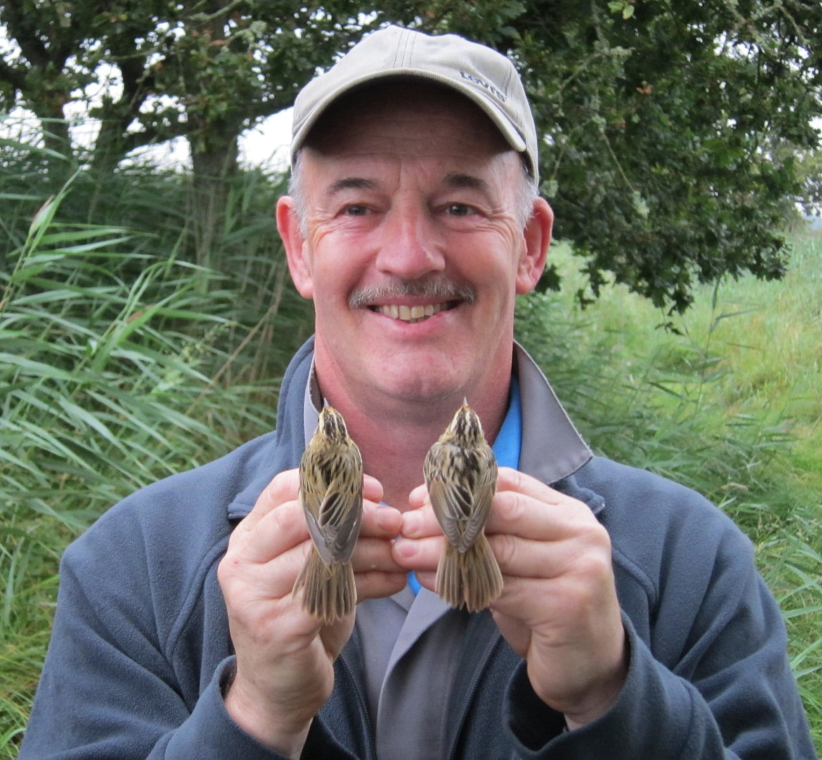

Stour Ringing Group Secretary is rewarded for hard work, 18th Aug 2012 (S.Robson)

The Bay was visited on 258 days as set out below.

|  |  |  |  |  |  |  |  |  |  |  |  |
| --- | --- | --- | --- | --- | --- | --- | --- | --- | --- | --- | --- |
| JAN | FEB | MAR | APR | MAY | JUN | JUL | AUG | SEP | OCT | NOV | DEC |
| 17 | 14 | 23 | 27 | 24 | 13 | 23 | 29 | 30 | 30 | 15 | 13 |

After two brilliant years at Lytchett, 2012 was merely “good”. Nonetheless there was one addition to Bay list. See Paul Morton’s account a finding the Great White Egret in Appendix 1. The Bay list now stands at 217.

Notable rarities also included 2 Aquatic Warblers (our 4th and 5th records). Lytchett Bay was the only site in the UK to record more than one of this red data book species. After 3 records of Cattle Egret in 2007 and 2008 we had to wait until 2012 for our 4th. This pales into insignificance compared to the 42 year wait for the second record of Nightingale. A singing bird in spring was my bird of the year. Bittern is definitely increasing, 2012 saw our 4th record and as I write in February 2013 I have just been made aware that we now have a 5th. Lytchett Bay’s geography means that some species common only a mile away can be very rare here. Ruddy Turnstone is one such example. A small flock in November was only the 3rd record. Egyptian Goose was also recorded for the 3rd time.

Watching a patch over a long time period gives the observer a very clear picture of species occurrence patterns. It is good to see another strong list of species that are on the up. The following all had their best year in the last 21. Dark-bellied Brent Goose, Mallard, Hobby, Green Sandpiper, Swallow, Tree Pipit, Pied Wagtail, Song Thrush, Jay, Chaffinch, Brambling and Crossbill. In addition, Herring Gull bred for the first time. The site also hosted a summering Red-breasted Merganser.

Five species are in real trouble at the Bay. Spotted Redshank has been declining for more than 10 years and reached now low point this year. After a couple of years of recovery Shelduck declined dramatically. Stonechat becomes ever scarcer. The reason for this decline is particularly puzzling given that it is not mirrored at other sites in the local area. Cettis Warbler is struggling to recover from recent cold winters and it remains to be seen if this change in fortunes can be reversed. Willow Warbler looks to be lost as a breeding bird, a pattern that extends other sites in southern England.

In total 141 species were recorded.

No of species seen annually at Lytchett Bay 1995 - 2012

**Ringing 2012**

2012 was really wet, record breakingly wet. It was the wettest year for more than 100 years and much of this fell in April and June, key months for our breeding species. Not surprisingly numbers of birds ringed was well down on the previous year.

878 birds of 41 species were ringed. Stour Ringing Group’s focus largely switched to our other key migration site at Durlston CP NNR, as the autumn progressed.

The highlight of the ringing year was the finding of a Lytchett Bay ringed Sedge Warbler in the Canary Islands. An account of this appears in Appendix 2. A very good number of recoveries and controls occurred during the year and these include a Spanish ringed Teal which was shot at Lytchett Bay and a Danish ringed Black-headed Gull which was seen in the field. Add to that some interesting colour-ringed Black-tailed Godwits and some additional movements of Sedge Warbler, not to mention the Aquatic Warblers and we can conclude that our efforts were well rewarded.

The Groups activities were again concentrated around the banks of the Sherford. As the autumn progressed we again took advantage of a weedy maize crop in the Stubble Field. Wagtails were again the late autumn focus at Lytchett Heath. There was a small amount of training activity at Sandy Close Pond.

17,344 birds of 81 species have been ringed since 1983.

The full details, controls, recoveries and interesting re-traps are in the systematic list. Appendix 3 details the individual species totals and is included at the end of the report.

**Acknowledgements**

Please remember that the major part of the site is private and that access is at the discretion of the farmer and the estate. Please respect this privilege.

Stour Ringing Group would like to thank Wessex Water and the landowner, the Lees Estate, for their kind permission to ring at Lytchett Bay and for access to Holton Lee. Savills Land Agents gave permission to ring on land around Lytchett Heath on behalf of Lord Wimborne and we are very grateful for this.

We are grateful to the RSPB for their support in relation to various matters associated with their site and look forward to working with them in 2013.

I’d like to add additional thanks to Paul Morton and Nick & Jacqui Hull who put in considerable effort to watch the Bay this year and added significantly to the records in this years database.

### Systematic List 2012

Species names are followed by up to 3 numbers. The first is the maximum known count recorded at the Bay. This now includes historical counts by observers going back to 1975. The middle figure (when necessary) is the max count in the period since 1992. The final figure is the number of years in which the species has been recorded since 1992. This is the year in which the current spell of comprehensive coverage began.

The symbol which follows each species name shows the direction of travel of the species status at Lytchett Bay over the last 5 years. I think these are quite intuitive; strongly increasing, increasing, stable, declining and strongly declining. Hopefully this feature will enable others to compare the data from this site with experiences at their own site and engender some debate and understanding.

**Mute Swan:** (58 – 21) ****

Common winter visitor, present in small numbers throughout the year. Bred between 2002 and 2007. After a significant increase in the early part of this century the numbers of this species visiting the Bay have started to decline again.

|  |  |  |  |  |  |  |  |  |  |  |  |
| --- | --- | --- | --- | --- | --- | --- | --- | --- | --- | --- | --- |
| JAN | FEB | MAR | APR | MAY | JUN | JUL | AUG | SEP | OCT | NOV | DEC |
| 20 | 24 | 5 | 2 | 4 | 2 | 2 | n.c. | 2 | 17 | n.c. | 13 |

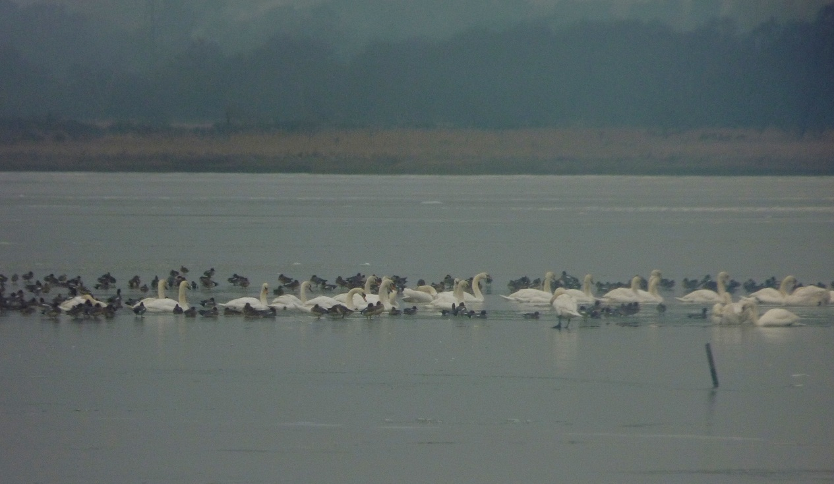

*The bay was 90% frozen on the morning 4th Feb 2012. Waterfowl concentrated in one of the remaining patches of open water. (S. Robson)*

**Greylag Goose:** (25 – 13) ****

Scarce feral wanderer. Just two records this year. 2 on 30th Mar and 4w on 13th Jul.

**Dark-bellied Brent Goose:** (86 – 13) ****

Scarce visitor. Another record year. Birds were present from 1st Jan until 5th Apr. The first returning birds were on 27th Oct and the species was recorded daily until the end of the year. 86 on 14th Jan is a record count for the Bay, the previous best being 58 on 31st Dec 2011.

|  |  |  |  |  |  |  |  |  |  |  |  |
| --- | --- | --- | --- | --- | --- | --- | --- | --- | --- | --- | --- |
| JAN | FEB | MAR | APR | MAY | JUN | JUL | AUG | SEP | OCT | NOV | DEC |
| 86 | 40 | 34 | 1 | 0 | 0 | 0 | 0 | 0 | 2 | 24 | 26 |

**Barnacle Goose:** (42 – 6)

Rare visitor. After the wild flock of 2010 and 2011 just 1 bird this year. Likely that it was a feral wanderer rather than a wild bird. 1 flew south with Canada Geese on 17th Nov.

**Canada Goose:** (145 – 21) ****

Increasingly frequent visitor.

|  |  |  |  |  |  |  |  |  |  |  |  |
| --- | --- | --- | --- | --- | --- | --- | --- | --- | --- | --- | --- |
| JAN | FEB | MAR | APR | MAY | JUN | JUL | AUG | SEP | OCT | NOV | DEC |
| 10 | 2 | n.c. | 5 | 31 | 20 | 15 | 60 | 35 | 75 | 10 | n.c. |

**Egyptian Goose:**

Third record. 3 spent some time in the Bay on 24th Mar (SR).

**Shelduck:** (645 – 548 – 21) ****

Occasional breeder and winter visitor. None bred this year. As predicted last year the recent recovery of this species has ended and in fact 2012 was the worst year on record by some distance. Compare this year’s counts to the maximum for the last 21 years.

*Bay monthly max:*

|  |  |  |  |  |  |  |  |  |  |  |  |
| --- | --- | --- | --- | --- | --- | --- | --- | --- | --- | --- | --- |
| JAN | FEB | MAR | APR | MAY | JUN | JUL | AUG | SEP | OCT | NOV | DEC |
| 15 | 5 | 25 | 14 | 10 | 2 | 11 | 0 | 0 | 2 | 4 | 5 |

**Wigeon:** (671 – 21) ****

Increasingly common winter visitor. Absent from 29th Apr until 30th Aug.

*Bay monthly max:*

|  |  |  |  |  |  |  |  |  |  |  |  |
| --- | --- | --- | --- | --- | --- | --- | --- | --- | --- | --- | --- |
| JAN | FEB | MAR | APR | MAY | JUN | JUL | AUG | SEP | OCT | NOV | DEC |
| 300 | 354 | 2 | 1 | 0 | 0 | 0 | 1 | 10 | 143 | 300 | 208 |

**Gadwall:** (73 – 16) ****

Occasional visitor. A pair took up residence on the Far Fields on 11th Apr and was present until 24th Jun (latest departure date). Breeding was not proven or thought likely. 3 birds were present on 8th May.

Recorded on 6 dates until end Mar. Max of 13 on 19th Feb. In the second half of the year there was just 1 record, 2 on 10th Sep.

**Teal:** (488 – 21) ****

Winter visitor and passage migrant. No records between 1st May and 12th Aug. The max count was on 3rd Feb.

*Bay monthly max:*

|  |  |  |  |  |  |  |  |  |  |  |  |
| --- | --- | --- | --- | --- | --- | --- | --- | --- | --- | --- | --- |
| JAN | FEB | MAR | APR | MAY | JUN | JUL | AUG | SEP | OCT | NOV | DEC |
| 124 | 316 | 200 | 100 | 5 | 0 | 0 | 76 | 70 | 100 | 288 | 88 |

*5076930 – was ringed as a male on 28th Feb 2006 at Ribeira, A’ Coruna, Spain. It was shot at Lytchett Bay 1782 days later on 15th Dec 2010. A movement of 1052km.*

**Mallard:** (106 – 21) ****

Breeds at several sites around the recording area. For the 6th year in a row a pair arrived on Sandy Close Pond in mid Feb, stayed for the spring, but did not breed.

106 on 29th Aug was an all time record count for the Bay surpassing the previous record of 100 on 31st Dec 1978.

*Bay monthly max:*

|  |  |  |  |  |  |  |  |  |  |  |  |
| --- | --- | --- | --- | --- | --- | --- | --- | --- | --- | --- | --- |
| JAN | FEB | MAR | APR | MAY | JUN | JUL | AUG | SEP | OCT | NOV | DEC |
| 10 | 8 | Br | Br | Br | Br | n.c. | 106 | 28 | 34 | 6 | 13 |

**Northern Pintail:** (21 - 13) ****

Scare visitor. Seen on 3 dates in autumn. 1 on 14th Sep, 3 on 28th Oct, 2 on 5th Nov.

**Shoveler:** (7 – 20) ****

Scarce visitor, which can occur at any time. Seen on 3 dates. 1 on 22nd Jul, 2 on 16th Oct and 3 on 4th Nov.

**Pochard:** (24 – 12) ****

Rare visitor. 1 on 2nd Nov.

**Goldeneye:** (12 – 20) ****

Declining winter visitor. After none in 2011 it was good to see this species return this year. 2 were present on both 16th and 21st Feb.

**Red-breasted Merganser:** (73 – 21) ****

Winter visitor. Recorded on 29 dates (22 in 2011,17 in 2010). Present until 2nd Apr and from 18th Nov.

An eclipse male was present from 8th – 26th Jul and was the first summer record at the Bay.

*Bay monthly max:*

|  |  |  |  |  |  |  |  |  |  |  |  |
| --- | --- | --- | --- | --- | --- | --- | --- | --- | --- | --- | --- |
| JAN | FEB | MAR | APR | MAY | JUN | JUL | AUG | SEP | OCT | NOV | DEC |
| 6 | 16 | 16 | 1 | 0 | 0 | 1 | 0 | 0 | 0 | 4 | 4 |

A 1stw female was found in a garden in Lytchett Way on 24th Dec. It had elastic wrapped around its head and bill. Having been fed overnight it was ringed and released in to the Bay on Christmas Bay. The first time this species has been ringed at the Bay.

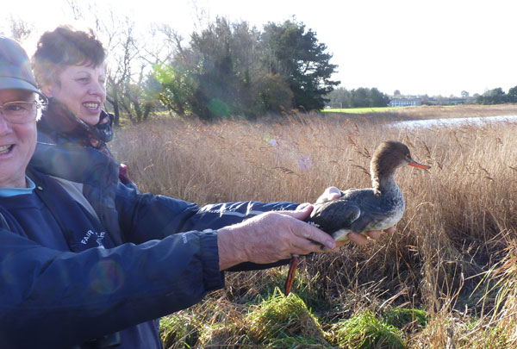

*This lucky merganser had a special Christmas present. Saved from almost certain death it was released on 25th Dec by Ian Lewis (N. Hull).*

**Goosander:** (3 – 5)

Rare visitor. A redhead was in the Bay on 21st Feb (NHo).

**Pheasant: **

Increasingly common resident. Established in all parts of the recording area.

**Little Grebe:** (12 - 21) ****

Winter visitor. Recorded until 29th Mar and from 28th Aug. Max 9 on 16th Dec.

**Great Crested Grebe;** (4 - 18) ****

Increasingly frequent visitor. Recorded on 28 dates in Jan, Feb, Apr, Jul, Aug, Sep and Oct. Max 3 on several dates.

**Cormorant:** (203 – 21) ****

Regular visitor. No significant counts.

**Bittern:** (1 – 3)

4th record. 1 was seen on Otter Island on 10th Feb (per Holton Lee log).

**Cattle Egret:**

4th record. 1 on the Far Fields on 10th – 13th Apr (PM et al).

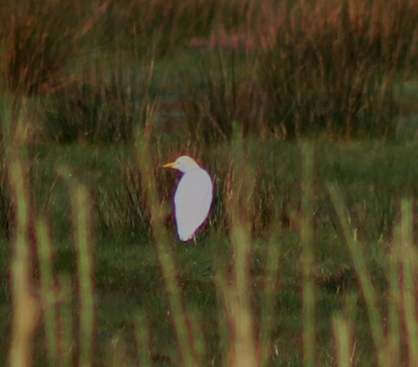

*After a flurry in 2007 and 2008 we had to wait 4 more years for our next one. This bird on 10th April started “the Morton hot streak” which produced a number of excellent sightings throughout the spring of 2012. (P.Morton)*

**Little Egret:** (29 – 20) **** Common visitor. Numbers have stabalised in recent years. 29 on 29th Sep equaled the site record for the 3rd year in a row.

*Bay monthly max:*

|  |  |  |  |  |  |  |  |  |  |  |  |
| --- | --- | --- | --- | --- | --- | --- | --- | --- | --- | --- | --- |
| JAN | FEB | MAR | APR | MAY | JUN | JUL | AUG | SEP | OCT | NOV | DEC |
| 10 | 3 | 6 | 9 | n.c. | 5 | 16 | 18 | 29 | 22 | n.c. | 6 |

**Great White Egret:**

First record for the Bay. One was seen to fly NE on 15th Apr (PM). See Appendix 1.

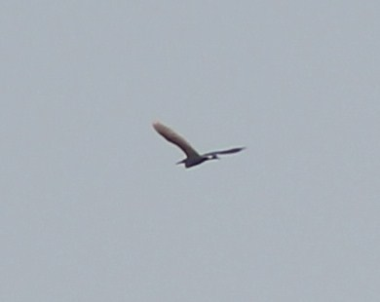

*No species has a more chequered history on the Lytchett Bay list than Great White Egret. This bird ended the wait and completed the Morton Egret hat-trick in a single week!*

*(P. Morton)*

**Grey Heron:** (10 – 21) ****

Recorded frequently throughout the year. Max 6 on several dates.

**Red Kite:** (1 – 7) ****

13th to 15th records. Three 3 spring migrants. The recent change in status of this species now means that it would be disappointing to have a blank year.

One east over the Bay and then Sandy Close Pond, a nice addition to the garden list on 23rd Mar (SR, MS). One east over the Far Fields on 25th May (SR) and another at same site on 27th May (AB).

**Marsh Harrier:** (6 – 20) ****

Irregular visitor. Another good year. Noted on 41 dates.

The roost established in 2011 continued through Jan into early Feb. Max 5 on 15th Jan. Only one in spring on 4th Mar. 4 records in Jun including 2 on 10th. The first of the autumn was on 21st Aug, 9 sightings involving at least 11 birds until end of Sep. Roosting recorded again from 10th Oct. Increased to a max of 3 by 17th Dec.

**Hen Harrier:** (2 – 20) ****

Irregular Visitor. Only one record this year, a grey male on 31st Dec (PM).

**Sparrowhawk:** (3 – 21) ****

Uncommon visitor. Recorded on 38 dates and in every month, well above the average number of annual sightings (24.9 p.a. 1992-2011). Max 3 on 23rd Oct.

**Common Buzzard:** (15 – 21) ****

The commonest raptor of the area. Breeds widely in the vicinity.

**Osprey:** (4 – 20) ****

Annual passage migrant. 2 in spring. 1 on 27th Mar and 1 on 14th Apr. Seen on 11 dates between 27th Aug and 23rd Sep. All singles except 2 on 30th and 31st Aug.

**Kestrel:** (3 – 21) ****

Frequently seen resident. Probably under recorded but only logged on 7 dates.

**Merlin:** (2 – 17) ****

Scarce winter visitor. A poor year with 1 on 7th Feb the only record.

**Hobby;** (3 – 19) ****

Irregular summer visitor. Another record year with 14 birds recorded on 13 dates. After two on 28th Apr, there were records in each month through to 19th Sep.

**Peregrine:** (2 – 20) ****

Uncommon visitor. Recorded on 15 dates. The average number of dates is 9.1 p.a. (1992 – 2011). None between 8th May and 16th Jul.

**Water Rail:** (23 – 21) ****

Common resident and winter visitor. Juveniles seen all around the Bay in summer. The 2004 breeding survey established a population estimate of more than 60 pairs in the Bay.

**Moorhen:** (12 – 21) ****

An uncommon resident. Scattered sightings from across the recording area, including pairs at Folly Pond, Far Fields and Turlin Stream.

**Oystercatcher:** (400 – 21) ****

A common winter visitor and passage migrant. Turlin Fields and Turlin Shore at high tide remain the favored locations, though more birds now remain in the bay to feed at low tide than in previous years. The maximum count was on 4th Nov.

*Bay monthly max:*

|  |  |  |  |  |  |  |  |  |  |  |  |
| --- | --- | --- | --- | --- | --- | --- | --- | --- | --- | --- | --- |
| JAN | FEB | MAR | APR | MAY | JUN | JUL | AUG | SEP | OCT | NOV | DEC |
| 120 | n.c. | 17 | 29 | 41 | 37 | 25 | 27 | 68 | 90 | 318 | 58 |

**Pied Avocet:** (327 – 20) ****

Increasingly regular winter visitor and passage migrant. Occurrence closely related with cold weather. No records between 10th Mar and 19th Nov.

*Bay monthly max:*

|  |  |  |  |  |  |  |  |  |  |  |  |
| --- | --- | --- | --- | --- | --- | --- | --- | --- | --- | --- | --- |
| JAN | FEB | MAR | APR | MAY | JUN | JUL | AUG | SEP | OCT | NOV | DEC |
| 1 | 40 | 2 | 0 | 0 | 0 | 0 | 0 | 0 | 0 | 38 | 70 |

**Ringed Plover;** (17 – 10 – 17) ****

Scarce visitor. Return passage produced 2 on 31st Aug and 1 on 4th Sep.

**Little Ringed Plover:** (5 – 10)

Scarce visitor. 2 on the Pool on 25th Mar, with one remaining the next day.

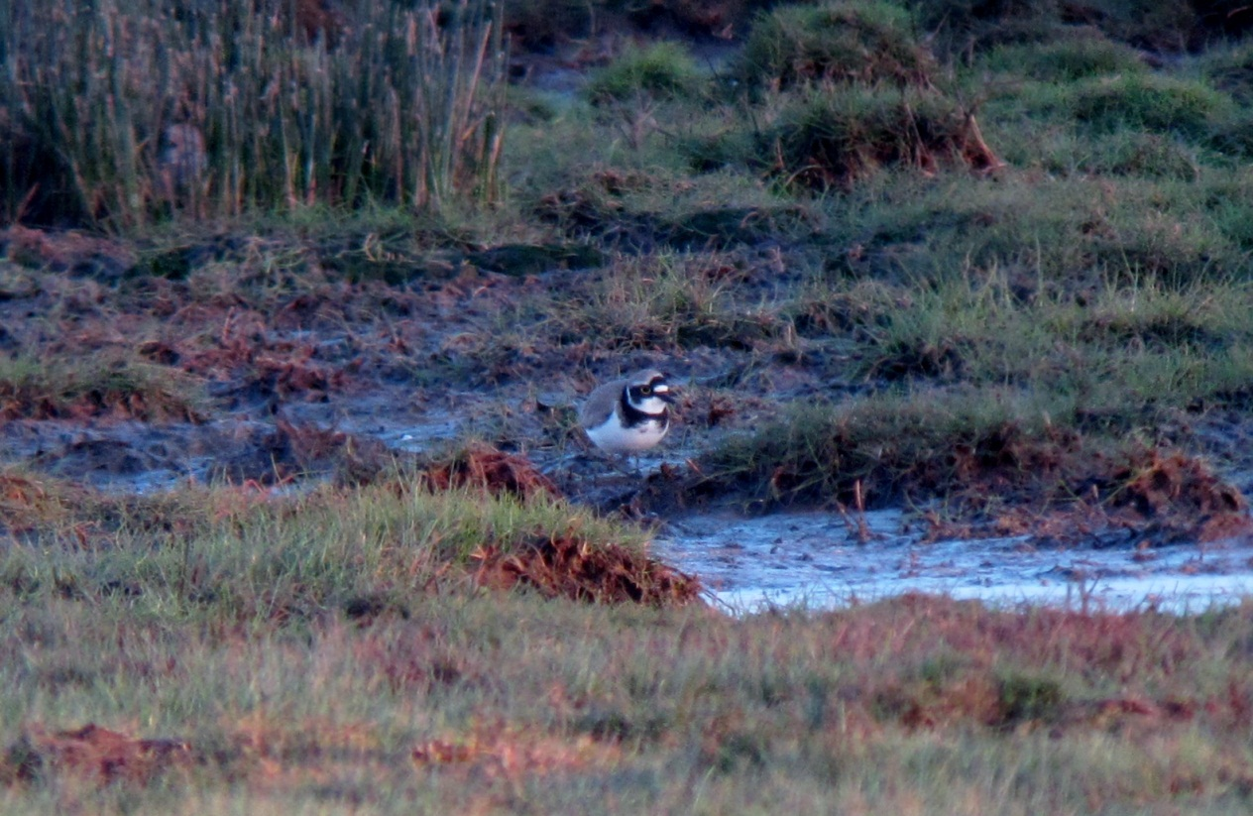 *The Pool remains “the” place for LRP at Lytchett. Early spring the time to search (S.Robson)*

**Golden Plover:** (160 – 12)

Scarce visitor. A good year with 4 records. 14 on 13th Jan, 2 on 21st Jan, 3n on 28th Sep and 2e on 27th Oct.

**Lapwing:** (3000 – 21) ****

Formerly bred, now a non breeding visitor in much smaller number. Bred regularly during early 1990’s. Last confirmed breeding 1999. A pair was noted displaying at the end of Apr into early May. Recorded daily in each winter period, signs that the declines of the last decade may now have ended? The max count was on 7th Feb.

*Bay monthly max:*

|  |  |  |  |  |  |  |  |  |  |  |  |
| --- | --- | --- | --- | --- | --- | --- | --- | --- | --- | --- | --- |
| JAN | FEB | MAR | APR | MAY | JUN | JUL | AUG | SEP | OCT | NOV | DEC |
| 600 | 815 | 0 | 4 | 2 | 0 | 13 | 22 | 24 | 61 | 138 | 280 |

**Dunlin:** (1800 – 1200 – 21) ****

Regular winter visitor and passage migrant. Numbers currently much less than 1990’s. Another decent year.

*Bay monthly max:*

|  |  |  |  |  |  |  |  |  |  |  |  |
| --- | --- | --- | --- | --- | --- | --- | --- | --- | --- | --- | --- |
| JAN | FEB | MAR | APR | MAY | JUN | JUL | AUG | SEP | OCT | NOV | DEC |
| 250 | 372 | 20 | 0 | 15 | 0 | 1 | 8 | 4 | 10 | 100 | 82 |

**Jack Snipe:** (5 - 13) ****

Scarce but under recorded winter visitor. Recorded on 2 dates. Singles on 12th Sep (the earliest return date) and 1st Dec. Both records on Far Fields.

**Snipe:** (160 – 109 – 21) ****

Winter visitor, occurs in smaller numbers than 1990’s. Recorded until 24th Mar, returning on the 9th Aug.

2012 was a very wet year and may be this contributed to what was an excellent showing by this species. Two habitats are predominantly occupied. Saltings and the Far Fields. Inward migration was particularly notable during Aug and Sep with flocks of up to 32 seen arriving from the east.

*Bay monthly max:*

|  |  |  |  |  |  |  |  |  |  |  |  |
| --- | --- | --- | --- | --- | --- | --- | --- | --- | --- | --- | --- |
| JAN | FEB | MAR | APR | MAY | JUN | JUL | AUG | SEP | OCT | NOV | DEC |
| 56 | 37 | 41 | 0 | 0 | 0 | 3 | 32 | 46 | 62 | n.c. | 81 |

**Woodcock:** (5 – 11) ****

Scarce but under recorded winter visitor. The number of records of this species is largely a reflection of the effort made to see them. They are probably present throughout each winter.

3 in Stubble Field on 15th Jan and then singles on two further dates to 16th Feb.

**Black-tailed Godwit:** (1240 – 21) ****

Common passage migrant and winter visitor. Max 420 on 2nd Oct. The species abandoned Poole Harbour for the Avon Valley toward the end of the year. The wet weather having returned the fresh water meadows to their former glory. Peak counts in the valley approached 3,500.

*Bay monthly max:*

|  |  |  |  |  |  |  |  |  |  |  |  |
| --- | --- | --- | --- | --- | --- | --- | --- | --- | --- | --- | --- |
| JAN | FEB | MAR | APR | MAY | JUN | JUL | AUG | SEP | OCT | NOV | DEC |
| 235 | 120 | 180 | 228 | 12 | 0 | 5 | 115 | 230 | 420 | 55 | 0 |

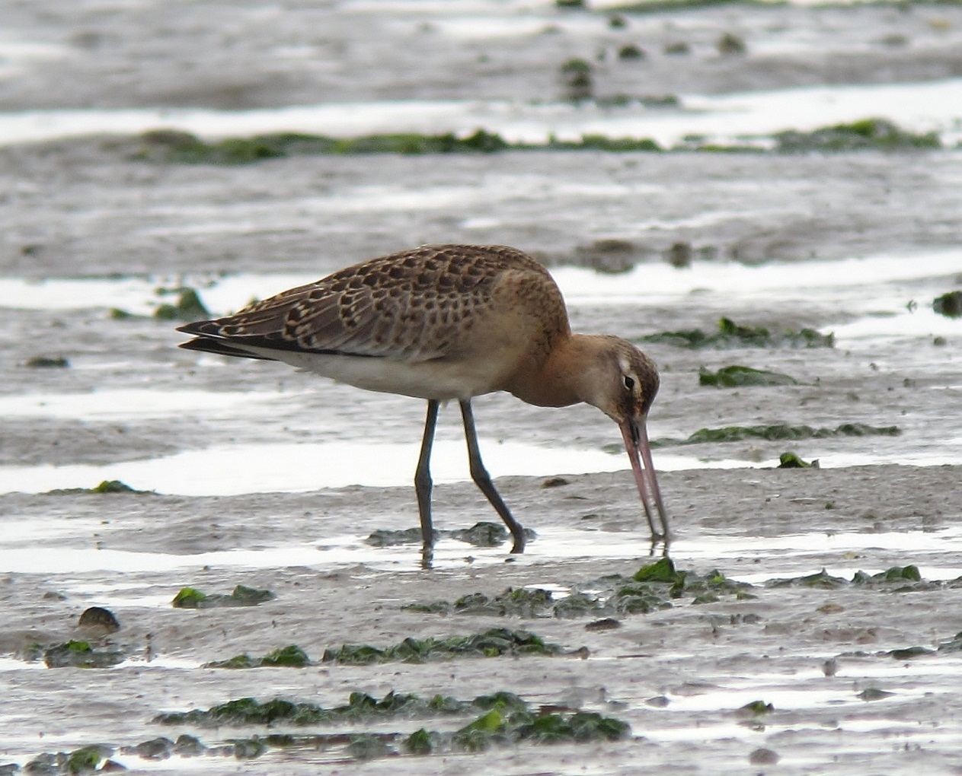

*Juvenile Black-tailed Godwit, Sept 2012, always a highlight when seen well (S. Robson)*

Over the last 20 years colour ringed birds have proved that birds visiting Lytchett Bay breed in Iceland (*L.l.islandica*)*.* Predominantly, birds seen at Lytchett Bay on migration, winter in Western France. However some have also been recorded in Portugal, Ireland, Holland, Belgium, NE England as well as many locations along the south coast.

Colour ringed birds were recorded as follows.

*LG+RO was present on 30th Aug, 16th and 28th Sep.*

*It had been ringed at Langhús, Fljót, N Iceland as an adult female on 26th June*

*2002. This bird also visited the Bay in 2006, 2007 & 2008. It has also been seen on Humberside, the Avon Valley, and Western France and wintered in Tejo Estuary, Setúbal, W Portugal in Jan 2008.*

*YOO+YRY was present on 24th Apr 2012.*

*It had been ringed on the Axe Estuary, Devon on 5th Mar 2011 as a 1st W female. It spent the summer of 2011 on the North Norfolk coast at Titchwell and Cley.*

*RG-YR was present on 16th Sep 2012.*

*It had been ringed as a pullus on 3rd Jul 2006 at Reykholar, NW Iceland. It has also been seen in the Isle of Lewis, Belfast, Staffordshire and Cheshire.*

*GY+GW(flag) was present on 19th Nov 2012.*

*It had been ringed as breeding female on 19th June 2012 at Kaldaðarnes, Árnessýsla, S Iceland. It had been at Wareham in Poole Harbour in Oct 2012.*

Left leg always given first, all rings above the tibia (unless preceded by the mark //). Recently some birds have been marked with leg flags rather than rings. Colours are:

O = Orange

L = Lime (this can look very washed out in the field, approaching white)

R = Red

W = White

Y = Yellow

G = Green

B = Blue

N = Niger

Many thanks to Pete Potts and the Farlington Ringing Group, Jose Alves and Vigfus Eyjolfsson for supplying this information.

**Bar-tailed Godwit:** (110 – 17) ****

Scare visitor. Recorded on 5 dates. 2 on 22nd Apr, 2 on 30th Apr and 1st May, 4 on 17th May and 1 on 9th Sep.

**Whimbrel:** (157 – 21) ****

Passage migrant, most numerous in spring. First was not until 19th Apr, as 2011. There were 79 bird days (59 in 2011) to the 17th May. Max 28 on 1st May. Autumn passage involved 42 bird days between 13th Jul and 14th Sep. Max 4 on 2 dates.

**Curlew:** (104 – 21) ****

Common winter visitor and passage migrant.

*Bay monthly max:*

|  |  |  |  |  |  |  |  |  |  |  |  |
| --- | --- | --- | --- | --- | --- | --- | --- | --- | --- | --- | --- |
| JAN | FEB | MAR | APR | MAY | JUN | JUL | AUG | SEP | OCT | NOV | DEC |
| 58 | 24 | 28 | 54 | 6 | 6 | 64 | 46 | 53 | 22 | 43 | 49 |

This species showed a significant change in its high tide behavior. Whereas birds were in the past rare on the Pool, this changed from mid Sep. Presumably the sodden ground enabled more effective probing and feeding? Max 17 on 14th Dec.

**Common Sandpiper:** (10 – 21) ****

Uncommon passage migrant. Recorded on 2 dates in spring. After 1 on 22nd Apr, warm damp weather brought a fall of migrants on 1st May. 3 were on the Turlin Shore and a fourth visited Sandy Close Pond before flying off up the street calling!

There was 22 bird days between 8th Jul and 21st Sep. Max 5 on 8th Jul.

**Green Sandpiper:** (14 – 21) ****

Common autumn migrant and winter visitor, occasional in spring. The Far Fields and western most part of the Bay are the favoured sites. Up to 2 present from the beginning of the year until 19th Apr. The first returning bird was on 5th Jul. After this, birds were seen on most visits until the year end. 14 on 30th Aug was a record for the Bay surpassing 10 on 14th Aug 2004.

*Monthly max:*

|  |  |  |  |  |  |  |  |  |  |  |  |
| --- | --- | --- | --- | --- | --- | --- | --- | --- | --- | --- | --- |
| JAN | FEB | MAR | APR | MAY | JUN | JUL | AUG | SEP | OCT | NOV | DEC |
| 2 | 1 | 2 | 1 | 0 | 0 | 5 | 14 | 5 | 5 | 3 | 3 |

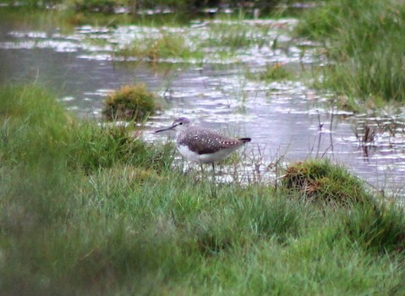

*A record year for this increasingly common Tringa. (P. Morton)*

**Spotted Redshank:** (68 – 42 – 21) ****

Declining passage migrant and scarce winter visitor. Recorded only 15 dates (18 in 2011). As recently as 1998 the species was typically recorded on 148 dates.

2 on 19th Nov was the only date with more than 1. The worst year on record.

*Bay monthly max*

|  |  |  |  |  |  |  |  |  |  |  |  |
| --- | --- | --- | --- | --- | --- | --- | --- | --- | --- | --- | --- |
| JAN | FEB | MAR | APR | MAY | JUN | JUL | AUG | SEP | OCT | NOV | DEC |
| 0 | 1 | 0 | 1 | 0 | 0 | 0 | 1 | 1 | 1 | 2 | 0 |

**Greenshank:** (49 – 27 – 21) ****

Common passage migrant and winter visitor. Recorded on 116 dates. Recorded until 11th May, max 5 on 18th Mar. The first returning bird was noted on the 8th Jul. Max 15 on 10th Sep.

Away from the Bay itself birds were regularly found on the Sherford Pools and Far Fields. The Pool is used less frequently, no doubt due to the increased availability of these alternatives.

*Pool monthly max;*

|  |  |  |  |  |  |  |  |  |  |  |  |
| --- | --- | --- | --- | --- | --- | --- | --- | --- | --- | --- | --- |
| JAN | FEB | MAR | APR | MAY | JUN | JUL | AUG | SEP | OCT | NOV | DEC |
| 0 | 0 | 0 | 3 | 0 | 0 | 0 | 2 | 1 | 1 | 0 | 3 |

*Bay monthly max:*

|  |  |  |  |  |  |  |  |  |  |  |  |
| --- | --- | --- | --- | --- | --- | --- | --- | --- | --- | --- | --- |
| JAN | FEB | MAR | APR | MAY | JUN | JUL | AUG | SEP | OCT | NOV | DEC |
| 3 | 3 | 5 | 2 | 1 | 0 | 4 | 12 | 15 | 9 | 3 | 6 |

**Wood Sandpiper:** (2 – 9)

Very scarce migrant. Another good year with 2 on 21st Aug (KEL) and 1 on 30th Aug (TE, KEL). Typically elusive preferring grazed pools within the reed bed.

**Redshank:** (608 – 436 – 21) ****

Common winter visitor with small breeding population on salt marsh. Unlike Greenshank the Pool was used, with a max of 108 in Dec. The monthly figures obscure the disappearance of this species from mid July to late Aug which occurs each year.

*Bay monthly max:*

|  |  |  |  |  |  |  |  |  |  |  |  |
| --- | --- | --- | --- | --- | --- | --- | --- | --- | --- | --- | --- |
| JAN | FEB | MAR | APR | MAY | JUN | JUL | AUG | SEP | OCT | NOV | DEC |
| 100 | 112 | 200 | 30 | Br | Br | 6 | 2 | 91 | 162 | 87 | 108 |

*The colour ringed bird, Y/R + B, seen on two dates in Nov 2011 has not been traced to a colour ringing scheme.*

**Ruddy Turnstone:** (9 – 3)

3rd record. 9 were roosting on Turlin Point on 2nd Nov. Three times the previous record count!

**Black-headed Gull:** (12000 – 7000 – 21) ****

A very common visitor. 1000’s regularly frequent the bay en route to the Wareham Channel roost. The first juveniles were noted on 8th Jul. 2 ringed at Sandy Close Pond.

*An Ad bird seen on the 3rd Feb bore a white ring with three black digits. This enabled it to be assigned to a Danish ringing scheme.*

**Mediterranean Gull:** (37 – 20) ****

Spring and early summer visitor, occasional at other times. The explosion in this species population in Britain continues.

The peak occurrence at the Bay is during the period when pairs are establishing territories at the breeding islands in the Wareham Channel. This is quite different to other parts of Poole Harbour where maxima occur after the breeding season.

Assessing bird days between Mar and Jun was again impossible due to abundance of bird movements. Max count was on 17th Apr. There no records after 13th Jul.

*Monthly max:*

|  |  |  |  |  |  |  |  |  |  |  |  |
| --- | --- | --- | --- | --- | --- | --- | --- | --- | --- | --- | --- |
| JAN | FEB | MAR | APR | MAY | JUN | JUL | AUG | SEP | OCT | NOV | DEC |
| 1 | 2 | 15 | 30 | 6 | 5 | 10 | 0 | 0 | 0 | 0 | 0 |

**Common Gull:** (3000 – 21) ****

A common winter visitor and passage migrant, especially in spring. The last birds of winter were seen on 26th Apr. The first returning bird was on 18th Jul. No specific counts this year.

**Lesser Black backed Gull:** (2128 – 21) ****

Abundant autumn and common spring passage migrant and uncommon winter visitor. Rarely counted.

**Herring Gull:** (2500 – 21) ****

Common winter visitor and passage migrant. First breeding record. A pair raised two young on the roof of a domestic house at Shore Ave (NHu, JH). No counts made this year.

**Yellow legged Gull:** (65 – 20) ****

Frequent visitor, peaking in summer. Under recorded.

*Bay monthly max:*

|  |  |  |  |  |  |  |  |  |  |  |  |
| --- | --- | --- | --- | --- | --- | --- | --- | --- | --- | --- | --- |
| JAN | FEB | MAR | APR | MAY | JUN | JUL | AUG | SEP | OCT | NOV | DEC |
| 1 | 0 | 0 | 1 | 0 | 0 | 1 | 3 | 8 | 6 | 2 | 0 |

**Great Black backed Gull:** (151 – 21) ****

Daily visitor throughout the year in small numbers.

**Sandwich Tern:** (5 – 21) ****

Uncommon summer visitor. Seen on 19 dates between 24th Mar and 9th Oct. Max 5 on 23rd and 28th Sep equaled the record count for the Bay.

**Common Tern:** (25 – 21) ****

Uncommon summer visitor. An good year with records on 27 dates between 30th Jun and 13th Sep. Max 5 on 14th Jul.

**Stock Dove:** (29 – 21) ** **

Uncommon Resident. Max 6 on 13th Jul.

**Wood Pigeon:** (10,246 – 21) ****

Common resident and autumn migrant. 1095 w on 6th Nov was the only notable flight. 1 ringed.

**Collared Dove:** (14 – 21) ****

Uncommon resident. No specific records submitted but no change in status.

**Cuckoo:** (2 – 20) ****

Scarce visitor in spring. After none in 2011 it was good hear this species song again. Recorded on 7 dates between 27th Apr and 16th Jun. All records except 1 at Border Road coming from the western side of the Bay.

**Barn Owl:** (2 – 13) ****

Recent breeder. The nest box at French’s Farm has been removed. One at Policeman’s Lane on 4th Dec was the only record.

**Tawny Owl:** (2 – 21) ****

Uncommon resident. Seems to be declining at the Bay? Confirmed to have bred at the Water Works when 2 fledglings were photographed on 24th May (PM). The only other records came from Sandy Close, occasionally throughout the year.

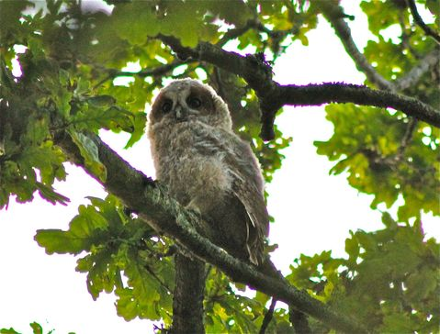

*Juvenile Tawny Owl, May 2012 (P. Morton)*

**Nightjar:** (3 – 12) ****

Irregular breeder. At least 1 pair present during breeding season. The only other record was one over the Far Fields on 13th Sep.

**Swift:** (113 – 21) ****

Passage migrant and possible local breeder. First seen on 28th Apr with 35 over Far Fields. Then recorded regularly until 28th Aug (latest departure date). No other counts greater than 30.

**Kingfisher:** (3 – 21) ****

Passage migrant and uncommon winter visitor. Bred in 2000. No records between 19th Feb and 22nd Jul. 6 ringed.

**Green Woodpecker: **

Breeding resident. Bred successfully and recorded in all parts of the Bay. No change in status.

**Great Spotted Woodpecker: **

Breeding Resident. Seen regularly in most parts of the Bay. Drumming heard in most areas during spring and two nests found. 6 ringed.

*LB33006 – a 1stW bird ringed at Sandy Close Pond on 19th Dec 2009 was found dead at Upton Country Park, 904 days later on 10th Jun 2012. A movement of 2km.*

**Skylark:** (781 - 21) ****

Scarce breeder and passage migrant. 1 or 2 territories established and held throughout the spring. Only 1 early winter record, a single on Saltings on 21st Jan. A very poor autumn passage. 3 birds were back in stubble by the year end.

**Sand Martin:** (5000 – 21) ****

Common passage migrant. First record was 28th Mar. The last record of the year was on 26th Sep. Max 30 on 1st May roosting on Turlin Shore. 7 ringed.

**Swallow:** (1000 – 800 – 21) ****

Common passage migrant, breeds at French’s Farm. Recorded from 6th Apr until 4th Nov (latest departure date). Max numbers occurred in autumn, peaking at 800 on 7th Sep, the biggest count in the period since 1992. 127 ringed.

*V800359 – A pullus ringed on 11th Aug 2012 at Spetisbury, Dorset, was re-trapped at Lytchett Bay 27 days later on 7th Sep. A movement of 11km.*

*Y962055 – A pullus ringed on 25th Jun 2012 at South Wingfield, Derbyshire, was re-trapped at Lytchett Bay 80 days later on 13th Sep. A movement of 267km.*

**House Martin:** (1800 – 21) ****

Common passage migrant, breeding colonies on edge of recording area at Watery Lane and Turlin Moor. First noted on 27th Apr. The Watery Lane colony collapsed this year with only 2 nests. 4 additional nests were found nearby in an area that had not been previously monitored. The colony at Turlin Moor was not surveyed. Autumn passage peaked at 200 on 12th Sep and the last bird being seen on 10th Oct.

No of House Martin nests at the Watery Lane colony 2003 – 2012. No of nest collapsed or destroyed in brackets.

|  |  |  |  |  |  |  |  |  |  |
| --- | --- | --- | --- | --- | --- | --- | --- | --- | --- |
| 2003 | 2004 | 2005 | 2006 | 2007 | 2008 | 2009 | 2010 | 2011 | 2012 |
| 13 (9) | 15 (4) | 15 (5) | 16 (6) | 14 (5) | 13 (8) | 15 (5) | 8 (7) | 13 (4) | 2 (0) |

**Tree Pipit:** (10 – 17) ****

Scarce passage migrant. Birds started roosting in the un-harvested maize crop in late Aug and this led to a record year with 47 bird days between 23rd Aug and 21st Sep. Max 10 on 17th Sep, a record count surpassing 6 on 28th Aug 1994. 1 ringed.

**Meadow Pipit:** (167 – 21) ****

Breeding resident and common passage migrant. Autumn passage was unremarkable and peaked at 45 on 28th Sep. 3 ringed.

**Rock Pipit:** (50 – 21) ****

Common winter visitor. Recorded until 18th Mar and from 28th Oct. Common on saltings throughout the winter. No surveys undertaken.

**Water Pipit:** (20 – 15)

Scarce winter visitor. At least one was on the Far Fields on 2nd and 9th Dec. The nature of the rushy habitat made observation very difficult and it is likely that more than one bird was present and that the species was present throughout the month.

**Yellow Wagtail:** (90 – 21) ****

Uncommon passage migrant. 2 spring records. Singles on 1st and 5th May. Autumn migration started on 25th Aug and was even better than last year’s record with 512 bird days until 6th Oct (latest departure date). Max 72 on 4th Sep. 10 ringed.

**Grey Wagtail:** (12 – 21) ****

Winter visitor, passage migrant and occasional breeder. 1 pair may have bred. Autumn passage was obvious across the whole area but numbers were typically low.

**Pied Wagtail:** (500 – 21) ****

Recorded throughout the year, common in autumn. Bred successfully. Birds roost at various points around the Bay during peak migration in October. Autumn roost peaked on 10th Oct with at least 500, a record count. 233 ringed.

**Wren: **

Common resident. 10 ringed.

**Dunnock: **

Common resident. 6 ringed.

**Robin: **

Common resident. The Big Bird Count on 21st Jan produced a Bay total of 21. 10 ringed.

**Nightingale:**

Second record. A singing male was at Border Road during a good spring fall on 1st May (SR). The only other record was way back in 1970 when two local school boy birders, Ewan Brodie and Roger Howell, found one near the allotments on Slough Lane.

**Common Redstart:** (2 – 14) ****

Scarce autumn migrant. Unusually more seen in spring than autumn. A male near the Pool on 5th Apr. A female at Border Road on 2nd May. The only autumn record was one at Sandy Close Pond on 31st Aug.

**Whinchat:** (11 – 19) ****

Scarce passage migrant. 3 on the Far Fields on 4th May were truly exceptional. Another poor autumn. Seen on only 3 dates between 31st Aug and 7th Oct. Max 3 on 31st Aug. All birds were on the Far Fields except one at Lytchett Way.

**Stonechat:** (23 – 21) ****

Past common breeding resident (7 pairs in 2002), recently changed status to uncommon migrant. Another dreadful year. Recorded on only 16 visits (17 in 2011, 34 in 2010, 19 in 2009, 35 in 2008). 4 spring records between 6th Mar and 27th Apr. In autumn between 25th Jun and 2nd Dec. Max 3 on 3rd Sep. 1 ringed.

**Northern Wheatear:** (15 – 21) ****

Uncommon passage migrant. 20 bird days in spring between 20th Mar and 8th May. Max 12 on 27th Apr. These included a male Greenland Wheatear. 1 ringed.

A very poor autumn with only 2 birds. Easily the worst autumn on record. 1 on 31st Aug and 1 on 7th Oct.

**Blackbird:** (45 – 21) ****

Common Resident. A minor movement in Oct included 13n on 23rd. 4 ringed.

**Fieldfare:** (258 – 21) ****

Uncommon winter visitor. Scarce in the first part of the year. The first record in autumn occurred as part of the large thrush flight on 23rd Oct, 32n. There were two further northward movements of similar magnitude on 26th Oct and 5th Nov.

**Song Thrush:** (1256 – 21) ****

Breeding resident. A complete breeding survey found 11 territories.

The best thrush flight ever recorded at the Bay occurred on 23rd Oct at Border Road. The majority of birds were Song Thrush and Redwing yet many were silent and flying at some height. Of 400 specifically identified 356 were Song Thrush. In addition a further 1029 Song Thrush or Redwing was counted. Applying the same % breakdown it is reasonable to conclude that 900 were Song Thrush giving an amazing total of 1256n. The previous best was 473 on 11th Oct 2010.

In the late winter up to 20 birds used the uncut maize crop for cover. 6 ringed.

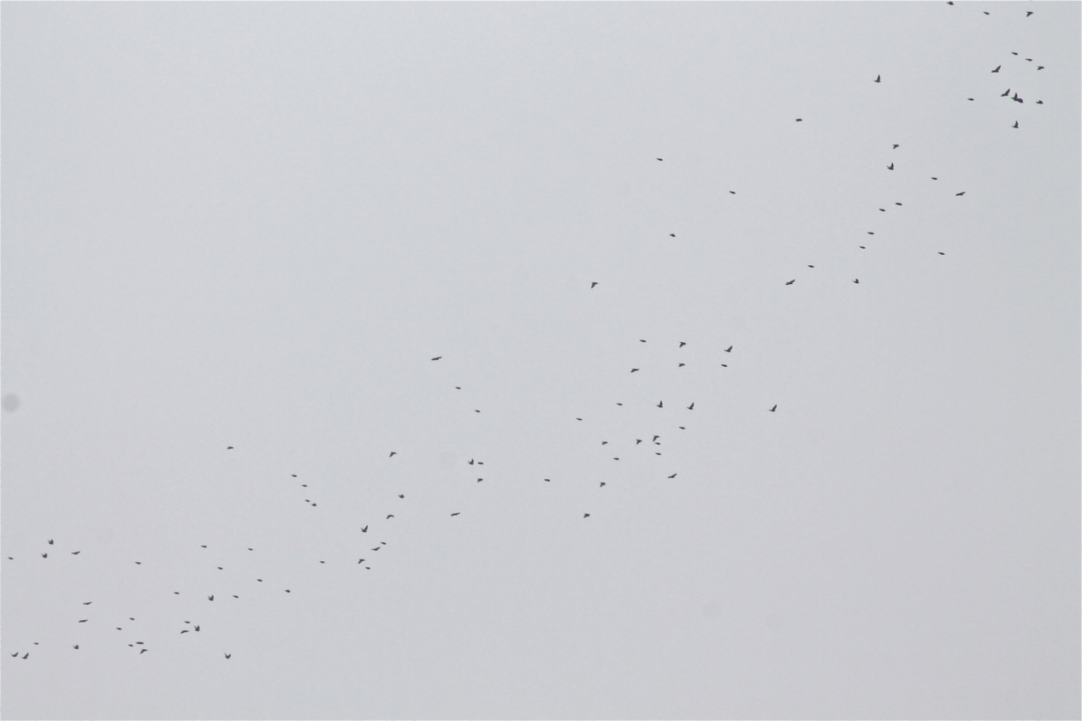

*Thrushes pour north during the best morning flight ever witnessed at Border Rd, 23rd Oct 2012 (P. Morton)*

**Redwing:** (1000 – 514 – 21) ****

Winter visitor. Occasionally seen during the first winter period but not after mid Feb. First returning bird was on 10th Oct. 43n were specifically identified on 23rd Oct, with a further 130 likely to have been this species. The following day a secondary flight produced 150n. Subsequent movements included 62n on 5th Nov and 38n on 28th Nov.

**Mistle Thrush:** (60 - 16 – 21) ****

Uncommon resident. Outrageously scarce for the third year in a row. Only 2 records both of singles before autumn. Only 10 bird days between 21st Oct and the end of the year.

**Cetti's Warbler:** (11 males – 20) ****

Breeding resident. As few as 4 territories (5 in 2011, 9 in 2010). Present at Sandy Close Pond outside the breeding season at both ends of the year but only on single dates. 3 ringed.

**Grasshopper Warbler:** (7 – 14) ****

Passage migrant, under recorded. 1 reeling bird at Chad’s Copse found during the fall on 1st May. A very poor autumn with only 2 birds both on 31st Aug. 2 ringed.

**Aquatic Warbler:** (2 – 3)

4th and 5th records for the Bay. Two 1st W birds were trapped and ringed on the 18th Aug (SB, RG, SR et al). Both Birds were caught on the same round and were within 3m of each other in the same net.

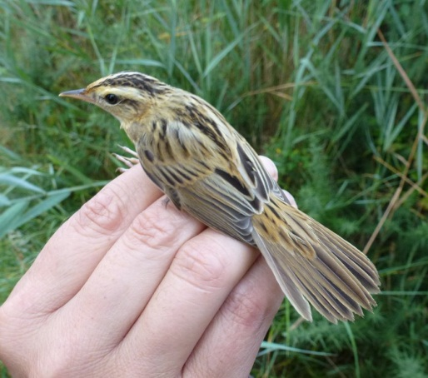 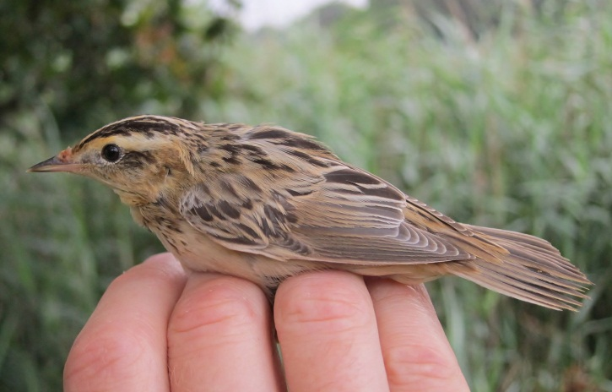

*South-easterly winds again produced the goods in August. (T. Elborn left, S Robson right)*

In total, 10 of this internationally red listed species were reported in the UK in 2012.

**Sedge Warbler:** (96 – 21) ****

Passage migrant. Spring passage was poor with only 6 birds between 28th Apr and 22nd May. In autumn 245 between 14th Jul and 6th Oct. Max 54 on 31st Aug.

Daily max and bird days are given in the following table.

|  |  |  |  |  |  |  |  |  |  |  |  |
| --- | --- | --- | --- | --- | --- | --- | --- | --- | --- | --- | --- |
| JAN | FEB | MAR | APR | MAY | JUN | JUL | AUG | SEP | OCT | NOV | DEC |
|  |  |  | 1 | 2 |  | 15 | 54 | 16 |  |  |  |
|  |  |  | 1 | 5 |  | 20 | 179 | 46 |  |  |  |

*L517544 – A 1stW bird ringed on 6th Aug 2011 at Lytchett Bay, was photographed in the field and the ring read at Tias, Lanzarote, Canary Islands, 282 days later on 14th May 2012. A movement of 2613km. (See article in Appendix 3).*

Three south coast movements, all west to east.

*L517379 – A 1stW bird ringed on 5th Aug 2011 at Lytchett Bay, was re-trapped at Icklesham, East Sussex the following day on 6th Aug 2011. A movement of 192km.*

*Y251697 – A 1stW bird ringed on 1st Sep 2011 at Lytchett Bay, was re-trapped at Icklesham, East Sussex, 4 days later on 5th Sep 2011. A movement of 192km.*

*Y752811 – A 1stW bird ringed on 30th Aug 2012 at Gunwalloe, Cornwall was re-trapped at Lytchett Bay 9 days later on 8th Sep 2012. A movement of 241km.*

More typical exchanges between Lytchett and France

*6280028 – Was ringed on 15th Aug 2009 at Saint-Vigor-d'Ymonville, Seine-Maritim, France, was re-trapped at Lytchett Bay, 725 days later on 10th Aug 2011 as an Ad female. A movement of 221km.*

*V810673 – A 1stW bird ringed on 18th Aug 2009 at Lytchett Bay, was re-trapped at Tour aux, Moutons, Loire Atlantique, France, 723 days later on 11th Aug 2011. A movement of 380km.*

*L517952 – A 1stW bird ringed on 14th Aug 2012 at Lytchett Bay, was re-trapped at Finistere, Treogat, Trunval, France, 8 days later on 22nd Aug 2012. A movement of 352km.*

*Y251624 – A 1stW bird ringed on 30th Aug 2011 at Lytchett Bay, was re-trapped at Tour aux, Moutons, Loire Atlantique, France, 14 days later on 13th Sep 2011. A movement of 380km.*

Two further movements….

*Y251157 – A 1stW bird ringed on 24th Aug 2011 at Lytchett Bay, was re-trapped at Thornham, Norfolk 301 days later on 20th June 2012. A movement of 306km.*

*Y895417 – A 1stW bird ringed on 26th Aug 2012 at Stalbridge, Dorset, was re-trapped at Lytchett Bay, 13 days later on 8th Sep 2012. A movement of 35km.*

**Reed Warbler:** (84 males – 21)  ****

Common summer visitor. Present between 10th Apr and 10th Oct. No survey undertaken but status unchanged. 77 ringed.

**Dartford Warbler:** (2 pairs – 19) ****

Breeding resident. All records from Lytchett Heath where the species may have bred. 1 on 16th Apr, 1st May, 18th Jul and then regularly during Oct.

**Whitethroat:** (8 – 19) ****

Uncommon passage migrant. A very good spring. 19 bird days between 1st May and 5th Jun. Max 6 on 4th May. 10 bird days in autumn between 21st Jul and 24th Sep. Max 2 on 31st Aug. 5 on ringed.

**Garden Warbler:** (5 – 19) ****

Scarce passage migrant. 2 on 4th May was a good spring record. Autumn was poor with only two records. 1 at Turlin Moor on 13th Aug and one at Border Road on 28th Aug.

**Blackcap:** (13 – 21) ****

Passage migrant, summer visitor and scarce winter visitor. A survey found 10 territories during the breeding season. Scarce during the first winter period at Sandy Close Pond with only 2 sightings of a male in Jan. The first presumed migrant was on 24thMar. Autumn migration was unremarkable. The best day count was 8 on 6th Oct. with the last record being on 28th Oct. A single wintering bird back at Sandy Close Pond on two dates in Dec. 4 ringed.

Daily max and bird days are given in the following table.

|  |  |  |  |  |  |  |  |  |  |  |  |
| --- | --- | --- | --- | --- | --- | --- | --- | --- | --- | --- | --- |
| JAN | FEB | MAR | APR | MAY | JUN | JUL | AUG | SEP | OCT | NOV | DEC |
| 1 |  | 1 | 4 | b | b | b | 4 | 3 | 8 | 0 | 1 |
| w |  | 4 | 20 | b | b | b | 11 | 17 | 19 | 0 | w |

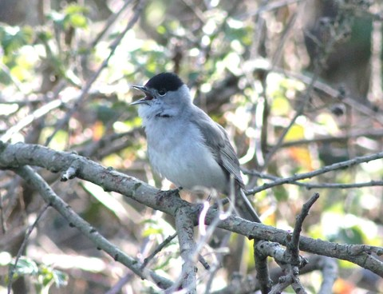

*Breeding pairs of this tuneful Sylvia continue to increase but passage migrants seem to largely by pass Lytchett. (P. Morton)*

**Chiffchaff:** (42 – 21) ****

Breeding summer visitor and passage migrant. An incomplete survey found 11 breeding territories. 3 records in the first winter period. At Sandy Close Pond on 7th Jan and at Lytchett Way on 13th and 21st Jan. The first spring migrant was on 17th Mar. The best day was the 5th Apr with 11. Autumn migration was excellent for the second year in a row. Max 27 on 6th Oct. The last bird of the year was on 6th Nov. 12 ringed.

Daily max and bird days are given in the following table.

|  |  |  |  |  |  |  |  |  |  |  |  |
| --- | --- | --- | --- | --- | --- | --- | --- | --- | --- | --- | --- |
| JAN | FEB | MAR | APR | MAY | JUN | JUL | AUG | SEP | OCT | NOV | DEC |
| 1 |  | 7 | 11 | b | b | b | 22 | 24 | 27 | 1 |  |
| 3 |  | 20 | 28 | b | b | b | 41 | 100 | 70 | 1 |  |

**Willow Warbler:** (23 – 21) ****

Breeding summer visitor and passage migrant. Looks like this species has been lost a local breeder, none have held territory since 2009. The first record was on 3rd Apr. Spring migration was dreadful. Only recorded on 4 dates. Max 8 on 4th May. Autumn migration started on 21st Jul and lasted until 17th Sep. Generally poor, max 6 on 23rd and 24th Aug. 7 ringed.

Daily max and bird days are given in the following table.

|  |  |  |  |  |  |  |  |  |  |  |  |
| --- | --- | --- | --- | --- | --- | --- | --- | --- | --- | --- | --- |
| JAN | FEB | MAR | APR | MAY | JUN | JUL | AUG | SEP | OCT | NOV | DEC |
|  |  |  | 3 | 8 |  | 2 | 6 | 1 |  |  |  |
|  |  |  | 5 | 8 |  | 5 | 46 | 5 |  |  |  |

**Goldcrest:** (14 – 21) ****

Passage migrant, which occasionally breeds. Singing males were present at 4 locations during late Apr and May. These were presumably breeding. 3 ringed.

Daily max and bird days are given in the following table.

|  |  |  |  |  |  |  |  |  |  |  |  |
| --- | --- | --- | --- | --- | --- | --- | --- | --- | --- | --- | --- |
| JAN | FEB | MAR | APR | MAY | JUN | JUL | AUG | SEP | OCT | NOV | DEC |
| 5 |  | 1 | b | b | b |  |  | 3 | 10 | 2 | 2 |
| 9 |  | 1 | b | b | b |  |  | 12 | 49 | 4 | 4 |

**Spotted Flycatcher:** (8 – 6 – 21) ****

Passage migrant, previously bred. Another poor year. 2 at Turlin Moor on 9th Sep and 1 at the Cottage on 19th Sep. The best year in the last 21 was 2002 when there were 40 bird days in autumn.

**Bearded Tit:** (33 – 21) ****

Rare breeder and scarce passage migrant. No survey took place and there were no incidental records during the breeding season. 6 were seen in Jan. Scarce in autumn with a max count of 8 on 6th Oct.

**Long tailed Tit: **

Common resident. Regularly recorded from most sites at the Bay.

**Coal Tit: **

Uncommon resident, increasing. Recorded from most sites this year across the calendar. 1 ringed.

**Blue Tit: **

Common resident. 41 ringed.

**Great Tit: **

Common resident. 27 ringed.

**Nuthatch: **

Uncommon. Regularly seen between 17th Jun and the end of the year. All records from Sandy Close Pond or the Cottage – Water Works area. Max 2 at Sandy Close Pond on 6th Oct.

**Treecreeper: **

Uncommon. Only recorded on 5 dates in Jan, Mar, Sep and Dec.

**Jay:** (12 – 21) ****

Resident. Regularly seen throughout the year but most often in autumn. 2012 was a year of Jay migration. Hints of this were seen at Lytchett when high flying Jays were seen in Oct. 6 on 4th and 12 on 6th. The latter was a max count for the Bay.

**Magpie: **

Common Resident. 1 ringed.

**Jackdaw:** (205 – 21) ****

Resident. Recorded throughout the year. Very common in autumn around French’s Farm. Max 130 on 23rd Sep. Hints of migration were noted with 102nw over Border Road on 21st Oct and 83w at Lytchett Way on 28th Oct.

**Rook:** (185 – 21) ****

Breeds on edge of recording area. 22 nests at the Watery Lane colony (20 in 2011, 16 in 2010).

**Carrion Crow:** (100 – 21) ****

Common Resident, increasing. Large numbers seem now to be present throughout the year. 65 were on the Far Fields on 14th Jan. Birds were attracted to the harvested maize field throughout the autumn. Discarded corn on the cob could be found across the whole recording area!

**Raven:** (7 – 18) ****

Irregular visitor. Annual since the first record in 1995. 33 bird days on 21 dates throughout the year. Max 4 on 2nd Oct.

**Starling:** (35000 – 5600 – 21) ****

Common resident**.** No big numbers this year. Max 350 on 24th Oct. 5 ringed.

**House Sparrow:** (85 – 21) ****

Resident. Usually recorded around the urban fringe. Bred at Turlin Moor, Border Road and French’s Farm. Max 40 at Turlin on 8th Sep. 5 ringed.

**Chaffinch:** (450 – 21) ****

Breeding resident and winter visitor. Few in the first winter period. 130n over Border Road on 23rd Oct was a good visible migration count. The abandoned maize crop pulled in more and more birds as winter developed. At least 450 were present on 8th Dec, a week before the crop was unnecessarily cut. This is more than 3 times the previous best count. By the year end only 50 remained in naked stubble. 2 ringed.

**Brambling:** (10 – 18) ****

Scarce Visitor. The first record was not until autumn. Singles north over Border Road on 23rd and 24th Oct. Another north over same site on 6th Nov. In between times 1 was in the maize on 4th Nov, increasing to 10 by 30th Nov. A record count for the Bay. None were seen after 8th Dec.

**Greenfinch:** (60 – 21) ****

Common breeding resident, which appears to be declining. Border Drive, Turlin Moor and Stubble Field were the favored areas. Max 25 in maize on 8th Dec. 7 ringed.

*NC89840 – An Ad female bird ringed at Sandy Close Pond on 3rd Jan 2010 was found dead in a garden in Hamworthy, Poole, 964 days later on 24th Aug 2012. A movement of 2km.*

**Goldfinch:** (120 – 21) ****

Uncommon breeding resident and passage migrant. Flocks frequently recorded in the autumn, max 30 - 50 at Turlin Moor, Border Road and the Stubble Field. 11 ringed.

*Y251820 - A juvenile bird ringed on 14th Sep 2011 at Lytchett Bay was killed by flying into a window in Merley, Poole, Dorset 424 days later on 11th Nov 2012. A movement of 7km.*

**Siskin:** (280 – 18) ****

Passage migrant and occasional winter visitor. After odd birds in winter and occasional sightings at Sandy Close Pond feeders up to 28th Apr it was surprise to have birds back there between 21st and 24th Jun. Suggesting local breeding. Autumn migration from 6th Sep to the 7th Nov. 85 bird days, max 12 on 3 dates. 1 ringed.

**Linnet:** (250 – 21) ****

Uncommon breeding resident. Possibly bred at 2 sites. The traditional roost at Lytchett Way was used in both winter periods. Max 156 on 21st Jan and 60 on 28th Sep. In spring the Stubble Field attracted a good flock. Max 200 on 4th Apr. Thin on the ground in late autumn. 1 ringed.

**Lesser Redpoll:** (40 – 17) ****

Scarce passage migrant. A poor year with only 7 bird days between 7th Jul and 5th Nov.

**Crossbill:** (21 – 7)

Rare visitor. A record breaking year. 21ne over Far Fields on 14th Jul, 15 over Far Fields on 17th Jul, 1 over Stubble Field on 23rd Sep and finally 1n over Border Road on 9th Oct.

**Bullfinch:** (11 – 21) ****

Uncommon but increasing. Like 2011, widely recorded across the area throughout the year. Max 8 at Sandy Close Pond on 17th June. 5 ringed.

**Reed Bunting:** (110 – 21) ****

Breeding resident. No breeding survey but no reason to suspect any change from 2011 when 23 singing males were present. Following the discovery of a reed bed roost in 2011 further effort was made to monitor these in 2012. 4 roosts were monitored producing totals of 42, 26, 21 and 27 during Jan. The winter population is therefore estimated to be in the region of 110 birds. Visited feeders at Sandy Close Pond on regular basis throughout the year. 25 ringed.

*L174025 – a 1stW bird ringed at Hengistbury Head, Dorset on 6th Aug 2011 was re-trapped 91 days later at Lytchett Bay on 5th Nov 2011. A movement of 21km.*

*Y512298 – An Ad male ringed at Longham Lakes, Dorset on 28th May 2012 was re-trapped 103 days later at Lytchett Bay on 8th Sep 2012. A movement of 11km.*

List of contributors: I Alexander, D Bandfield, A Brown, M Constantine, S. Davis, J.Dowling, T Elborn, M Gould, R Gifford, N Hopper, R. Howell, J Hull, N. Hull, K E Lane, P Levey, I M Lewis, P Morton, B.J. Robson, S Robson, M. Smith, S.W. Smith, S Walls, R Webb, D White and L Woodford. With additional information from Holton Lee log, Birdguides, RSPB and the Dorset Bird Club.

**Appendix 1**

**Great White Egret, 15th April 2012, the first record for Lytchett Bay**

At around 08:15am on the 15th of April 2012 I was walking around the far fields that sit to the west of Lytchett Bay searching for spring migrants. I have now been helping Shaun Robson monitor this site for a couple of years to record and monitor bird totals and bird species. It is also a site I know very well from being involved in many ringing sessions over a two year period. The weather was calm and still with only 10% cloud cover and warm rising sun hung to the east.

Having only recorded a few Willow Warbler I decided to go and check the body of water that makes up Lytchett Bay in search for possible passage waders or waterfowl. I approached the water by walking along the sea wall to the large concrete block that we use as a ringing station. While I was stood scanning the bay I noticed a large heron flying in very high from the south west, over Turlin Moor housing estate and heading north east. The bird was large, long-winged and flying with purpose but with a lazy wing beat. Without binoculars I instantly ID'd it as Grey Heron and wasn't going to give it much thought until the height the bird was flying seemed odd. I got my bins on it and realised I was looking at an all white heron. The bird was thick billed, and had a bulging neck/throat.

Being so early in the morning, the sun was still very low and annoyingly as soon as I realised what I was looking at it flew right across the sun, only to disappear for about 30 seconds until re-appeared the other side of the sun blind spot. I grabbed my camera and got a couple of record shots to help prove the ID of the bird. I sent the photos to the DRBC who helped confirm the bird was indeed a Great White Egret.

Paul Morton

**Appendix 2**

**The Canary Islands Sedge Warbler – courtesy of the BTO “Demog Blog”**

**06 June 2012**[**Late Sedge Warbler**](http://btoringing.blogspot.co.uk/2012/06/late-sedge-warbler.html)

With so many migrant warblers back on territory now, some even with small chicks, its always quite surprising to hear of late-comers. One such recovery involved Sedge Warbler L517544, photographed on Tias Golf Course, Lanzarote (Canary Islands) on 14th-16th May. Incredibly, the photographs (some of which are below) were good enough to read the ring number.

[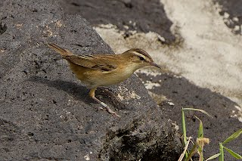](http://2.bp.blogspot.com/-1GSF7ClpD7s/T8UMZ08nTlI/AAAAAAAAAgg/MZDFGhi508I/s1600/IMG_1053.jpg)

[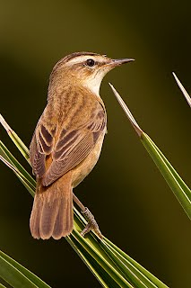](http://2.bp.blogspot.com/-jgijKiKJORk/T8UMi46niqI/AAAAAAAAAgo/VykmdIrjAF8/s1600/IMG_1739.jpg)

This bird arrived on the golf course following a few days of mist and northerly winds, and turned up with several other Sedge and Reed Warblers. It had originally been ringed on 6th August 2011 at Lytchett Bay, Poole Harbour (Dorset). It's unclear whether this is a late migrant or a bird that for some reason won't breed this year, but is very unusual all the same. This is just the third BTO-ringed Sedge Warbler to be reported from the islands, with previous birds being a bird from Barnsley (South Yorkshire) found dead on Roque del Este (an uninhabited island 12km northeast of Lanzarote) in September 1986 and one from Sandwich Bay (Kent) killed by a bird of prey on Gran Canaria in August 2009.

[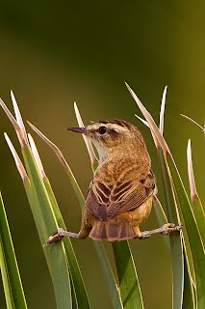](http://4.bp.blogspot.com/-o4YyrSyTvnU/T8UMvmxaIhI/AAAAAAAAAg0/s7Tz3DfVML8/s1600/IMG_1758.jpg)

Many thanks to [David Pérez Rodríguez](http://ornitoaddiction.blogspot.com.es/) and Toño Salazar for reporting this and for the photographs of the bird here.

**Appendix 3**

**Retraps/**

**Full grown** **Pulli** **Recoverie** **Total**

**Red-breasted Merganser 1 0 0 1**

**Black-headed Gull 2 0 0 2**

**Wood Pigeon 1 0 0 1**

**Great Spotted Woodpecker 6 0 2 8**

**Kingfisher** **6** **0** **0** **6**

**Sand Martin** **7** **0** **0** **7**

**Swallow** **127** **0** **2** **129**

**Tree Pipit** **1** **0** **0** **1**

**Meadow Pipit** **3** **0** **0** **3**

**Yellow Wagtail** **10** **0** **1** **11**

**Pied/White Wagtail** **233** **0** **0** **233**

**Wren** **10** **0** **2** **12**

**Dunnock** **6** **0** **0** **6**

**Robin** **10** **0** **2** **12**

**Stonechat** **1** **0** **0** **1**

**Wheatear** **1** **0** **0** **1**

**Blackbird** **4** **0** **0** **4**

**Song Thrush** **6** **0** **0** **6**

**Cetti's Warbler** **3** **0** **0** **3**

**Grasshopper Warbler** **2** **0** **0** **2**

**Aquatic Warbler** **2** **0** **0** **2**

**Sedge Warbler** **206** **0** **4** **210**

**Reed Warbler** **77** **1** **25** **103**

**Whitethroat** **5** **0** **0** **5**

**Blackcap** **4** **0** **1** **5**

**Chiffchaff** **12** **0** **0** **12**

**Willow Warbler** **7** **0** **0** **7**

**Goldcrest** **3** **0** **0** **3**

**Coal Tit 1 0 0 1**

**Blue Tit** **41** **0** **26** **67**

**Great Tit** **27** **0** **9** **36**

**Magpie 1 0 0 1**

**Starling 5 0 0 5**

**House Sparrow 5 0 0 5**

**Chaffinch** **2** **0** **0** **2**

**Greenfinch 7 0 0 7**

**Goldfinch** **11** **0** **0** **11**

**Siskin 1 0 0 1**

**Bullfinch 5 0 2 7**

**Linnet** **1** **0** **0** **1**

**Reed Bunting** **25** **0** **8** **33**

**Annual Total:** **878** **1** **84** **963**