Lytchett Bay 2010

**Bird and Ringing Report**

***Shaun Robson***

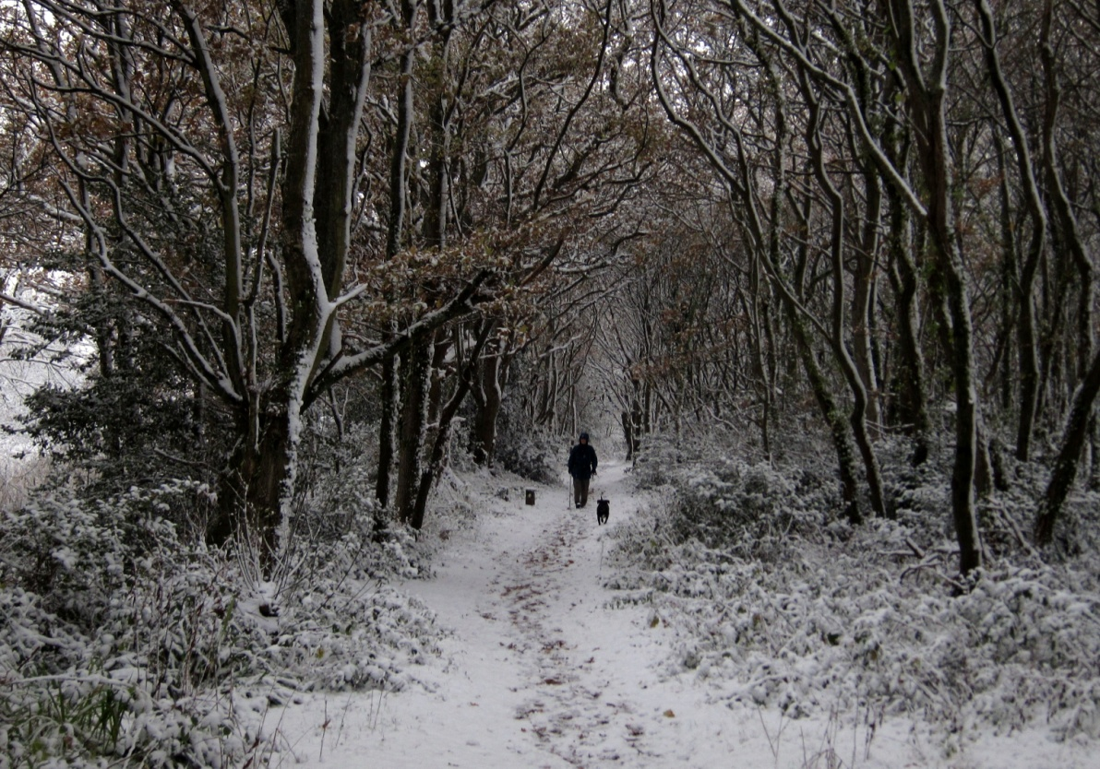

The Bay was visited on 244 days as set out below.

|  |  |  |  |  |  |  |  |  |  |  |  |
| --- | --- | --- | --- | --- | --- | --- | --- | --- | --- | --- | --- |
| JAN | FEB | MAR | APR | MAY | JUN | JUL | AUG | SEP | OCT | NOV | DEC |
| 21 | 10 | 22 | 29 | 10 | 10 | 26 | 28 | 19 | 29 | 22 | 18 |



2010 was a record breaking year in many ways. 147 species were recorded. The most in any year since 1992. The cold weather at either end of the year was more severe than anything in recent memory. However, exceptional bird movements and concentrations extended well beyond these periods. It was a thrilling year. Little Egret, Wigeon, Gadwall, Teal, Marsh Harrier, Osprey, Peregrine, Coot, Avocet, Grey Plover, Mediterranean Gull, Wood Pigeon, Skylark, Meadow Pipit, Ring Ouzel, Fieldfare, Song Thrush, Willow Warbler, Bearded Tit, Raven and Brambling all had record day counts or occurred in greater numbers than ever before.

Scarce visitors added to the enjoyment and included the 1st record of Whooper Swan, arguably the first record of wild Barnacle Geese, 2nd record of Waxwing, 3rd record of Bittern, 4th & 5th records of Spoonbill, 6th and 7th records of Red Kite and the first Little Gull since 2004.

The Lytchett Bay list now stands at 211.

A key shortfall in recording occurred during the first 10 days of September – unfortunately this coincided with a strong push of common migrants in eastern Dorset. Consequently records from that month for Blackcap, Willow Warbler, Chiffchaff, Spotted Flycatcher, etc should only be compared with data from other years with this caveat in mind.

RSPB activity on the site continued with the construction of a new sluice. Hopefully this will continue to improve the habitat for waders and wildfowl on the Far Fields.

**Ringing 2010**

1733 birds of 42 species were ringed. This is the second biggest annual total since ringing began at Lytchett Bay. 1810 in 1984 being the highest.

The Groups focus was again around the banks of the Sherford. Much training activity was centered on Sandy Close Pond, where 291 birds were ringed.

The full details, controls, recoveries and interesting re-traps are in the systematic list. An appendix, detailing the individual species totals is included at the end of the report.

**Acknowledgements**

Please remember that the major part of the site is private and that access is at the discretion of the farmer and the estate. Please respect this privilege.

Wessex Water and the landowner, the Lees Estate, for their kind permission to ring at Lytchett Bay and for access to Holton Lee. Permission has recently been granted by Lord Wimborne’s agent to allow ringing on land around Lytchett Heath and we are very grateful for this.

Many thanks to Craig Daters and his RSPB colleagues for the interest shown in the site this year.

### Systematic List 2010

Species names are followed by up to 3 numbers. The first is the maximum known count recorded at the Bay. This now includes historical counts by observers going back to 1975 and has recently been enhanced by Guy Dutson who has provided new data from his visits between 1982 and 1988. The middle figure (when necessary) is the max count in the period since 1992. The final figure is the number of years in which the species has been recorded since 1992. This is the year in which the current spell of comprehensive coverage began.

The symbol which follows each species name shows the direction of travel of the species status at Lytchett Bay over the last 5 years. I think these are quite intuitive; strongly increasing, increasing, stable, declining and strongly declining. Hopefully this feature will enable others to compare the data from this site with experiences at their own site and engender some debate and understanding.

**Mute Swan:** (58 – 19) ****

Common winter visitor, present in small numbers throughout the year. Bred between 2002 and 2007.

|  |  |  |  |  |  |  |  |  |  |  |  |
| --- | --- | --- | --- | --- | --- | --- | --- | --- | --- | --- | --- |
| JAN | FEB | MAR | APR | MAY | JUN | JUL | AUG | SEP | OCT | NOV | DEC |
| 46 | 26 | n.c. | 12 | 2 | 4 | n.c. | 14 | 12 | 32 | 38 | 42 |

**Whooper Swan:**

First record. An Ad and Juv were found grazing on the Pool in the early evening of 27th Oct (SR et al). They remained loyal to the site until 13th Nov, having moved to the Far Fields on the 6th Nov. 2010 was a good autumn for this species in southern Britain where winter records are increasing.

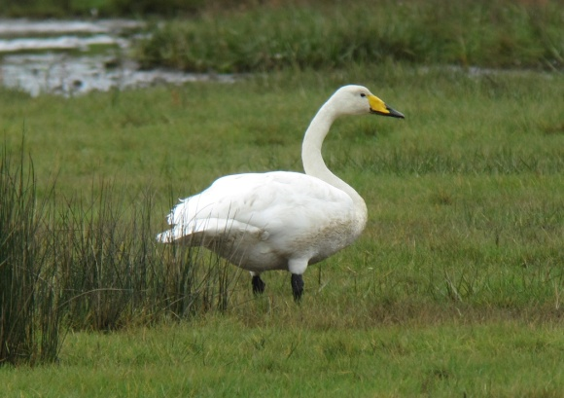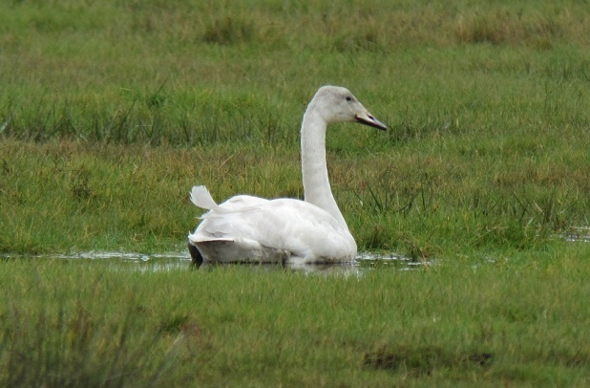

Ad and Juv Whooper Swans (S. Robson)

**Greater White-fronted Goose:** (23 – 5)

A juv circled the Bay several times during the severe weather on the 2nd Dec before heading off east. The first record since 2006.

**Greylag Goose:** (25 – 11) ****

Scarce feral wanderer. Recorded on 5 dates. 2 on 27th Feb, 7 on 10th Apr, 1 on 13th Apr, 4 on 2nd Oct and 1 on 10th Nov.

**Dark-bellied Brent Goose:** (35 – 11) ****

Scarce visitor. 2 were surprise guests on the 6th July with one remaining on and off until 7th Aug. 3 were found during the freezing conditions on the 3rd Dec.

**Barnacle Goose:** (42 – 4)

Rare visitor. Arguably the first wild birds to occur at the site. The three previous records undoubtedly referred to feral wanderers. A flock of 42 were found at Studland on 6th Dec and relocated to the Far Fields on 12th Dec where they remained into the New Year. Presumably from the breeding population on Novaya Zemlya, which winters in Holland. This population is increasing and prone to displacement to SE England during severe weather. One of the many highlights of 2010.

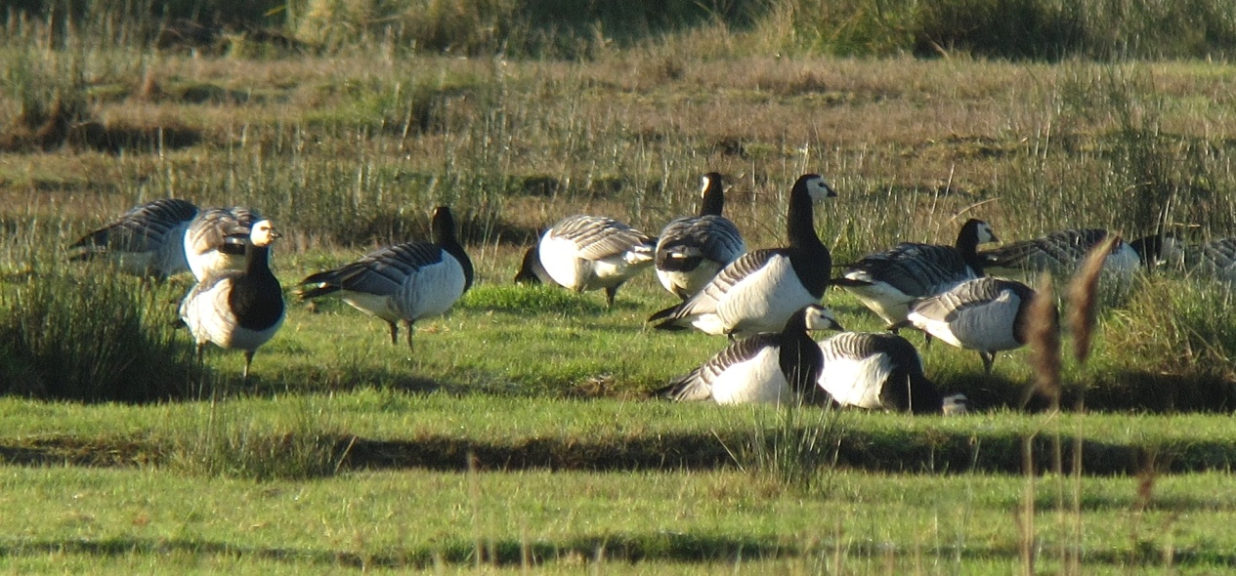

Barnacle Geese, 12 of the flock of 42 that lingered into 2011 (S. Robson)

**Canada Goose:** (137 – 19) ****

Increasingly frequent visitor. Still no indication that lingering spring birds are attempting to breed. Max 25 on 28th Oct.

|  |  |  |  |  |  |  |  |  |  |  |  |
| --- | --- | --- | --- | --- | --- | --- | --- | --- | --- | --- | --- |
| JAN | FEB | MAR | APR | MAY | JUN | JUL | AUG | SEP | OCT | NOV | DEC |
| 12 | 2 | 10 | 4 | 5 | 10 | 0 | 22 | 0 | 25 | 7 | 20 |

**Shelduck:** (645 – 548 – 19)  ** **(last 3 years only)

Bred for the first time since at least 2007. 3 pairs were believed to have hatched young. The Dec count is another slight improvement toward numbers that were present in the mid 90’s (400+).

*Bay monthly max:*

|  |  |  |  |  |  |  |  |  |  |  |  |
| --- | --- | --- | --- | --- | --- | --- | --- | --- | --- | --- | --- |
| JAN | FEB | MAR | APR | MAY | JUN | JUL | AUG | SEP | OCT | NOV | DEC |
| 166 | 138 | 70 | 62 | Br | Br | Br | 3 | 1 | 32 | 120 | 216 |

**Wigeon:** (588 – 19) ****

Increasingly common winter visitor. Absent from 28th Mar until 12th Sep. Another record year. 588 on 9th Jan surpassed the previous best of 424 on 29th Nov 2007.

*Bay monthly max:*

|  |  |  |  |  |  |  |  |  |  |  |  |
| --- | --- | --- | --- | --- | --- | --- | --- | --- | --- | --- | --- |
| JAN | FEB | MAR | APR | MAY | JUN | JUL | AUG | SEP | OCT | NOV | DEC |
| 588 | 200 | 150 | 0 | 0 | 0 | 0 | 0 | 8 | 73 | 458 | 556 |

**Gadwall:** (55 – 14) ****

Occasional visitor. A significant change in status. Recorded on 24 dates but in reality frequently seen in the first winter period until the 11th May and the present from the 19th Nov until the end of the year. The snowy conditions on the 2nd Dec led to an influx of 22 birds. However this was only the start, the persistent freeze increased the Bay’s population to a record 55 by the 31st. The previous record was 6 on 31st Dec 2008!

**Teal:** (488 – 19) ****

Winter visitor and passage migrant. No records between 14th Apr and 22nd Jul. 488 on 13th Dec was a new record for the Bay, surpassing the previous best of 402 on 19th Dec 2004.

*Bay monthly max:*

|  |  |  |  |  |  |  |  |  |  |  |  |
| --- | --- | --- | --- | --- | --- | --- | --- | --- | --- | --- | --- |
| JAN | FEB | MAR | APR | MAY | JUN | JUL | AUG | SEP | OCT | NOV | DEC |
| 200 | 243 | 27 | 118 | 0 | 0 | 1 | 16 | 119 | 100 | 266 | 488 |

**Mallard:** (100 – 56 – 19) ****

Breeds at several sites around the recording area. For the 4th year in a row a pair arrived on Sandy Close Pond in mid Feb, stayed for the spring, but did not breed. The count of 56 on 27th Nov is the biggest in the period since 1992.

*Bay monthly max:*

|  |  |  |  |  |  |  |  |  |  |  |  |
| --- | --- | --- | --- | --- | --- | --- | --- | --- | --- | --- | --- |
| JAN | FEB | MAR | APR | MAY | JUN | JUL | AUG | SEP | OCT | NOV | DEC |
| 20 | n.c | Br | Br | Br | 13 | 35 | 46 | 47 | n.c. | 56 | n.c. |

**Northern Pintail:** (21 - 11) ****

Scare visitor. Seen on 7 dates, making this a good year. 6 were in the Bay during freezing conditions on 9th Jan. 2 were on the Pool on the 15th. A male appeared on 2 dates in spring on Folly Pond. In autumn 1 was present on 29th Oct and 1st Nov then 2 arrived in Dec freeze on the 2nd.

**Shoveler:** (7 – 18) ****

Scarce visitor, which can occur at any time. A very good year with records on 11 dates and likely to have been present on several more. Up to 5 between 4th and 16th Jan. 2 on 23rd Apr. Recorded on 3 dates in autumn inc 2 east over Border Road on 20th Oct.

**Common Pochard:** (24 – 11) ****

Rare visitor. The cold weather produced records at both ends of the year. 4 were present on 9th and 10th Jan. 1 on 16th Nov, 2 on 8th Dec and 6 on 18th Dec. The latter being the biggest count since 1999

**Tufted Duck:** (20 – 7 – 9) ****

Rare visitor. 6 records, mostly associated with the cold weather. 4 on 9th Jan, 4 on 25th Mar, 1 on 30th Nov, 1 on 2nd Dec, 1 on 18th Dec and finally 7 on 22nd Dec. The constituting the biggest flock since 1987.

**Goldeneye:** (12 – 19) ****

Declining winter visitor. Recorded on only 11 dates. Absent between 13th Mar and 16th Nov. The last date being the only record in the second winter period. All records were singles except 2 on the last spring date.

**Red-breasted Merganser:** (73 – 19) ****

Declining winter visitor. Recorded on only 17 dates. Present until 2nd Apr and from 31st Oct.

*Bay monthly max:*

|  |  |  |  |  |  |  |  |  |  |  |  |
| --- | --- | --- | --- | --- | --- | --- | --- | --- | --- | --- | --- |
| JAN | FEB | MAR | APR | MAY | JUN | JUL | AUG | SEP | OCT | NOV | DEC |
| 2 | 7 | 10 | 3 | 0 | 0 | 0 | 0 | 0 | 1 | 2 | 1 |

**Pheasant: **

Increasingly common resident. Established in all parts of the recording area.

**Little Grebe:** (11 - 19) ****

Winter visitor. Recorded until 2nd Apr and from 22nd Aug. Max 10 on 31st Oct.

**Great Crested Grebe;** (4 - 16) ****

Occasional visitor. Recorded on 4 dates up to 29th Apr and 4 dates from 13th Oct. Max 2 on 13th -14th Oct.

**Cormorant:** (203 – 19) ****

Regular visitor. No specific counts submitted.

**Bittern:**

3rd record. 1 was present in PH Field on 5th – 6th Jan. No doubt displaced by the severe weather. The last record occurred in 1998.

**Little Egret:** (29 – 18) **** Common visitor. Numbers have stabalised in recent years. A new record count of 29 was made on 25th Aug (KEL). The previous max count 25 was in Sep 2009.

*Bay monthly max:*

|  |  |  |  |  |  |  |  |  |  |  |  |
| --- | --- | --- | --- | --- | --- | --- | --- | --- | --- | --- | --- |
| JAN | FEB | MAR | APR | MAY | JUN | JUL | AUG | SEP | OCT | NOV | DEC |
| 2 | 13 | 3 | 6 | n.c. | n.c. | 13 | 29 | 21 | 11 | n.c. | 5 |

**Grey Heron:** (10 – 19) ****

Recorded frequently throughout the year. Max 6 on 2nd Aug.

**Spoonbill:**

Fourth and fifth records and the first since 1995. A 1st W was present on 6th – 8th Jan (TE,SR) during severe weather. 2, an Ad and 1stW, flew east on 9th Jan (SR).

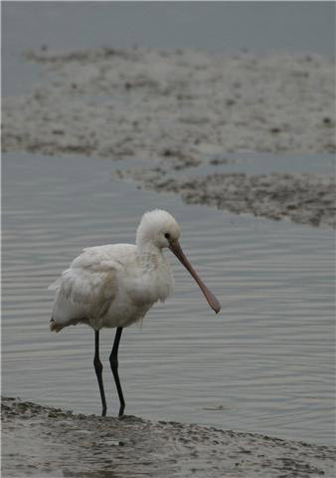 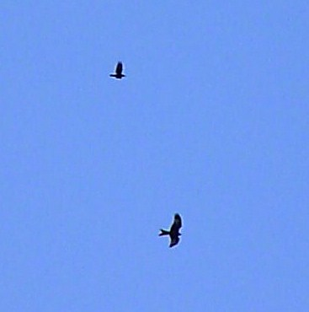

Spoonbill 6th Jan (T Elborn) Red Kite, 10th Nov (S Robson)

**Red Kite:**

6th and 7th records. One flew NW over the Stubble Field on the 10th Nov giving suburb views (KEL, SR). On the 2nd Dec one, possibly the same bird as above, lingered throughout the afternoon (SR).

**Marsh Harrier:** (3 – 18) ****

Irregular visitor. A record year, surpassing 1998’s 27 sightings.. Recorded on 34 dates. No records between 22nd Apr, when a male and female were present, and 10th July. 3 were present together on the 27th Nov, a record for the Bay.

**Hen Harrier:** (2 – 18) ****

Irregular Visitor. 3 records. One on 31st Jan over Otter Island. A ringtail arrived from the east over Border Road on 20th Oct and a male at Lytchett Saltings on 23rd Nov.

**Sparrowhawk:** (3 – 19) ****

Uncommon visitor. Recorded on 36 dates, well above the average number of annual sightings (23.4 p.a. 1992-2008). 3 together on the 12th Oct at Border Road was the biggest single count at the Bay.

**Common Buzzard:** (15 – 19) ****

The commonest raptor of the area. Breeds widely in the vicinity.

**Osprey:** (4 – 18) ****

Annual passage migrant. None in spring but a surprise record on 20th June, the first in that month. A good autumn with records on 15 dates between 31st Jul and 12th Oct. The highlight was the 7th Aug when 4 birds were concluded to have visited the Bay. 2 in the morning headed off to their usual feeding posts near Morden, then in the late afternoon two arrived over Sandy Close Pond high from the east. There were records of two birds on 3 other dates.

**Kestrel:** (3 – 19) ****

Frequently seen resident. It is 4 years since breeding was confirmed and this year there were no records between 28th May and 11th Sep.

**Merlin:** (2 – 15) ****

Scarce winter visitor. A good year with records on 6 dates. 9th Jan, 12th Mar, 25th Oct, 28th Oct, 30th Nov, 31st Dec. All singles.

**Hobby;** (2 – 17) ****

Irregular visitor. Singles recorded on 5 dates between 3rd Jun and 25th Aug.

**Peregrine:** (2 – 18) ****

Uncommon visitor. Recorded on 26 dates, the best showing in the period since 1992 and double the previous best of 13 in 2008. The average number of dates was 6.7 p.a. (1992 – 2008). A single bird favoured resting in the Far Fields on several dates in Mar and Apr and did nothing to encourage waders and wildfowl on to this improved habitat!

**Water Rail:** (23 – 19) ****

Common resident and winter visitor. No specific records this year but no perceived change in status. The 2004 breeding survey established a population estimate of more than 60 pairs in the Bay.

**Moorhen:** (12 – 19) ****

An uncommon resident. At least 4 pairs scattered across recording area, including pairs at Sandy Close Pond and, for the first time, Folly Pond. Only 1 brood was raised by the pair at Sandy Close as compared 2 two in 2009. 1 full grown young was killed by a cat.

**Coot:** (59 – 9)

In 19 years of watching the site there had only ever been 8 records of Coot. All single birds. On my final visit of 2010, on 31st Dec, I was astonished to see a flock of 4! Further scanning revealed a flock of 6, then 10, then…..in total there were 59 birds. Apparently there had been a huge exodus of Coot from Continental Europe (J Lidster pers comm.).

**Oystercatcher:** (400 – 19) ****

A common winter visitor and passage migrant. Turlin Fields and Turlin Shore at high tide remain the favored locations, though more birds now remain in the bay to feed at low tide than in previous years. The maximum count was on 16th Jan.

*Bay monthly max:*

|  |  |  |  |  |  |  |  |  |  |  |  |
| --- | --- | --- | --- | --- | --- | --- | --- | --- | --- | --- | --- |
| JAN | FEB | MAR | APR | MAY | JUN | JUL | AUG | SEP | OCT | NOV | DEC |
| 281 | 45 | n.c. | 15 | 6 | 27 | 29 | 54 | n.c. | 175 | 154 | n.c. |

**Pied Avocet:** (327 – 18) ****

Increasingly regular winter visitor and passage migrant. A record year. Absent from 13th Mar until 25th Oct. Numbers during both winter periods were consistently high and a new record count of 282 was made on 10th Jan, but this was broken on 23rd Dec when 327 were present (TE)

*Bay monthly max:*

|  |  |  |  |  |  |  |  |  |  |  |  |
| --- | --- | --- | --- | --- | --- | --- | --- | --- | --- | --- | --- |
| JAN | FEB | MAR | APR | MAY | JUN | JUL | AUG | SEP | OCT | NOV | DEC |
| 282 | 170 | 1 | 0 | 0 | 0 | 0 | 0 | 0 | 2 | 196 | 327 |

**Ringed Plover;** (17 – 10 – 15) ****

Scarce visitor. Singles on 25th Jul and 6th Aug.

**Golden Plover:** (160 – 10)

Scarce visitor. 6 were in the stubble during snow on the 6th Jan. 8 flew over on the on 6th Mar and 1 passed over with Lapwing during the cold weather movement on 2nd Dec.

**Grey Plover:** (14 - 14) ****

Scarce visitor. The best year on record with birds noted on 18 dates. 1 in spring on 15th Apr. Then seen on many visits from 1st Oct until the year end. Birds favoured the Far Fields as well as the Bay. Max 5 on 31st Oct.

**Lapwing:** (3000 – 19) ****

Formerly bred, now a declining winter visitor. Bred regularly during early 1990’s. Last confirmed breeding 1999. Recorded on at least 79 dates (only 30 in 2009). Numbers present in most months were substantially higher than recent years. Max of 631 occurred as part of cold weather movement on 2nd Dec.

This species bred again at a site within 2km of the Bay in 2009. There is still hope.

*Bay monthly max:*

|  |  |  |  |  |  |  |  |  |  |  |  |
| --- | --- | --- | --- | --- | --- | --- | --- | --- | --- | --- | --- |
| JAN | FEB | MAR | APR | MAY | JUN | JUL | AUG | SEP | OCT | NOV | DEC |
| 445 | 558 | 30 | 1 | 0 | 16 | 22 | 24 | 25 | 150 | 220 | 631 |

**Red Knot:** (34 - 11) ****

Scarce migrant. 11 were present on 13th Sep with 1 on the 19th and 25th.

**Curlew Sandpiper:** (3 – 6)

Rare visitor. 1 juv was present on 17th Oct (SR)

**Dunlin:** (1800 – 1200 – 19) ****

Declining winter visitor and passage migrant. 2010 produced a significant increase in records compared to recent years. Visits in both winter periods produced consistently good flocks. The counts in excess of 500 during Dec were the best since 1200 in Dec 1996. The max of 563 was on 2nd Dec.

*Bay monthly max:*

|  |  |  |  |  |  |  |  |  |  |  |  |
| --- | --- | --- | --- | --- | --- | --- | --- | --- | --- | --- | --- |
| JAN | FEB | MAR | APR | MAY | JUN | JUL | AUG | SEP | OCT | NOV | DEC |
| 110 | 226 | 70 | 3 | 0 | 0 | 2 | 5 | 7 | 11 | 371 | 563 |

**Ruff:** (9 – 16) ****

Scarce migrant, usually in autumn. 2 juvs graced the flooded Far Fields on the 1st Oct and were joined by a 3rd the next day.

**Jack Snipe:** (5 - 11) ****

Scarce but under recorded winter visitor. Singles on 5 dates. 5th Jan at Lytchett Way; 6th, 8th and 10th Oct on the Far Fields; 2nd Dec arriving over Lytchett Way with Common Snipe during snow showers.

**Snipe:** (160 – 109 – 19) ****

Declining winter visitor. Recorded until 19th Apr, returning on the 30th Jul. Numbers of Snipe at the Bay declined rapidly at the end of the 20th century. Unsurprisingly as result of cold weather movements at either end of the year 2010 produced more records than any other year this century and on the 2nd Dec the best day count in the period since 1992. 1 ringed.

*Bay monthly max:*

|  |  |  |  |  |  |  |  |  |  |  |  |
| --- | --- | --- | --- | --- | --- | --- | --- | --- | --- | --- | --- |
| JAN | FEB | MAR | APR | MAY | JUN | JUL | AUG | SEP | OCT | NOV | DEC |
| 40 | 16 | 12 | 2 | 0 | 0 | 1 | 1 | 7 | 20 | 7 | 109 |

**Woodcock:** (5 – 9) ****

Scarce but under recorded winter visitor. The number of records of this species is largely a reflection of the effort made to see them. They are probably present frequently throughout the winter. 5 records all in the first 3 months. 1 on 8th Jan, 2 on 9th Jan, 1 on 10th Jan, 1 on 28th Feb and 1 on 12th Mar.

**Black-tailed Godwit:** (1240 – 19) ****

Common passage migrant and winter visitor. Birds were occasionally attracted to The Pool during the autumn. Max 40.

*Bay monthly max:*

|  |  |  |  |  |  |  |  |  |  |  |  |
| --- | --- | --- | --- | --- | --- | --- | --- | --- | --- | --- | --- |
| JAN | FEB | MAR | APR | MAY | JUN | JUL | AUG | SEP | OCT | NOV | DEC |
| 115 | 170 | 340 | 400 | 109 | 1 | 15 | 35 | 49 | 53 | 105 | 150 |

Over the last 11 years colour ringed birds have proved that birds visiting Lytchett Bay breed in Iceland (*L.l.islandica*)*.* Predominantly, birds seen at Lytchett Bay on migration, winter in Western France. However some have also been recorded in Portugal, SW Ireland, Holland, Belgium, NE England as well as many locations along the south coast.

Colour ringed birds were recorded as follows.

Y//R+YL was present on 7th Mar. (photo)

It had been ringed as an Ad F at Farlington Marshes, Hants on 13th Aug 2008. All other sightings have been along the south coast of Hampshire.

WN+RW(X) was present on 10th Mar. (photo).

It had been ringed as an Ad F on 11th July 2009 at Siglufjordur, North Iceland. It has subsequently been seen on The Humber in N Lincolnshire on 23rd Jul 2010. It was back at Middlebere on 22nd Aug.

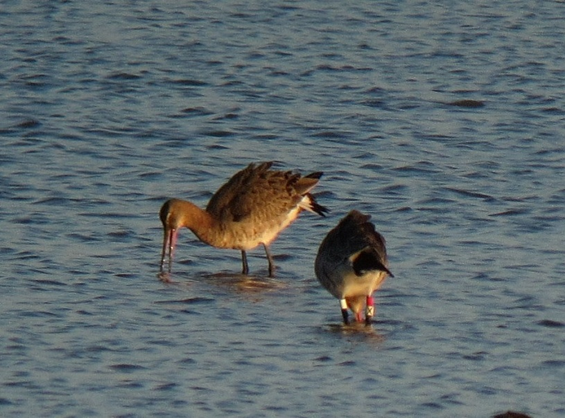

G//R+WG was present on 10th Mar.

It had been ringed as an Ad F at Farlington Marshes, Hants on 10th Sep 2008. As well as regular sightings in Langstone Harbour, it was also recorded at the Forth Estuary in eastern Scotland on 2nd Jul 2009.

Y+GL was present on 10th Mar.

It had been ringed as a F at Farlington Marshes, Hants on 13th Aug 2008. All subsequent sightings have been in South Hants.

OLR+GYG was present on 19th & 20th Mar and again on 8th Nov & 15th Nov.

It had been ringed as an Ad at Iken, Suffolk on 12th Sep 2008. It has also been seen at the Somerset Levels in Dec 2009.

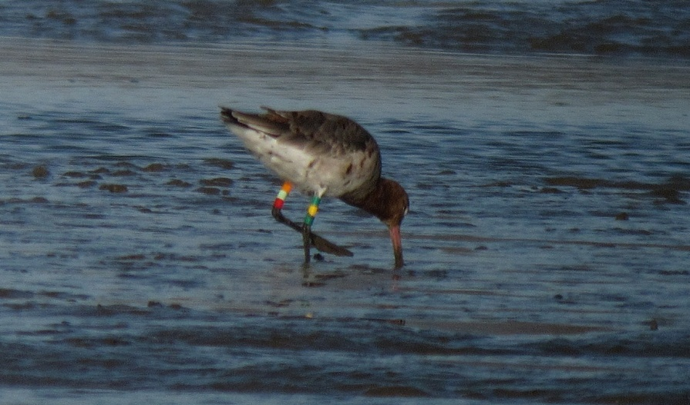

G//R+WW was present on 5th Apr. (photo)

It had been ringed as an Ad F at Farlington Marshes, Hants on 8th Sep 2008. This is the first sighting outside Hampshire.

R(8)+WY was present on 15th Nov.

It had been ringed as an Ad F on 15th July 2010 at Siglufjordur, North Iceland.

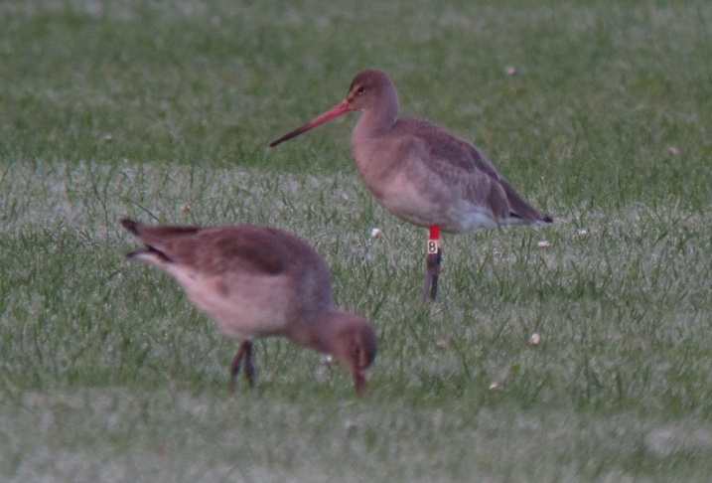

**2008:** An outstanding record.

G//R+YR was present on 6th, 8th and 9th Apr.

It had been ringed at Farlington Marshes, Hants as an Ad M on 14th Sep 2005. All subsequent sightings have been in SE Hants or West Sussex except for one at Vogalaekur, Myrar, west of Borganes, W Iceland on 21st Apr 2007.

Left leg always given first, all rings above the tibia (unless preceded by the mark //). Recently some birds have been marked with leg flags rather than rings. Colours are:

O = Orange

L = Lime (this can look very washed out in the field, approaching white)

R = Red

W = White

Y = Yellow

G = Green

B = Blue

N = Niger

Many thanks to Pete Potts and the Farlington Ringing Group, Ruth Croger, Jose Alves, Tomas Gretar Gunnersson and Vigfus Eyjolfsson for supplying this information.

**Bar-tailed Godwit:** (20 – 15) ****

Scare visitor. Recorded on 6 dates. 1 on 15th Apr was the only occurrence in spring. 5 on 12th Sep were the first of the autumn and only multiple count of the year. Singles then occurred on 13th and 19th Sep, 2nd Oct and 21st Nov.

**Whimbrel:** (157 – 19) ****

Passage migrant, most numerous in Spring. Following the first on 14th Apr there were only 73 bird days to the 17th May. Max 14 on 12th May. A similarly poor pattern to that in 2009. Autumn passage involved 29 bird days between 25th Jul and 19th Sep. Max 6 on 4th Aug.

**Curlew:** (104 – 19) ****

Common winter visitor and passage migrant. Small flocks of up to 10 frequently roosted and fed at high tide on the Pool, the Stubble Field and PH Field.

*Bay monthly max:*

|  |  |  |  |  |  |  |  |  |  |  |  |
| --- | --- | --- | --- | --- | --- | --- | --- | --- | --- | --- | --- |
| JAN | FEB | MAR | APR | MAY | JUN | JUL | AUG | SEP | OCT | NOV | DEC |
| 54 | n.c. | 54 | 47 | 0 | 3 | 23 | 35 | 22 | 52 | 77 | n.c. |

**Spotted Redshank:** (68 – 42 – 19) ****

Declining passage migrant and scarce winter visitor. Recorded on 30 dates (19 in 2009). This elegant species was once a “write in” for any visit in spring or autumn and would be seen in every month of the year. The first signs of decline were recognised in 1998 when the number of days on which the species was seen fell from 148 to 102.

Max 9 on 23rd Sep. Absent between 7th Apr and 8th Aug.

*Pool monthly max:*

|  |  |  |  |  |  |  |  |  |  |  |  |
| --- | --- | --- | --- | --- | --- | --- | --- | --- | --- | --- | --- |
| JAN | FEB | MAR | APR | MAY | JUN | JUL | AUG | SEP | OCT | NOV | DEC |
| 2 | 0 | 2 | 0 | 0 | 0 | 0 | 0 | 9 | 4 | 0 | 0 |

*Bay monthly max*

|  |  |  |  |  |  |  |  |  |  |  |  |
| --- | --- | --- | --- | --- | --- | --- | --- | --- | --- | --- | --- |
| JAN | FEB | MAR | APR | MAY | JUN | JUL | AUG | SEP | OCT | NOV | DEC |
| 1 | 2 | 2 | 2 | 0 | 0 | 0 | 2 | 1 | 1 | 0 | 1 |

**Redshank:** (608 – 436 – 19) ****

Common winter visitor with small breeding population on salt marsh. The max count of 220 was on 31st Oct.

*Pool monthly max:*

|  |  |  |  |  |  |  |  |  |  |  |  |
| --- | --- | --- | --- | --- | --- | --- | --- | --- | --- | --- | --- |
| JAN | FEB | MAR | APR | MAY | JUN | JUL | AUG | SEP | OCT | NOV | DEC |
| 58 | 15 | 20 | n.c. | 0 | 0 | 0 | 0 | 18 | 40 | 125 | 22 |

*Bay monthly max:*

|  |  |  |  |  |  |  |  |  |  |  |  |
| --- | --- | --- | --- | --- | --- | --- | --- | --- | --- | --- | --- |
| JAN | FEB | MAR | APR | MAY | JUN | JUL | AUG | SEP | OCT | NOV | DEC |
| 121 | 80 | 98 | n.c. | n.c. | n.c. | 6 | 4 | 147 | 220 | n.c. | n.c. |

**Greenshank:** (49 – 27 – 19) ****

Common passage migrant and winter visitor. Recorded until 28th Apr. The first returning bird was noted on the rather late date of 22nd July. A decent autumn, max 14 on 10th Sep. Birds

regularly used the Far Fields in autumn. Max 6.

*Pool monthly max;*

|  |  |  |  |  |  |  |  |  |  |  |  |
| --- | --- | --- | --- | --- | --- | --- | --- | --- | --- | --- | --- |
| JAN | FEB | MAR | APR | MAY | JUN | JUL | AUG | SEP | OCT | NOV | DEC |
| 1 | 0 | 1 | 1 | 0 | 0 | 0 | 5 | 14 | 9 | 2 | 1 |

*Bay monthly max:*

|  |  |  |  |  |  |  |  |  |  |  |  |
| --- | --- | --- | --- | --- | --- | --- | --- | --- | --- | --- | --- |
| JAN | FEB | MAR | APR | MAY | JUN | JUL | AUG | SEP | OCT | NOV | DEC |
| 3 | 0 | 2 | 3 | 0 | 0 | 4 | 8 | 8 | 4 | 3 | 2 |

**Green Sandpiper:** (10 – 19) ****

Common autumn migrant and winter visitor, occasional in spring. The Far Fields and western most part of the Bay are the favoured sites. An excellent year with birds recorded on most visits up until 22nd Apr. Returning on 1st July. Recorded on most visits until the years end. Max 7 on 1st Oct.

*Monthly max:*

|  |  |  |  |  |  |  |  |  |  |  |  |
| --- | --- | --- | --- | --- | --- | --- | --- | --- | --- | --- | --- |
| JAN | FEB | MAR | APR | MAY | JUN | JUL | AUG | SEP | OCT | NOV | DEC |
| 2 | 3 | 2 | 2 | 0 | 0 | 4 | 6 | 6 | 7 | 1 | 2 |

**Common Sandpiper:** (10 – 19) ****

Uncommon passage migrant. Two spring records. 2 on 16th and 3 on 20th Apr. Return passage started with 1 on 10th Jul and birds were noted on a 10 further dates until 12th Sep. All singles bar 2 on 16th Aug and 3 on 12th Sep.

**Black-headed Gull:** (12000 – 7000 – 19) ****

A very common visitor. 1000’s regularly frequent the bay en route to the Wareham Channel roost. The first juveniles were noted on 19th Jun. 2 ringed.

**Little Gull:** (1 - 11)

The first record since 2004. A juv visited the Pool during stormy weather on 3rd Oct

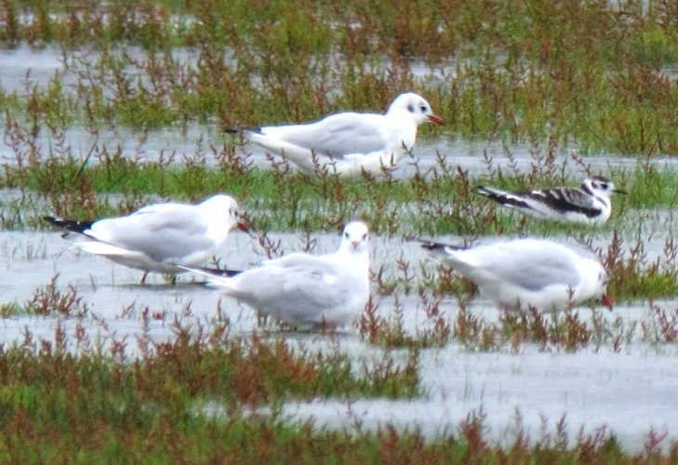

Juv Little Gull, 3rd Oct (S Robson)

**Mediterranean Gull:** (15 – 18) ****

Spring and early summer visitor – a period when pairs are establishing territories at the breeding islands in the Wareham Channel (87 pairs attempted to breed there in 2008). A new record total of 161 bird days between 6th Mar and 16th Jul. Max of 11 on 15th Apr and 19th Jun. On the latter date, 3Ad and 8 1stS were roosting in the recently ploughed Stubble Field at high tide.

*Monthly max:*

|  |  |  |  |  |  |  |  |  |  |  |  |
| --- | --- | --- | --- | --- | --- | --- | --- | --- | --- | --- | --- |
| JAN | FEB | MAR | APR | MAY | JUN | JUL | AUG | SEP | OCT | NOV | DEC |
| 0 | 0 | 3 | 11 | 10 | 11 | 6 | 0 | 0 | 0 | 0 | 0 |

**Common Gull:** (1700 – 19) ****

A common winter visitor and passage migrant, especially in spring. Max 500 on 10th Mar. The last birds of winter were seen on 25th Apr. The first returning bird was on 16th Jul.

**Lesser Black backed Gull:** (2128 – 19) ****

Abundant autumn and common spring passage migrant and uncommon winter visitor. Rarely counted.

**Herring Gull:** (2000 – 19) ****

Common winter visitor and passage migrant.

**Yellow legged Gull:** (65 – 18) ****

Frequent visitor, peaking in summer. Under recorded.

*Bay monthly max:*

|  |  |  |  |  |  |  |  |  |  |  |  |
| --- | --- | --- | --- | --- | --- | --- | --- | --- | --- | --- | --- |
| JAN | FEB | MAR | APR | MAY | JUN | JUL | AUG | SEP | OCT | NOV | DEC |
| 0 | 1 | 1 | 0 | 0 | 0 | 9 | 9 | 9 | 1 | 1 | 1 |

**Great Black backed Gull:** (151 – 19) ****

Daily visitor throughout the year in small numbers.

**Sandwich Tern:** (5 – 19) ****

Uncommon summer visitor. 12 bird days noted on 8 dates between 4th Apr and 26th Sep.

**Common Tern:** (25 – 19) ****

Uncommon summer visitor. Seen on 12 dates between 1st Jul and 13th Aug. Max 7 on 7th Aug.

**Stock Dove:** (29 – 19) ** **

Uncommon Resident. Max 6 on 17th Jul.

**Wood Pigeon:** (10,246 – 19) ****

Common resident and autumn migrant. A new record count, exceeding the previous best almost tenfold. 10,245 flew west over Border Road on the cold clear morning of the 7th Nov. This coincided with a massive record movement of this species across Poole Harbour. 1 ringed.

**Collared Dove:** (14 – 19) ****

Uncommon resident. No specific records submitted but no change in status.

**Cuckoo:** (2 – 19) ****

Uncommon summer visitor. One on 1st May at Beach Road was the only record of a very very poor year.

**Barn Owl:** (2 – 12) ****

Recent breeder. Did not breed in the box at French’s Farm. Only 2 records. Singles at Beach Road on 30th Jun and the Bay on 9th Jul.

**Tawny Owl:** (2 – 19) ****

Uncommon resident. Seems to be declining at the Bay. Records came from Sandy Close, The Cottage, Lytchett Heath and French’s Farm until Apr and from Sep.

**Nightjar:** (3 – 10) ****

Irregular breeder. A relatively poor year with a male at Beach Road on 30th Jun and singles churring around the stubble and Far Fields at the end of July.

**Swift:** (113 – 19) ****

Passage migrant and possible local breeder. Not seen until 6th Jun. Then recorded regularly around Sandy Close until 2nd Aug. Max 14 on 12th Jun. No significant migration was witnessed.

**Kingfisher:** (3 – 19) ****

Passage migrant and uncommon winter visitor. Bred in 2000 and must breed just outside the recording area most years. Recorded in both winter periods. Up to 2 present until the 28th Feb but then no more records until 13th Aug. Decidedly scarce at the year end with none noted after the 24th Nov. 5 ringed.

Of the 5 new birds ringed in 2010 only 1 was re-trapped.

SA27393 – 1st yr ringed on 18th Sep; still present on 6th Nov (49 days)

**Green Woodpecker: **

Breeding resident. Bred successfully and recorded in all parts of the Bay. No change in status.

**Great Spotted Woodpecker: **

Breeding Resident. Seen regularly in most parts of the Bay. Drumming heard in most areas during spring. 6 ringed.

**Woodlark:** (15 – 11)

Scarce passage migrant and occasional winter visitor. Breeds at Holton Lee. The habitat at the past wintering site again remained unsuitable and there were no records from there. 1 in the Stubble Field on the 7th – 8th Nov was the first record at that location. Further excitement was provided by 2 calling birds west over Lytchett Way during the cold weather movement on 2nd Dec.

**Skylark:** (781 - 19) ****

Scarce breeder and passage migrant. At least 2 territories established and held throughout the spring. However it was at either end of the year in cold weather that this species made its mark. 141 in the Stubble Field during snow on the 6th Jan was the best count since I started to visit in 1992. Numbers dwindled slowly over the following days but 40 were still present on the 12th. After a steady trickle during autumn peaking at 11 on 7th Nov, all records were broken on 2nd Dec when at least 781 flew west. Birds were then recorded daily until the year end including 26 over Sandy Close on 20th Dec.

**Sand Martin:** (5000 – 19) ****

Common passage migrant. First record was 25th Mar. The last record of the year was on 26th Sep. A slight hint of autumn gatherings during Jul, peaking at 180 on 13th. 2 ringed.

**Swallow:** (1000 – 540 – 19) ****

Common passage migrant, breeds at French’s Farm. Recorded from 30th Mar until 16th Oct. Max numbers occurred in autumn, peaking at 350 on 20th Sep. 24 ringed.

**House Martin:** (1800 – 19) ****

Common passage migrant, breeding colonies on edge of recording area at Watery Lane and Turlin Moor. The size of the breeding colony at Watery Lane was only 8 nests (plus 7 failed or destroyed). This represents a significant decline on all previous years. The colony at Turlin Moor was not surveyed. Autumn passage was poor with a peak of only 100 on 13th Sep and the last bird being seen on 8th Oct.

No of House Martin nests at the Watery Lane colony 1999 – 2010. No of nest collapsed or destroyed in brackets.

|  |  |  |  |  |  |  |  |  |  |  |  |
| --- | --- | --- | --- | --- | --- | --- | --- | --- | --- | --- | --- |
| 1999 | 2000 | 2001 | 2002 | 2003 | 2004 | 2005 | 2006 | 2007 | 2008 | 2009 | 2010 |
| 15(?) | 10(?) | 19(?) | 13(6) | 13(9) | 15(4) | 15(5) | 16(6) | 14(5) | 13(8) | 15(5) | 8(7) |

**Tree Pipit:** (6 – 15) ****

Scarce passage migrant. 5 bird days over 3 dates between 16th and 31th Aug. All fly-overs.

**Meadow Pipit:** (167 – 19) ****

Breeding resident and common passage migrant. 2 singing birds on territory during the breeding season. Cold weather enticed 75 on to Turlin Field on 6th Jan. Autumn passage peaked at a record 167n over the Far Fields on 25th Sep. 21 ringed.

**Rock Pipit:** (50 – 19) ****

Common winter visitor. Recorded until 21st Mar and from 17th Oct. Common on saltings throughout the winter. Max count was 30 on 9th Jan. 4 ringed.

**Yellow Wagtail:** (44 – 19) ****

Uncommon passage migrant. No records in spring. Another good autumn. 147 bird days between 16th Aug and 9th Sep. Max 38 on 30th Aug.

**Grey Wagtail:** (12 – 19) ****

Winter visitor, passage migrant and occasional breeder. Present throughout the year with the exception of the period 27th Mar to 10th Jul.

**Pied Wagtail:** (400 – 19) ****

Recorded throughout the year, common in autumn. Bred successfully. Birds roost at various points around the Bay during peak migration in October. Autumn roost peaked at 400, equaling the best count at the site, on 4th and 12th Oct. 375 ringed on 5 dates between 4th and 31st Oct. Not one single bird was caught more than once, demonstrating the rate of change at roost sites during autumn migration.

X503353 – A juvenile bird ringed on 3rd June 2010 at Invermark, Angus, Scotland, was re-trapped at Lytchett Bay 131 days later on 12th Oct 2010. A movement of 688km.

V219430 – A juvenile bird ringed on 29th Apr 2009 at Bere Regis, Dorset, was re-trapped at Lytchett Bay 539 days later on 20th Oct 2010. A movement of 12km.

**Waxwing:**

2nd record. A massive and early influx into northern and eastern Britain occurred during the autumn but birds were slow to penetrate Dorset. 1 reached the junction of Sandy Lane and Slough Lane on 23rd Dec (PW). The first record was way back in 1996!

**Wren: **

Common resident. 37 ringed.

**Dunnock: **

Common resident. 21 ringed.

**Robin: **

Common resident. 33 ringed.

**Common Redstart:** (2 – 12) ****

Scarce autumn migrant. A juv was a surprise visitor to the Far Fields on 6th Jul. 3 singles in autumn. 1 at Border Road on 24th Aug, 1 at Far Fields on 25th Aug and 1 at Turlin Moor on 31st Aug.

**Whinchat:** (11 – 17) ****

Scarce passage migrant. The national decline of this species is visible at the Bay with another poor autumn. 10 records between 14th Aug and 8th Oct all on the Far Fields. 2 on 3 dates.

**Stonechat:** (23 – 19) ****

Past common breeding resident, recently changed status to uncommon migrant A slight improvement on 2009. Recorded on only 34 visits (19 in 2009, 35 in 2008). No records between 4th Apr and 15th Jul. No day counts greater than 4. 2 ringed.

**Northern Wheatear:** (15 – 19) ****

Uncommon passage migrant. A good year. 22 bird days in spring between 25th Mar and 24th Apr. Max 8 on 19th Apr. 33 in autumn between 16th Aug and 10th Oct. Max 5 on 9th Sep.

**Ring Ouzel:** (3 – 6)

Scarce migrant. 3 flew north over Border Road during an exciting thrush flight on the morning of 11th Oct. This was a record count at the site.

**Blackbird:** (45 – 19) ****

Common Resident. No significant influxes in autumn, though recorded commonly across the area. 27 ringed.

**Fieldfare:** (258 – 19) ****

Uncommon winter visitor. A record year. The snow in Jan produced a large influx across coastal Dorset. The peak day was the 6th Jan. At least 229 were counted, though given the poor coverage and the constant visible movement this under represents the true presence. Numbers remained high until at least the 12th Jan. As the thaw set in 180 were feeding on Turlin Moor on the 11th.

Autumn passage was very strong despite no records until 1st Nov. On this date a record movement of 258n occurred over Border Road. Another movement of 120n occurred on 7th Nov, again at Border Road.

Interestingly, the big freeze of early Dec produced virtually no thrush movements.

**Song Thrush:** (473 – 19) ****

Breeding resident. Estimated to be stable across the area but incomplete survey conducted. 6 territories noted. 16 were in the Stubble Field on 1st Jan, but there was no appreciable influx during the cold weather in Jan. 11 ringed.

An excellent migration flight on the 11th Oct produced a record 473n over Border Road. A lesser movement the following day produced 176.

**Redwing:** (1000 – 514 – 19) ****

Winter visitor. Not as numerous as Fieldfare during the Jan snow. Max 70 on 9th. The last record of spring was 6 on 19th Mar. From 11th Oct, when 55n joined the thrush flight at Border Road. 514n during another big flight on the 1st Nov was the biggest day count in the period since 1992.

**Mistle Thrush:** (16 – 19) ****

Uncommon resident. Very scarce this year with records on only 6 dates mainly in autumn. Max 3 on 28th Nov.

**Cetti's Warbler:** (11 pairs – 18) ****

Breeding resident. 9 territories, one up on 2009. Present at Sandy Close Pond outside the breeding season at both ends of the year. 15 ringed.

X361399 – A 1st yr female bird ringed on 25th Aug, was re-trapped at Hengistbury Head 9 days later on 3rd Sep. A movement of 21km..

**Grasshopper Warbler:** (7 – 12) ****

Passage migrant, under recorded. A poor year with only 7 records between 24th Jul and 2nd Oct (the latest record at the Bay). Apart from 1 on Far Fields on 31st Aug, all other birds were trapped.

**Sedge Warbler:** (68 – 19) ****

Passage migrant. Spring passage was again poor with only 7 birds between 22nd Apr and 18th May. The first for Sandy Close Pond occurred on 1st May. In autumn, 237 from 18th Jul to 7th Oct. Max 36 trapped on the 16th Aug. 227 ringed.

Daily max and bird days are given in the following table.

|  |  |  |  |  |  |  |  |  |  |  |  |
| --- | --- | --- | --- | --- | --- | --- | --- | --- | --- | --- | --- |
| JAN | FEB | MAR | APR | MAY | JUN | JUL | AUG | SEP | OCT | NOV | DEC |
|  |  |  | 2 | 1 |  | 32 | 36 | 4 | 6 |  |  |
|  |  |  | 5 | 2 |  | 58 | 155 | 12 | 8 |  |  |

X559225 – An Ad bird ringed on 3rd May at Cardiff Wetland, South Wales, was re-trapped at Lytchett Bay 92 days later on 3rd Aug. A movement of 113km.

V221304 - A 1st yr bird ringed on 31st Jul 2009, was re-trapped at Uskmouth, Newport, Wales 365 days later on 31st Jul 2010. A movement of 110km.

X361307 – A 1st yr bird ringed on 13th Aug 2010, was re-trapped at Slapton Ley, Devon 9 days later on the 22nd Aug. A movement of 124km.

X396352 – A 1st yr bird ringed at Hengistbury Head, Christchurch Harbour on 28th Jul 2010, was re-trapped at Lytchett Bay 9 days later on 6th Aug. A movement of 21km.

X867156 – A 1st yr bird ringed at East Chevington, Northumberland on 22nd Aug 2010, was re-trapped at Lytchett Bay 9 days later on 31st Aug. A movement of 505km.

**Reed Warbler: **

Common summer visitor. Breeds in all areas of the Bay. Present between 22nd Apr and 16th Oct. 177 ringed.

V810519 – A 1st yr bird ringed at Lytchett Bay on 8th Aug 2009 was killed by a cat at Mios, Arcachon, Gironde, France on its second southerly migration 366 days later on 9th Aug 2009. A movement of 687km.

**Dartford Warbler:** (2 pairs – 17) ****

Breeding resident. Present at Lytchett Heath throughout the year until at least November. Probably bred. It is not yet known whether or not the Dec freeze wiped them out.

**Lesser Whitethroat:** (3 – 15) ****

Scarce passage migrant. Has bred. 3 singles on 12th, 14th and 24th Aug. All in the Turlin – Border area.

**Whitethroat:** (8 – 17) ****

Uncommon passage migrant. Only 2 in spring, singles on 10th Apr and 14th May. 15 bird days in autumn between 6th Aug and 9th Sep. 4 ringed.

**Garden Warbler:** (5 – 17) ****

Scarce passage migrant. In autumn, 14 bird days between 24th Jul and 24th Aug. Max 2 on several dates. 3 ringed.

**Blackcap:** (10 – 19) ****

Passage migrant, summer visitor and scarce winter visitor. c5 territories established during the breeding season. Present at Sandy Close Pond from the New Year until 10th Apr. Actual numbers difficult to ascertain but max day count was 3 on 3rd Apr. The first presumed migrant was on 7th Apr at Turlin Moor. 13 at the Water Works on 2nd Oct was the best single site day count at the Bay. The last record was on the 21st Oct. A single wintering bird back at Sandy Close Pond in Dec. 40 ringed.

Daily max and bird days are given in the following table.

|  |  |  |  |  |  |  |  |  |  |  |  |
| --- | --- | --- | --- | --- | --- | --- | --- | --- | --- | --- | --- |
| JAN | FEB | MAR | APR | MAY | JUN | JUL | AUG | SEP | OCT | NOV | DEC |
| 1 | 0 | 2 | 3 | b | b | b | 4 | 3 | 13 | 0 | 1 |
| w |  | w | 28 | b | b | b | 20 | 18 | 20 | 0 | w |

**Chiffchaff:** (27 – 19) ****

Breeding summer visitor and passage migrant. One was at Sandy Close Pond on 7th Feb. The first spring migrant arrived on 14th Mar. At least 7 territories were established, but survey incomplete. Autumn migration was average but included a strong movement in early Oct. Max 24 on 4th Oct. 55 ringed.

Daily max and bird days are given in the following table.

|  |  |  |  |  |  |  |  |  |  |  |  |
| --- | --- | --- | --- | --- | --- | --- | --- | --- | --- | --- | --- |
| JAN | FEB | MAR | APR | MAY | JUN | JUL | AUG | SEP | OCT | NOV | DEC |
|  | 1 | 2 | 8 | b | b | b | 5 | 9 | 24 | 2 | 0 |
|  | 1 | 10 | 35 | b | b | b | 32 | 45 | 66 | 1 | 0 |

**Willow Warbler:** (23 – 19) ****

Breeding summer visitor and passage migrant. A singing bird on 14th Mar at French’s Farm was the earliest ever site record. No breeding records this year for the first time. Following a poor migration in spring, autumn was very good with a new day maxima of 23 on 5th Aug. In Aug a visible movement along the Turlin Shore was noted early morning on several dates. The last bird was noted on 18th Sep. 28 ringed.

Daily max and bird days are given in the following table.

|  |  |  |  |  |  |  |  |  |  |  |  |
| --- | --- | --- | --- | --- | --- | --- | --- | --- | --- | --- | --- |
| JAN | FEB | MAR | APR | MAY | JUN | JUL | AUG | SEP | OCT | NOV | DEC |
|  |  | 1 | 1 |  |  | 4 | 23 | 1 |  |  |  |
|  |  | 1 | 3 |  |  | 18 | 86 | 1 |  |  |  |

**Goldcrest:** (14 – 19) ****

Passage migrant, which occasionally breeds. Another poor year but better than 2009. Bred in the vicinity of Sandy Close Pond. Max 9 on 31st Oct. Overall numbers remain low. 13 ringed.

Daily max and bird days are given in the following table.

|  |  |  |  |  |  |  |  |  |  |  |  |
| --- | --- | --- | --- | --- | --- | --- | --- | --- | --- | --- | --- |
| JAN | FEB | MAR | APR | MAY | JUN | JUL | AUG | SEP | OCT | NOV | DEC |
|  | 1 | 1 | b | b | b | 1 | 1 | 1 | 9 | 2 | 2 |
|  | 2 | 1 | b | b | b | 1 | 3 | 1 | 23 | 11 | 4 |

**Firecrest:** (3 – 9)

Rare visitor. 1 was present on 6th Oct (per Birdguides) then one was at the Waterworks on 10th Nov. 1 ringed.

**Spotted Flycatcher:** (8 – 6 – 19) ****

Passage migrant, previously bred. 1 in spring at Sandy Close Pond on 10th May was the only record of the year! Whilst there was a strong passage through Dorset in early Sep, the Bay was not covered during the first two weeks of that month. This is the peak period for records at the site.

**Bearded Tit:** (33 – 19) ****

Rare breeder and scarce passage migrant. At least 1 pair raised young with fledged juveniles trapped in July. The autumn produced the biggest influx since at least 1992. The movement began with 8 on 18th Sep, peaked at a record 33 on 2nd Oct and ended with 19 on 11th Dec. Many birds were “high flyers” heading west. In total there were 167 bird days in autumn. 37 ringed.

**Long tailed Tit: **

Common resident. Regularly recorded from most sites at the Bay. 27 ringed.

**Coal Tit: **

Uncommon resident. Seems to be gradually increasing. Recorded from most sites this year across the calendar. Confirmed breeding at Sandy Close Pond. 8 ringed.

**Blue Tit: **

Common resident. 160 ringed.

**Great Tit: **

Common resident. 68 ringed.

**Nuthatch: **

Uncommon. Only recorded in Jul and Aug when 2 juvs were regular visitors to feeders at Sandy Close Pond. The only other record came from the Cottage area. 2 ringed.

**Treecreeper: **

Uncommon. 2 at Sandy Close Pond on 27th Jul were the first record there. The only other records came from the Cottage area and PHF in the autumn. 2 ringed.

**Jay:** (6 – 19) ****

Resident. Regularly seen throughout the year but most often in autumn.

**Magpie: **

Common Resident. 2 ringed.

**Jackdaw:** (205 – 19) ****

Resident. Recorded throughout the year. 88nw on 21st Oct looked like migrants.

**Rook:** (185 – 19) ****

Breeds on edge of recording area. 16 nests at the Watery Lane colony (14 nests in 2008).

**Carrion Crow:** (68 – 19) ****

Common Resident, increasing.

**Raven:** (7 – 16) ****

Irregular visitor. Annual since the first record in 1995. 32 bird days on 21 dates throughout the year. A significant increase on previous years.

**Starling:** (35000 – 5600 – 19) ****

Common resident**.** The formation of a large roost in Poole means that flocks en route to roost are increasing at the Bay. On 10th Jan a single flock of 450e and on 31st Dec 1450e. In autumn some early morning movement was noted. 1st Nov 402nw and 7th Nov 500nw. On 9th Nov 600 were in the Stubble Field. 22 ringed.

**House Sparrow:** (85 – 19) ****

Resident. Usually recorded around the urban fringe. Bred at Turlin Moor, Border Road and French’s Farm. On 25th Jul, 85 were spread between the first two sites. A record count in the period since 1992. 2 ringed.

**Chaffinch:** (140 – 19) ****

Breeding resident and winter visitor. No significant counts in the first winter period but a flock of between 50 and 90 frequented the Stubble Field during autumn and late winter. 29n over Border Rd on 1st Nov gave a hint of passage. 33 ringed.

**Brambling:** (7 – 16) ****

Scarce Visitor. No records in the first part of the year but a good last couple of months started with 1 over Border Road on 1st Nov. 7 were then over Lytchett Heath on 6th Nov, 1 in Stubble Field on 7th, 7 at the Water Works on 10th, 1 there on 13th, 2 over Far Fields on 19th and one in Stubble Field on 4th Dec. 1 arrived at Sandy Close Pond on 2nd Dec and up to 2 were seen daily until the year end. The best year on record.

**Greenfinch:** (60 – 19) ****

Common breeding resident. Border Drive, Turlin Moor and Stubble Field were the favored areas. Max 30 at latter on 4th Dec. 62 ringed.

TE31319 – A 1st yr bird ringed on 14th Jul 2010, was found dying in Corfe Mullen 50 days later on 2nd Sep. A movement of 4km.

**Goldfinch:** (120 – 19) ****

Uncommon breeding resident and passage migrant. Flocks frequently recorded in the autumn, max 40 at several sites. Regular visitor, in small numbers, to feeders at Sandy Close Pond. 73 ringed.

**Siskin:** (280 – 16) ****

Passage migrant. Occasionally seen at feeders at Sandy Close Pond between 1st Jan and 31st Mar. Max of only 2 on 20th Feb. Recorded occasionally from 2nd Oct to the 24th Nov in small numbers. Max 19 at Water Works on 2nd Oct. 1 ringed.

**Linnet:** (250 – 19) ****

Uncommon breeding resident, declining. May have bred at Lytchett Heath and Kings Bridge. Widespread in autumn and 2nd winter period. Peaks of 30 over Far Fields on 10th Oct, 50 in Stubble Field on 2nd Dec and 40 on saltings at Lytchett Heath on 4th.

**Lesser Redpoll:** (40 – 15) ****

Scarce passage migrant. A poor year. 1 over Far Fields on 30th Jul was unusual. 1 on 6th Nov and 3 on 11th Dec were the only other records.

**Bullfinch:** (6 – 19) ****

Uncommon. Recorded on 21 dates with only Jun and Jul missing out. Seen at all sites. Max 4 on 27th Nov. A substantial increase on recent years. 2 ringed.

**Yellowhammer:** (13 – 13)

Extinct breeding resident. Scarce passage migrant. 3 were in maize in the Stubble Field on 3rd Nov. 2 in stubbles there on 7th Nov. The first records since 2005.

**Reed Bunting:** (27 – 19) ****

Breeding resident. Estimate of 10 singing males. 35 juveniles ringed in Jul and early Aug suggesting a good breeding season. In autumn this species particularly favoured the weedy headlands of the Stubble Field. Max 22 there on 10th Nov. No records at Sandy Close feeders. 91 ringed.

V220924 – A 1st yr bird ringed on 11th Oct 2008 at Lytchett Bay, was killed in Upton, 523 days later, by flying into a window on 18th Mar 2010. Ringing suggests that most Reed Buntings at Lytchett Bay are strictly resident.

**Appendix 1**

**Lytchett Bay Ringing Totals 2010**

**Full grown** **Pulli** **Recoveries** **Total**

**Snipe** **1** **0** **0** **1**

**Black-headed Gull** **2** **0** **0** **2**

**Wood Pigeon 1 0 0 1**

**Kingfisher** **5** **0** **3** **8**

**Great Spotted Woodpecker** **6** **0** **3** **9**

**Sand Martin** **2** **0** **0** **2**

**Swallow** **24** **0** **0** **24**

**Meadow Pipit** **21** **0** **2** **23**

**Rock Pipit** **4** **0** **0** **4**

**Pied/White Wagtail** **375** **0** **2** **377**

**Wren** **37** **0** **25** **62**

**Dunnock** **21** **0** **23** **44**

**Robin** **33** **0** **29** **62**

**Stonechat** **2** **0** **0** **2**

**Blackbird** **27** **0** **19** **46**

**Song Thrush** **11** **0** **1** **12**

**Cetti's Warbler** **15** **0** **10** **25**

**Grasshopper Warbler** **6** **0** **0** **6**

**Sedge Warbler** **227** **0** **11** **238**

**Reed Warbler** **177** **0** **51** **228**

**Whitethroat** **4** **0** **0** **4**

**Garden Warbler** **3** **0** **0** **3**

**Blackcap** **38** **0** **0** **38**

**Chiffchaff** **57** **0** **3** **60**

**Willow Warbler** **28** **0** **0** **28**

**Goldcrest** **13** **0** **8** **21**

**Firecrest** **1** **0** **0** **1**

**Bearded Tit** **37** **0** **9** **46**

**Long-tailed Tit** **27** **0** **15** **42**

**Blue Tit** **160** **0** **136** **296**

**Great Tit** **68** **0** **47** **115**

**Nuthatch 2 0 3 5**

**Treecreeper** **2** **0** **0** **2**

**Magpie** **2** **0** **0** **2**

**Starling** **22** **0** **2** **24**

**House Sparrow 2 0 0 2**

**Chaffinch** **33** **0** **5** **38**

**Greenfinch** **62** **0** **1** **63**

**Goldfinch** **73** **0** **5** **78**

**Siskin 1 0 0 1**

**Bullfinch 2 0 0 2**

**Reed Bunting** **91** **0** **13** **104**

**Lytchett Bay total** **1773** **0** **427** **2200**

List of contributors: I Alexander, T Balmer, R Butler, M Constantine, J.Dowling, T Elborn, M Gould, R Gifford, S Humphries, K Lane, I Lewis, P Morton, S Robson, S.F. Smith, S Walls & P White. With additional information from Birdguides, RSPB and the Dorset Bird Club.