Lytchett Bay 2009

Shaun Robson

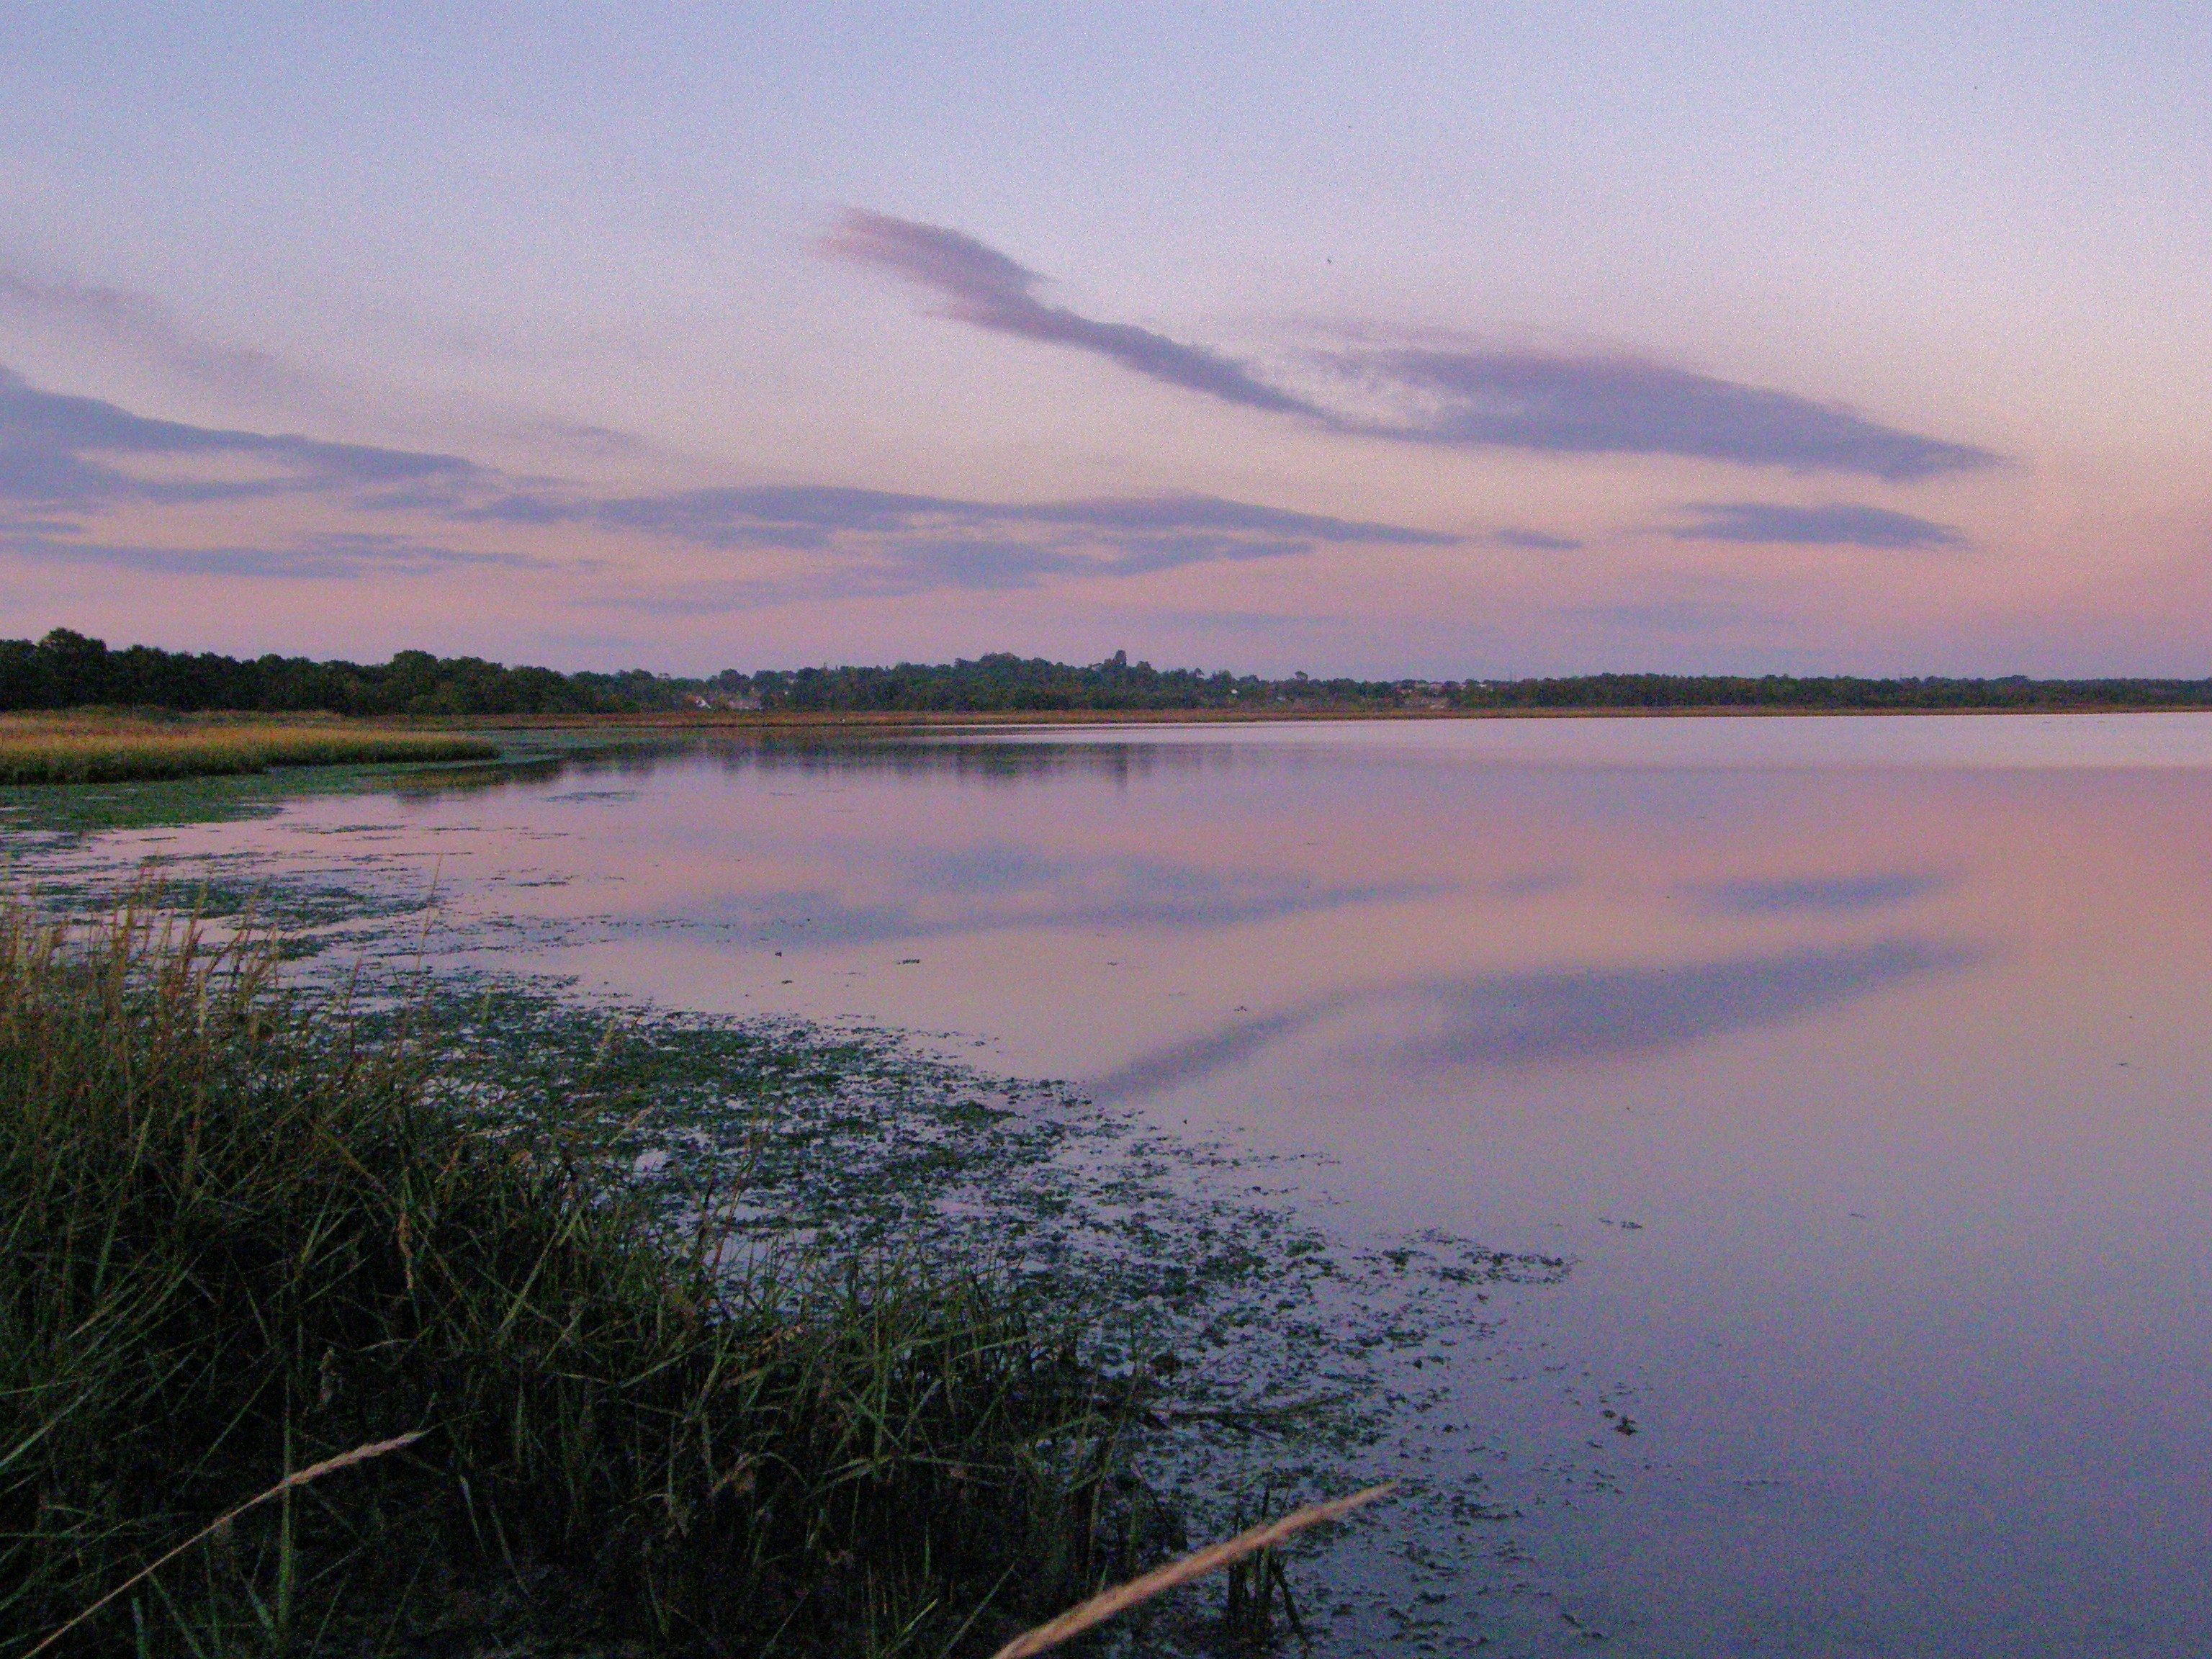

An enjoyable if somewhat ordinary year at the Bay.

Rarities were few; 3rd Great Northern Diver, 9th Ring-billed Gull and a silent Chiffchaff showing characters of the eastern race P.c.tristis.

Interest was brought by several record day counts, though the species involved do not surprise; Cormorant, Little Egret, Mute Swan, Avocet, Sedge Warbler and Carrion Crow. Peregrine, Mediterranean Gull and Collared Dove occurred more frequently than ever before. Reed Warbler arrived earlier than ever before and Osprey and Hobby lingered longer.

The species in “free fall” were also predictable given recent trends here and elsewhere. Goldeneye, Lapwing, Spotted Redshank, Stonechat and Goldcrest all had their worst year since 1992. Whilst none yet look like following the local “extinctions” suffered by Little Owl, Turtle Dove, Lesser Spotted Woodpecker, Water Pipit and Yellowhammer, they are all currently heading worryingly in that direction.

The Bay was visited on 209 days as set out below.

JAN | FEB | MAR | APR | MAY | JUN | JUL | AUG | SEP | OCT | NOV | DEC
16 | 8 | 19 | 27 | 16 | 14 | 15 | 27 | 28 | 26 | 8 | 5

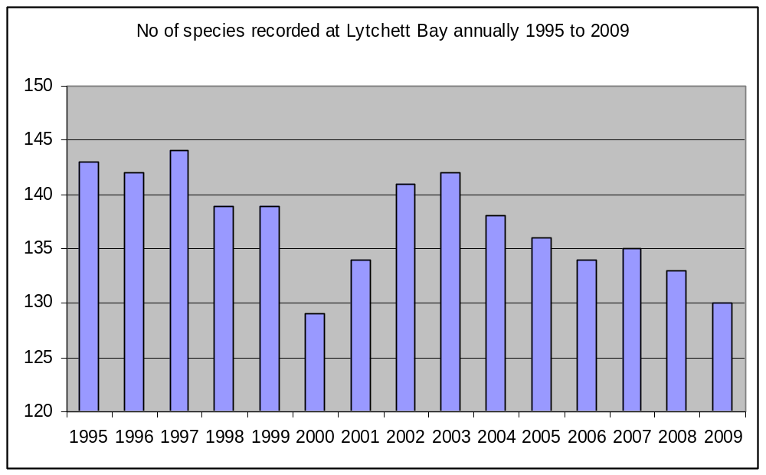

Ringing 2009
994 birds of 37 species were ringed.

The Groups focus was again around the banks of the Sherford and this reaped a series of good catches when the weather improved after July’s “washout and blow out”. 120 birds were caught on 8th August, a record morning for the site. The weather was generally unsuitable for drift Aquatic Warblers, and we drew another blank.

The full details, controls, recoveries and interesting re-traps are in the systematic list. An appendix, detailing the individual species totals is included at the end of the report.

Acknowledgements
Please remember that the major part of the site is private and that access is at the discretion of the farmer and the estate. Please respect this privilege.

Wessex Water and the landowner, the Lees Estate, for their kind permission to ring at Lytchett Bay and for access to Holton Lee.

Many thanks to Mark Singleton and his RSPB colleagues for the interest shown in the site this year.

Systematic List 2009
Species names are followed by up to 3 numbers. The first is the maximum known count recorded at the Bay. This now includes historical counts by observers going back to 1975. The middle figure (when necessary) is the max count in the period since 1992. The final figure is the number of years in which the species has been recorded since 1992.

I have also added in a new feature this year. A symbol which shows the direction of travel of the species status at Lytchett Bay over the last 5 years. I think these are quite intuitive, Strongly increasing, increasing, stable, declining and strongly declining. Hopefully this feature will enable others to compare the data from this site with experiences at their own site and engender some debate and understanding.
Great Northern Diver: (1 - 2)
3rd record. One was in the Bay on 26th Nov. (SR)

Little Grebe: (11 - 18) 
Winter visitor. Recorded until 21st Mar and from 12th Oct. Max 8 on 26th Nov.

Great Crested Grebe; (4 - 15) 
Occasional visitor. Recorded on only 2 dates. Single on 14th Mar and 2 on 26th Nov.

Cormorant: (203 – 18) 
Regular visitor. Each year brings ever greater numbers. 203 feeding in a tight flock on the mirror flat surface of the Bay early on the 26th Oct was a fine spectacle. The previous record was 150 on 28th Oct 2008.

Little Egret: (25 – 17)  Common visitor. Numbers have stabalised in recent years. A new record count of 25 was made on 27th Sept (IML). The previous max count 22 was on 3rd Sept 2005?.

Bay monthly max:
JAN | FEB | MAR | APR | MAY | JUN | JUL | AUG | SEP | OCT | NOV | DEC
n.c. | n.c. | 11 | n.c. | 4 | 12 | 13 | 20 | 25 | 5 | n.c. | n.c.

Grey Heron: (10 – 18) 
Recorded frequently throughout the year. Considerably scarcer than the previous species. An unremarkable year.

Mute Swan: (58 – 18) 
Common winter visitor, present in small numbers throughout the year. Bred between 2002 and 2007. 58 on 17th Jan was a new record count for the Bay, surpassing 51 on 17th Dec 2003.

JAN | FEB | MAR | APR | MAY | JUN | JUL | AUG | SEP | OCT | NOV | DEC
58 | n.c. | 16 | n.c. | 6 | 5 | 5 | 6 | 9 | 8 | n.c. | 41

Greylag Goose: (25 – 10) 
Scarce feral wanderer. Recorded on 2 dates. 1 on 13th Oct. 2 on 30th Nov.

Dark-bellied Brent Goose: (35 – 10) 
Scarce visitor. A single between 10th and 17th January continued the recent run of records of this species.

54 were noted on the late date of the 21st Apr. However these birds were only seen in flight and were probably south of Rockley Bridge. The record is included for interest only.

Canada Goose: (137 – 18) 
Increasingly frequent visitor. Still no indication that lingering spring birds are attempting to breed. Max 77 on 31st Aug.

JAN | FEB | MAR | APR | MAY | JUN | JUL | AUG | SEP | OCT | NOV | DEC
0 | 3 | 7 | 4 | 11 | 8 | 0 | 77 | 15 | 23 | 0 | 16

Shelduck: (645 – 548 – 18)   (last 2 years only)
Declining winter visitor and former breeder. For the second year running an improvement. The count of 213 on 17th Jan is the biggest since 407 on 15th Jan 1997.

Bay monthly max:
JAN | FEB | MAR | APR | MAY | JUN | JUL | AUG | SEP | OCT | NOV | DEC
213 | n.c. | 39 | 35 | 13 | 8 | 2 | 0 | 11 | 13 | 67 | 96

Wigeon: (424 – 18) 
Increasingly common winter visitor. Absent from 5th Apr until 16th Sep.

Bay monthly max:
JAN | FEB | MAR | APR | MAY | JUN | JUL | AUG | SEP | OCT | NOV | DEC
400 | n.c. | 35 | 2 | 0 | 0 | 0 | 0 | 9 | 62 | 145 | 353

Gadwall: (6 – 13) 
Occasional visitor. 8 bird days on 4 dates, between Jan and June. Max 3. A decline form the previous years peak..

Teal: (402 – 18) 
Winter visitor and passage migrant. No records between 10th Apr and 3rd Sep.

Bay monthly max:
JAN | FEB | MAR | APR | MAY | JUN | JUL | AUG | SEP | OCT | NOV | DEC
189 | 50 | 80 | 119 | 0 | 0 | 0 | 0 | 179 | n.c. | n.c. | 100

Mallard: (100 – 52 – 18) 
Breeds at several sites around the recording area. For the 3rd year running a pair arrived on Sandy Close Pond in mid Feb, stayed for the spring, but did not breed.

Bay monthly max:
JAN | FEB | MAR | APR | MAY | JUN | JUL | AUG | SEP | OCT | NOV | DEC
27 | n.c | 8 | br | br | 35 | 12 | 28 | 36 | 22 | n.c. | n.c.

Northern Pintail: (21 - 10) 
Scare visitor. Seen on 2 dates. Singles on 10th Feb and 2 on 13th Oct.

Shoveler: (7 – 17) 
Scarce visitor, which can occur at any time. Singles were recorded on 3 dates. A typical showing.

Common Pochard: (24 – 10) 
Rare visitor. 2 males were present on 21st Dec. The first since 2006.

Goldeneye: (12 – 18) 
Declining winter visitor. An early departure and late arrival, present until 23rd Feb and from 19th Dec. 2 were present in Jan and Feb but the only sightings at the year end related to a single male.

Red-breasted Merganser: (73 – 18) 
Common winter visitor. Present until 12th Apr and from 26th Nov. The second winter period gave the first indications that this species might be declining at the Bay?

Bay monthly max:
JAN | FEB | MAR | APR | MAY | JUN | JUL | AUG | SEP | OCT | NOV | DEC
13 | n.c. | 10 | 2 | 0 | 0 | 0 | 0 | 0 | 0 | 3 | n.c.

Osprey: (3 – 17) 
Annual passage migrant. 1 in spring on 12th Apr. Another poor autumn with only 6 records between 22nd Aug and 30th Oct. The last record was of a bird carrying a fish (R. Butler per Holton Lee logbook) and is the latest ever at Lytchett Bay.

Marsh Harrier: (2 – 17) 
Irregular visitor. An extremely good year after 2 poor ones. Recorded on 22 dates. No records between 14th Mar and 14th Sept. 2 were present on the latter date.

Hen Harrier: (2 – 17) 
Irregular Visitor. After none in 2008 it was good to have 4 records this year. Males were recorded on 16th Jan, 19th, 21st and 31st Dec.

Sparrowhawk: (2 – 18) 
Uncommon visitor. Recorded on 20 dates, just below the average number of annual sightings (23.4 p.a. 1992-2008). 1 ringed.

Common Buzzard: (15 – 18) 
The commonest raptor of the area. Breeds widely in the vicinity.

Kestrel: (3 – 18) 
Frequently seen resident. Breeding not confirmed for the third year running. 3 heading south on 18th Sep at Turlin Moor left an impression of migration.

Merlin: (2 – 14) 
Scarce winter visitor. Both records were at Border Road. Singles on 31st Jan and 28th Oct.

Hobby; (2 – 16) 
Irregular visitor. Singles recorded on 4 dates between 15th Aug and 27th Sep, the latest record at Lytchett Bay. A juv unsuccessfully trying to catch waders over the Pool on the 19th Sep was particularly special.

Peregrine: (2 – 17) 
Uncommon visitor. Recorded on 13 dates, the best showing in the period since 1992. The average number of dates is 6.7 p.a.

Pheasant: 
Increasingly common resident. Established in all parts of the recording area.

Water Rail: (23 – 18) 
Common resident and winter visitor. No specific records this year but no perceived change in status. The 2004 breeding survey established a population estimate of more than 60 pairs in the Bay.

Moorhen: (12 – 18) 
An uncommon resident. At least 3 pairs scattered across recording area, including a pair at Sandy Close Pond. These raised two broods, hatching 11 young, fledging at least 5. 1 adult ringed.

Oystercatcher: (400 – 18) 
A common winter visitor and passage migrant. Turlin Fields and Turlin Shore at high tide remain the favored locations, though more birds now remain in the bay to feed at low tide than in previous years. The maximum count was on 31st Jan.

Bay monthly max:
JAN | FEB | MAR | APR | MAY | JUN | JUL | AUG | SEP | OCT | NOV | DEC
193 | n.c. | n.c. | 2 | 2 | 10 | 10 | 1 | 42 | n.c. | n.c | n.c.

Pied Avocet: (166 – 17) 
Increasingly regular winter visitor and passage migrant. Absent from 31st Jan until 21st Oct. Numbers during Jan were consistently high and a new record count of 166 was made on 17th.

Bay monthly max:
JAN | FEB | MAR | APR | MAY | JUN | JUL | AUG | SEP | OCT | NOV | DEC
166 | 0 | 0 | 0 | 0 | 0 | 0 | 0 | 0 | 43 | 0 | 86

Grey Plover: (14 - 13) 
Scarce visitor. A single over Border Road on 13th Oct.

Ringed Plover; (17 – 10 – 14) 
Scarce visitor. Just 1 record. 5 were in the Bay on 24th Apr.

Lapwing: (3000 – 18) 
Formerly bred, now a declining winter visitor. Bred regularly during early 1990’s. Last confirmed breeding 1999. Recorded on 30 dates. The worst year on record, for the 3nd consecutive year. Recorded on only 14% of visits (30 out of 209).

This species bred again at a site within 2km of the Bay in 2009. There is still hope.

Bay monthly max:
JAN | FEB | MAR | APR | MAY | JUN | JUL | AUG | SEP | OCT | NOV | DEC
150 | 50 | 0 | 0 | 1 | 0 | 2 | 6 | 7 | 24 | 100 | 22

Dunlin: (1800 – 1200 – 18) 
Declining winter visitor and passage migrant. This uninspiring series of records was an improvement of 2008. The count toward the end of Dec was the best since 270 in Jan 2005.

Bay monthly max:
JAN | FEB | MAR | APR | MAY | JUN | JUL | AUG | SEP | OCT | NOV | DEC
6 | 0 | 2 | 1 | 0 | 0 | 0 | 6 | 5 | 1 | 0 | 150

Red Knot: (34 - 10) 
Scarce migrant. A single was roosting in the Bay with Common Redshank on 15th Sep.

Ruff: (9 – 15) 
Scarce migrant, usually in autumn. A single juv moved between the Pool and the Bay from 29th Sep to 6th Oct.

Woodcock: (5 – 8) 
Scarce but under recorded winter visitor. The number of records of this species is largely a reflection of the effort made to see them. They are probably present frequently throughout the winter. Singles on 3rd Jan and 21st Nov were the only records.

Jack Snipe: (5 - 10) 
Scarce but under recorded winter visitor. Singles on 3rd Jan and 21st Dec.

Snipe: (160 – 70 – 18) 
Declining winter visitor. Recorded until 21st Apr, returning on the 1st Aug. Numbers of Snipe at the Bay declined rapidly at the end of the 20th century. A slight improvement from the depth’s of 2008 was recorded.

Bay monthly max:
JAN | FEB | MAR | APR | MAY | JUN | JUL | AUG | SEP | OCT | NOV | DEC
22 | n.c. | 22 | 2 | 0 | 0 | 0 | 1 | 12 | 8 | 10 | 20

Black-tailed Godwit: (1240 – 18) 
Common passage migrant and winter visitor. A very poor year. Inexplicably no spring flocks formed. 1999 is the only year in the last 18 years that has seen so few. Birds were occasionally attracted to The Pool with max of 74 in Oct.

Bay monthly max:
JAN | FEB | MAR | APR | MAY | JUN | JUL | AUG | SEP | OCT | NOV | DEC
100 | n.c. | 25 | 26 | 0 | 19 | 1 | 25 | 38 | 83 | n.c. | 0

Over the last 10 years colour ringed birds have proved that birds visiting Lytchett Bay breed in Iceland (L.l.islandica). Predominantly, birds seen at Lytchett Bay on migration, winter in Western France. However some have also been recorded in Portugal, SW Ireland, Holland, Belgium, NE England as well as many locations along the south coast.

Colour ringed birds were recorded as follows.

GW+WR(flag) – A juv on the Pool on 25th Sep. Ringed at Stakkanes, north of Holmavik, NW
Iceland on 9th Jul 2009.

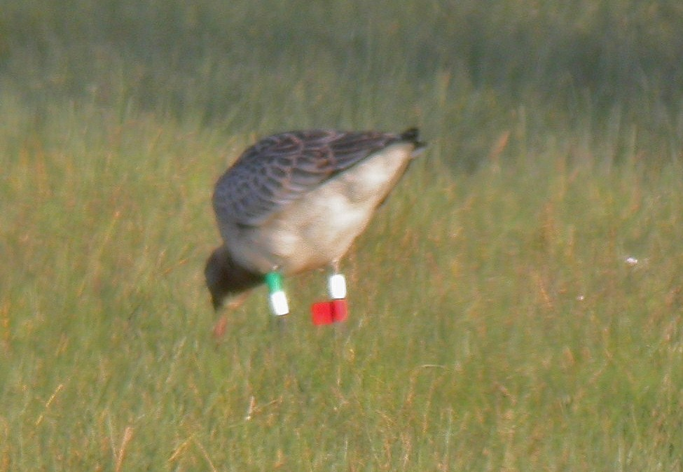

Left leg always given first, all rings above the tibia (unless preceded by the mark //). Recently some birds have been marked with leg flags rather than rings. Colours are:
O = Orange
L = Lime (this can look very washed out in the field, approaching white)
R = Red
W = White
Y = Yellow
G = Green
B = Blue
N = Niger

Many thanks to Tómas Grétar Gunnarsson for supplying this information.

Bar-tailed Godwit: (20 – 14) 
Scare visitor. A single on 14th Mar and 2 on 13th May was a typical showing.

Whimbrel: (157 – 18) 
Passage migrant, most numerous in spring. Following the first on 17th Apr there were only 70 bird days to the 10th May. Max 14 on 26th Apr. Perhaps the poorest showing in the last 18 years. Autumn passage was also very poor. 11 bird days between 1st and 22nd Aug. Max 4 on 7th.

Curlew: (104 – 18) 
Common winter visitor and passage migrant.

Bay monthly max:
JAN | FEB | MAR | APR | MAY | JUN | JUL | AUG | SEP | OCT | NOV | DEC
n.c. | n.c. | 38 | 16 | 0 | 4 | 23 | n.c. | 40 | 30 | n.c. | n.c.

Spotted Redshank: (68 – 42 – 18) 
Declining passage migrant and scarce winter visitor. Recorded on only 19 dates. This elegant species was once a “write in” for any visit in spring or autumn and would be seen in every month of the year. The first signs of decline were recognised in 1998 when the number of days on which the species was seen fell from 148 to 102.

Max 13 on 7th Oct. Absent between 14th Apr and 29th Aug.

Pool monthly max:
JAN | FEB | MAR | APR | MAY | JUN | JUL | AUG | SEP | OCT | NOV | DEC
1 | 0 | 2 | 1 | 0 | 0 | 0 | 3 | 0 | 13 | 0 | 0

Bay monthly max
JAN | FEB | MAR | APR | MAY | JUN | JUL | AUG | SEP | OCT | NOV | DEC
2 | 1 | 2 | 2 | 0 | 0 | 0 | 1 | 1 | 1 | 0 | 0

Redshank: (608 – 436 – 18) 
Common winter visitor. Small breeding population on salt marsh.

Pool monthly max:
JAN | FEB | MAR | APR | MAY | JUN | JUL | AUG | SEP | OCT | NOV | DEC
1 | 0 | 6 | 5 | 0 | 0 | 0 | 0 | 2 | 42 | 11 | 0

Bay monthly max:
JAN | FEB | MAR | APR | MAY | JUN | JUL | AUG | SEP | OCT | NOV | DEC
39 | 0 | 47 | 107 | n.c. | 13 | 7 | 12 | 109 | 188 | 11 | n.c.

Greenshank: (49 – 27 – 18) 
Common passage migrant and winter visitor. Recorded until 27th Apr. The first returning bird was noted on 5th July. Max 12 on 3rd Sep. None recorded in the last 2 months of the year.

Pool monthly max;
JAN | FEB | MAR | APR | MAY | JUN | JUL | AUG | SEP | OCT | NOV | DEC
1 | 0 | 4 | 1 | 0 | 0 | 2 | 5 | 7 | 7 | 0 | 0

Bay monthly max:
JAN | FEB | MAR | APR | MAY | JUN | JUL | AUG | SEP | OCT | NOV | DEC
1 | 1 | 3 | 3 | 0 | 0 | 2 | 10 | 12 | 3 | 0 | 0

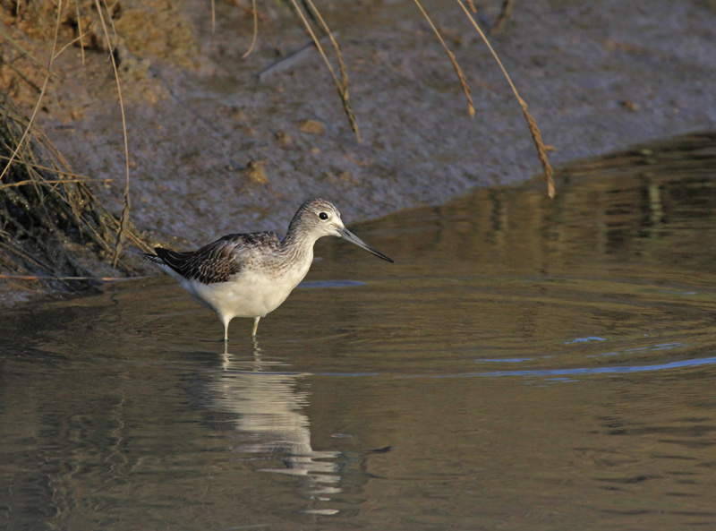
Greenshank near the sluice (c Aiden Brown)

Green Sandpiper: (10 – 18) 
Common autumn migrant and winter visitor, occasional in spring. The Far Fields and western most part of the Bay are the favoured sites. An excellent year with birds recorded on many visits up until 17th Apr. Returning on 5th July. Recorded on most visits until the years end. Max 7 on 7th Aug.

Monthly max:
JAN | FEB | MAR | APR | MAY | JUN | JUL | AUG | SEP | OCT | NOV | DEC
2 | 1 | 2 | 3 | 0 | 0 | 2 | 7 | 5 | 4 | 2 | 2

Common Sandpiper: (10 – 18) 
Uncommon passage migrant. Two in spring, on 22nd and 24th Apr. Return passage started with 3 on 6th Jul and singles were noted on a 6 further dates until 20th Sep.

Mediterranean Gull: (15 – 17) 
Uncommon visitor, stabalising after recent increase. Now established as a spring and early summer visitor – a period when pairs are establishing territories at the breeding islands in the Wareham Channel. A new record total. 115 bird days between 5th Mar and 5th Jul. Max 9 on 12th Apr. 1 juvenile seen on 2nd Aug.

Monthly max:
JAN | FEB | MAR | APR | MAY | JUN | JUL | AUG | SEP | OCT | NOV | DEC
0 | 0 | 5 | 9 | 4 | 4 | 2 | 1 | 0 | 0 | 0 | 0

Black-headed Gull: (12000 – 7000 – 18) 
A very common visitor. 1000’s regularly frequent the bay en route to the Wareham Channel roost. The first juveniles were noted on 12th Jun.

Ring-billed Gull: (2 – 8)
The ninth record. An adult in breeding plumage was well watched and photographed on 8th Mar (SR et al).

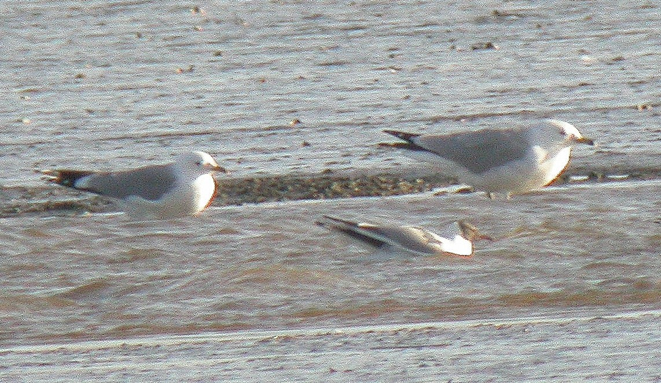
Ring-billed Gull March 2009. S. Robson

Common Gull: (1700 – 18) 
A common winter visitor and passage migrant, especially in spring. Max 300 on 8th Mar. The last birds of winter were seen on 14th Apr. The first returning bird was on 12th Jul.

Lesser Black backed Gull: (2128 – 18) 
Abundant autumn and common spring passage migrant and uncommon winter visitor. Rarely counted.

Herring Gull: (2000 – 18) 
Common winter visitor and passage migrant.

Yellow legged Gull: (65 – 17) 
Frequent visitor throughout the year, peaking in summer. Under recorded. As the species has become a more frequent sight, interest in it has inevitably declined. Max was on 10th Sep

Bay monthly max:
JAN | FEB | MAR | APR | MAY | JUN | JUL | AUG | SEP | OCT | NOV | DEC
1 | 0 | 0 | 1 | 0 | 0 | 5 | 5 | 15 | 8 | n.c. | 0

Great Black backed Gull: (151 – 18) 
Daily visitor throughout the year in small numbers.

Sandwich Tern: (5 – 18) 
Uncommon summer visitor. 12 bird days noted on 10 dates between 14th Jun and 27th Sep.

Common Tern: (25 – 18) 
Uncommon summer visitor. Seen on only 6 dates between 14th May and 7th Aug. Max 3.

Stock Dove: (29 – 18)  
Uncommon Resident. Max 9 on 10th Apr.

Wood Pigeon: (1368 – 18) 
Common resident. 2 ringed.

Collared Dove: (14 – 18) 
Uncommon resident. Rarely seen in the rural parts of the Bay, but regular on the urban fringe, particularly Beach Road, Lytchett Way and Border Road. 14 together at Turlin Moor on 26th Oct was the single biggest gathering recorded at the Bay.

Cuckoo: (2 – 18) 
Uncommon summer visitor. 11 records of a single male(s) from various areas on the northern shore between 18th Apr and 19th May.

Barn Owl: (2 – 11) 
Recent breeder. Following successful breeding in 2007 but a blank year in 2008, breeding again occurred at French’s Farm. 4 young were raised. As in 2007 the birds were very elusive and only once were seen away from the immediate vicinity of the nest. 4 ringed.

Tawny Owl: (2 – 18) 
Uncommon resident. Seems to be declining at the Bay. Records came from Sandy Close, Lytchett Heath and Far Fields in Feb, June and Aug respectively.

Nightjar: (3 – 9) 
Irregular breeder. Another good year with 2 males holding territory in early June. Singles were recorded on the Far Fields on 3 dates in Aug.

Swift: (113 – 18) 
Passage migrant and possible local breeder. Recorded between 24th Apr and 29th Jun. Regular sightings at Sandy Close Pond suggested that up to 3 pairs were nesting nearby. No significant migration was witnessed.

Kingfisher: (3 – 18) 
Passage migrant and uncommon winter visitor. Bred in 2000 and must breed just outside the recording area most years. Recorded in both winter periods. Absent between 1st Mar and 12th Jun. 8 ringed.

One of the birds ringed in previous years was re-trapped.

SA96777 – 1st yr ringed on 22nd Aug 2008, was re-trapped and sexed as a female on 19th Sep 2009. (394 days).

Of the 8 new birds ringed in 2009, 2 were re-trapped.

SA27385 – 1st yr ringed on 12th Aug, still present on 10th Oct (60 days)
SA96727 – 1st yr ringed on 24th Jul; still present on 6th Aug (14 days)

Green Woodpecker: 
Breeding resident. Bred successfully and recorded in all parts of the Bay. No change in status.

Great Spotted Woodpecker: 
Breeding Resident. Seen regularly in most parts of the Bay. 3 at Turlin Moor on 26th Oct may have been migrants. 3 ringed.

Skylark: (250 – 24 – 18) 
Scarce breeder and passage migrant. 1 territory established and held throughout the spring. Small numbers of migrants from 10th Oct. Max 24 on that date, the best count in the period since 1992.

Sand Martin: (5000 – 18) 
Common passage migrant. First record was 28th Mar. The last record of the year was on 18th Sep. Numbers were again very poor and the large early summer flocks of the 90‘s are a distant memory. 2 ringed.

Swallow: (1000 – 540 – 18) 
Common passage migrant, breeds at French’s Farm. Recorded from 31st Mar until 10th Oct. Max numbers occurred in autumn. 150 in both Aug and Oct. 15 ringed.

House Martin: (1800 – 18) 
Common passage migrant, breeding colonies on edge of recording area at Watery Lane and Turlin Moor. The first of the year was on 14th Apr. The size of the breeding colony at Watery Lane was 15 nests, 2 up on 2008 (plus 5 failed or destroyed). The colony at Turlin Moor was not surveyed.

Tree Pipit: (6 – 14) 
Scarce passage migrant. 5 bird days over 4 dates between 18th and 28th Aug.

Meadow Pipit: (130 – 18) 
Breeding resident and common passage migrant. 3 singing birds on territory during the breeding season. First signs of autumn migration on 17th Sep. Max of 93 in the stubble on 19th Oct. Small numbers present in both winter periods. 21 ringed.

Rock Pipit: (50 – 18) 
Common winter visitor. Recorded until 14th Mar and from 21st Oct. Common on saltings throughout the winter. Max count was 40 at Lytchett Heath on 21st Dec.

Yellow Wagtail: (44 – 18) 
Uncommon passage migrant. No records in spring. Another good autumn. 148 bird days between 17th Aug and 1st Oct. Max 44 on 10th Sep was the biggest count at the Bay since at least 1992.

Grey Wagtail: (12 – 18) 
Breeding resident and passage migrant. Present during the breeding season but breeding not confirmed. Frequently recorded on migration in Sep. Max 5 in Oct.

Pied Wagtail: (400 – 18) 
Recorded throughout the year, common in autumn. Bred successfully. Birds roost at various points around the Bay during peak migration in October. Autumn roost peaked at 330 on 10th Oct. 121 ringed.

Wren: 
Common resident. 18 ringed.

Dunnock: 
Common resident. 10 ringed.

Robin: 
Common resident. 16 ringed.

Common Redstart: (2 – 11) 
Scarce autumn migrant. Singles at Turlin Moor on 15th Sep and Sandy Close Pond on 18th Sep were the only records. The last being the latest record at the Bay.

Whinchat: (11 – 16) 
Scarce passage migrant. The national decline of this species is visible at the Bay with another poor autumn. Only 4 records involving 5 birds. On the Far Fields 1 on 14th Aug, 10th Sep, 2 on 17th and 1 on 24th.

Stonechat: (23 – 18) 
Past common breeding resident, recently changed status to uncommon migrant A sharp decline even within the context of the on going slide in this species fortunes. Recorded on only 19 visits - 9% (35 visits in 2008, 39 in 2007). Recorded on only 2 dates in Spring, Max 6 on 1st Mar. Then from 13th Aug on and off until the year end. Max 4 on several dates. 2 ringed.

V841769 – A 1st yr male, ringed on 27th Oct 2007 was taken by a cat in Wareham 442 days later on 11th Jan 2009.

Northern Wheatear: (15 – 18) 
Uncommon passage migrant. An average year. 3 bird days in spring 28th Mar and 14th May. 21 in autumn between 13th Aug and 24th Sep. Max 4 on 14th Aug and 17th Sep.

Blackbird: (45 – 18) 
Common Resident. No significant influxes in autumn, though recorded commonly across the area. 14 ringed.

Fieldfare: (121 – 18) 
Uncommon winter visitor. Very scarce for the 3rd year in a row. Only recorded on 3 dates. Max 3 on 30th Nov.

Song Thrush: (424 – 18) 
Breeding resident. Estimated to be stable across the area but incomplete survey conducted. 6 territories noted. No migration flights recorded again this year. 1 ringed.

Redwing: (1000 – 268 – 18) 
Winter visitor. Occasional records until 17th Mar. Max 15 on any one day. From 14th Oct. Two small flights. 91nne on 15th Oct at Border Road and 87ne on 29th Oct at Beach Road.

Mistle Thrush: (16 – 18) 
Breeding resident. Breeding not confirmed this year but no change in status perceived. Recorded throughout the year across the recording area.

Cetti's Warbler: (11 – 17) 
Breeding resident. 8 territories again this year. Better than expected given the cold winter preceding the breeding season. A young male remained at Sandy Close Pond from 28th July until the year end. 7 ringed.

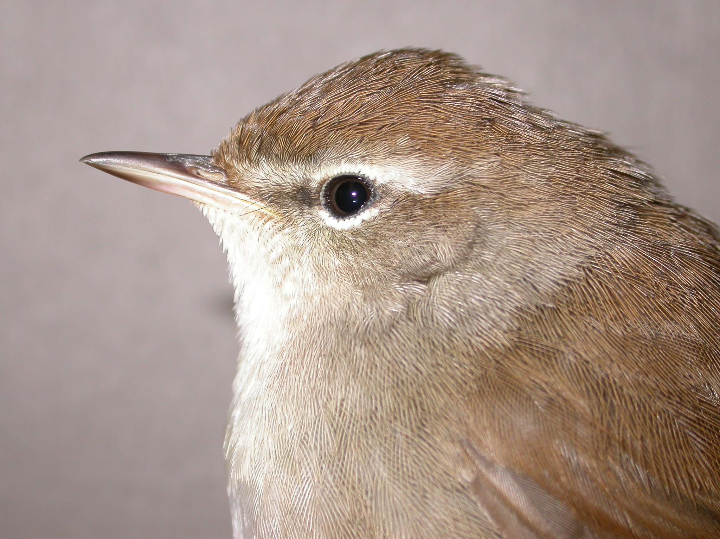
Cetti’s Warbler, Sandy Close Pond, Dec (S.Robson)
Grasshopper Warbler: (7 – 11) 
Passage migrant, under recorded. In contrast to last years record, 2009 was very poor. Only 7 were recorded in autumn between 31st Jul and 23rd Aug. All were ringed and none were re-trapped. 7 ringed.

Sedge Warbler: (68 – 18) 
Passage migrant. Spring passage was very poor with only 4 birds between 1st and 13th May. The autumn migration was strong for the second year in a row. In autumn, 308 from 30th Jul to 22nd Sep. Max 68 trapped on the 8th Aug. This was a new record day count at the Bay. 304 ringed.

Daily max and bird days are given in the following table.
JAN | FEB | MAR | APR | MAY | JUN | JUL | AUG | SEP | OCT | NOV | DEC
 |  |  | 0 | 2 |  | 49 | 68 | 6
 |  |  | 0 | 4 |  | 49 | 251 | 15

V841962 – A 1st yr bird ringed on 9th Aug 2008, was re-trapped at Radipole Lake 6 days later on 15th Aug 2008.

V220816 – A 1st yr bird ringed on 22nd Aug 2008, was re-trapped at Sandwich Bay, Kent the following day (23rd Aug 2008) a movement of 248km.

X727713 – A 1st yr bird ringed at Icklesham, East Sussex on 8th Aug 2009, was re-trapped at Lytchett Bay 4 days later on 12th Aug.

Two good examples of birds moving along the south coast on autumn migration.

Reed Warbler: 
Common summer visitor. Breeds in all areas of the Bay. Present between 12th Apr ( the earliest return date at the Bay) and 10th Sep. 95 ringed.

X297685 – A nestling ringed at Chew Valley Lake, Avon on 23rd June 2009, was re-trapped at Lytchett Bay 52 days later on 14th Aug.

Dartford Warbler: (2 pairs – 16) 
Breeding resident. The cold winter seemed to account for our breeding birds. The only record was one at Lytchett Heath on 20th Dec.

Whitethroat: (8 – 16) 
Uncommon passage migrant. 6 in spring between 15th Apr and 13th May. 13 bird days in autumn between 8th Aug and 1st Sep. 4 ringed.

Garden Warbler: (5 – 16) 
Scarce passage migrant. One in spring, singing on Far Fields on 1st May. In autumn, 9 between 8th and 18th Aug. Max 3 on 2 dates. 3 ringed.

Blackcap: (10 – 18) 
Passage migrant and summer visitor. Breeding population but perhaps as few as 3 territories. A male wintered at Sandy Close Pond, and remained until 10th Apr. The first presumed migrant was on 9th Apr. Max 4 on 12th Apr. Autumn migration was again poor, with the last record on the 13th Oct. 9 ringed.

Daily max and bird days are given in the following table.
JAN | FEB | MAR | APR | MAY | JUN | JUL | AUG | SEP | OCT | NOV | DEC
1 | 1 | 1 | 4 | b | b | b | 3 | 4 | 1 | 0 | 3
w | w | w | 20 | b | b | b | 10 | 20 | 4 | 0 | w

Chiffchaff: (27 – 18) 
Breeding summer visitor and passage migrant. The first spring migrant arrived on 15th Mar. At least 11 territories were established. Autumn migration was good. Max 23 on 19th Sep. 32 ringed.

Daily max and bird days are given in the following table.
JAN | FEB | MAR | APR | MAY | JUN | JUL | AUG | SEP | OCT | NOV | DEC
 |  | 3 | 14 | b | b | b | 7 | 23 | 6 | 1 | 1
 |  | 9 | 46 | b | b | b | 25 | 104 | 24 | 1 | 1

Eastern Chiffchaff:
One was at Sandy Close Pond on 15th Nov. Unfortunately it was silent and therefore confirmation as P.c.tristis was not possible.

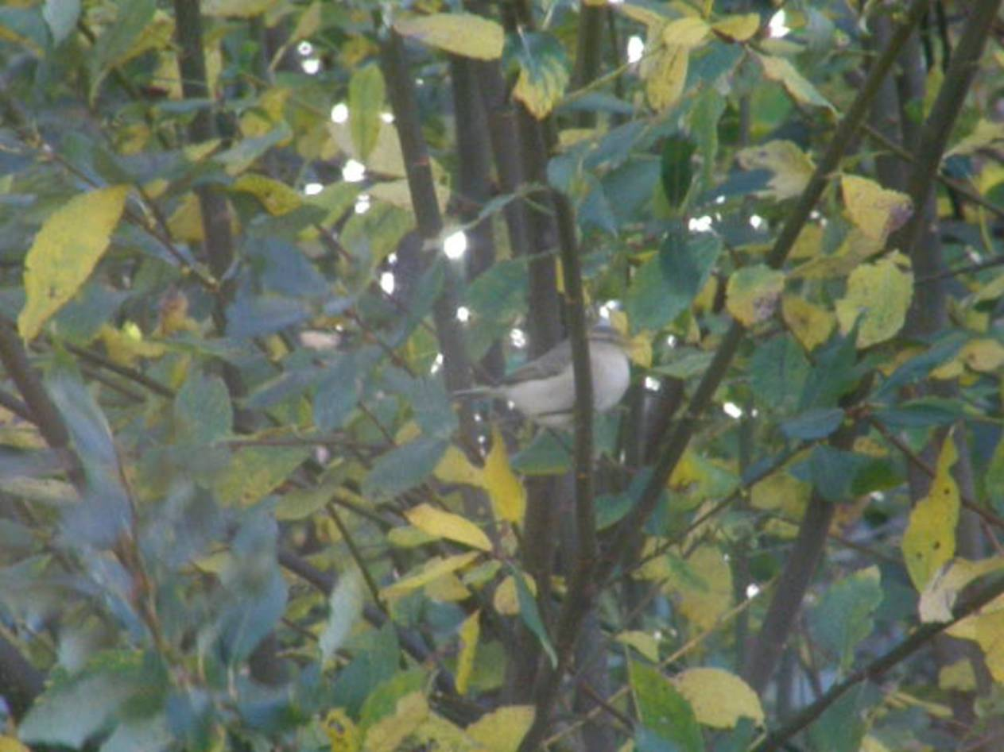

Poor video grab of the Eastern Chiffchaff (S. Robson)

Willow Warbler: (19 – 18) 
Breeding summer visitor and passage migrant. First recorded on 31st Mar at Sandy Close Pond. 1 territory established. Migration in both periods was again weak. The last bird was noted on 9th Sept. 16 ringed.

Daily max and bird days are given in the following table.
JAN | FEB | MAR | APR | MAY | JUN | JUL | AUG | SEP | OCT | NOV | DEC
 |  | 2 | 3 | b | b | 1 | 6 | 1
 |  | 2 | 12 | b | b | 1 | 28 | 1

Goldcrest: (14 – 18) 
Passage migrant, which occasionally breeds. Like the rest of Britain, a dreadful year. Recorded on only 9 dates. The cold winter must have taken a severe toll. 3 ringed.

Daily max and bird days are given in the following table.
JAN | FEB | MAR | APR | MAY | JUN | JUL | AUG | SEP | OCT | NOV | DEC
 | 2 | 1 | 1 |  |  |  |  | 1 | 1 | 1 | 1
 | 5 | 1 | 1 |  |  |  |  | 1 | 1 | 1 | 1

Spotted Flycatcher: (8 – 6 – 18) 
Passage migrant, previously bred. 2 in spring at Sandy Close Pond on 14th May. In autumn 6 records of single birds between 30th Aug and 17th Sep.

Bearded Tit: (29 – 18) 
Rare breeder. Present at two sites during the breeding season. At least 1 pair raised young with fledged juveniles seen in July. 4, high over on 10th Oct may have been migrants. 2 ringed.

Long tailed Tit: 
Common resident. Regularly recorded from most sites at the Bay. 27 ringed.

Coal Tit: 
Uncommon resident. Seems to be gradually increasing. Recorded from most sites this year across the calendar. 1 ringed.

Blue Tit: 
Common resident. 90 ringed.

Great Tit: 
Common resident. 37 ringed.

Nuthatch: 
Uncommon. Recorded in Mar, Jul, Aug and Sep in the area of the Cottage and French‘s Farm.

Treecreeper: 
Uncommon. Only 1 record this year. 9th Sep at Beach Road.

Jay: (6 – 18) 
Resident. Regularly seen throughout the year but most often in autumn.

Magpie: 
Common Resident.

Jackdaw: (205 – 18) 
Resident. Recorded throughout the year.

Rook: (185 – 18) 
Breeds on edge of recording area. The rookery was not surveyed this year. 14 nests in 2008.

Carrion Crow: (68 – 18) 
Common Resident, increasing. A record count of 68 in stubble on 16th Apr.

Raven: (7 – 15) 
Irregular visitor. Annual since the first record in 1995. 16 bird days on 10 dates throughout the year.

Starling: (35000 – 5600 – 18) 
Common resident. No roosting flocks recorded this year. Some early morning westerly movement was noted in Oct. Max 103 on 29th. 2 ringed.

House Sparrow: (80 – 18) 
Resident. Usually recorded around the urban fringe. Bred at Turlin Moor, Border Road and French’s Farm.

Chaffinch: (140 – 18) 
Breeding resident and winter visitor. No winter flocks seen this year. Up to 12 were regularly at Sandy Close Pond during each winter period. 8 ringed.

Brambling: (7 – 15) 
Scarce Visitor. The only record was a single at Sandy Close Pond on 24th Jan.

Greenfinch: (60 – 18) 
Common breeding resident. Border Drive, The Cottage and Turlin Moor remain the favored areas. 11 ringed.

Goldfinch: (120 – 18) 
Uncommon breeding resident and passage migrant. Flocks frequently recorded in the autumn, max 53 at Border Road. Regular visitor, in small numbers, to feeders at Sandy Close Pond. 43 ringed.

Siskin: (280 – 15) 
Passage migrant. Frequently seen at feeders at Sandy Close Pond between 1st Jan and 1st May. Max 6 on 28th Feb. Recorded occasionally from 12th Oct to the year end in small numbers. Max 11 over Sandy Close Pond on 29th Oct. 14 ringed.

Linnet: (250 – 18) 
Uncommon breeding resident, declining. A spring flock around the stubble peaked at 45 in early Apr. May have bred at Lytchett Heath and French‘s Farm. Autumn roost at Lytchett Way peaked at 43 in Oct.

Lesser Redpoll: (40 – 14) 
Scarce passage migrant. 1 at Sandy Close Pond on 21st Feb. In autumn only recorded on 2 dates, both in Oct. 16 over Water Works on 10th and 12 over Beach Road on 29th.

Bullfinch: (6 – 18) 
Uncommon. Recorded on 11 dates between Mar and Nov from scattered sites across the area.

Reed Bunting: (27 – 18) 
Breeding resident. No effort made to survey the breeding population but no change in status perceived. Only 1 record at Sandy Close Pond. 1 on 4th Mar. 40 ringed, of which 21 were juveniles.

Appendix 1 Lytchett Bay Ringing Totals 2009
Retraps/
Full grown Pulli Recoveries Total

Sparrowhawk 1 0 0 1
Moorhen 1 0 0 1
Wood Pigeon 2 0 0 2
Barn Owl 0 4 0 4
Kingfisher 8 0 4 12
Great Spotted Woodpecker 3 0 0 3
Sand Martin 2 0 0 2
Swallow 15 0 0 15
Meadow Pipit 21 0 0 21
Pied Wagtail 121 0 0 121
Wren 18 0 5 23
Dunnock 10 0 6 16
Robin 16 0 5 21
Stonechat 2 0 0 2
Blackbird 14 0 5 19
Song Thrush 1 0 0 1
Cetti's Warbler 7 0 2 9
Grasshopper Warbler 7 0 0 7
Sedge Warbler 304 0 5 309
Reed Warbler 95 0 9 104
Whitethroat 4 0 3 7
Garden Warbler 3 0 0 3
Blackcap 9 0 0 9
Chiffchaff 32 0 0 32
Willow Warbler 16 0 0 16
Goldcrest 3 0 0 3
Bearded Tit 2 0 0 2
Long-tailed Tit 27 0 2 29
Coal Tit 1 0 1 2
Blue Tit 90 0 28 18
Great Tit 37 0 5 42
Starling 2 0 1 3
Chaffinch 8 0 1 9
Greenfinch 11 0 0 11
Goldfinch 43 0 1 44
Siskin 14 0 0 14
Reed Bunting 40 0 0 40
Total: 994 0 0 1077

List of contributors: G.J Armstrong, I Alexander, T Balmer, A Brown, R Butler, M Constantine, J.S Dowling, T Elborn, M Gould, R Gifford, N.Hopper, K Lane, I M Lewis, S Robson, S Walls.

